Unit 1 Second Grade
New vocabulary:-

board لوح

children اطفال
desk مقعد
Jordan الاردن 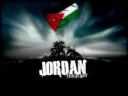
mosque مسجد
page صفحة 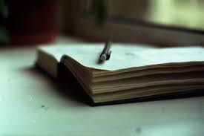
Pencil case مقلمة 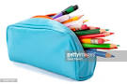
rubber ممحاة 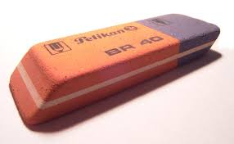
ruler مسطره
turn يقلب 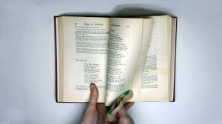
functions and activities
Good morning.
Good morning.

How are you?
I’m very well thank you
What’s your name?
I’m -------

Structures:
Yes /No questions and answers:-
Is this a mosque?

Yes it is.
Is it a pencil case?
?

No it isn’t.

Answer please:-
Is it a ball?
Is it a doll?

Is it a bike?
Is it a car?
Is it a cat?
Is it atable?

Choose please:-
Good morning,------------ a- Teacher b- mum c- girl
. Is it a girl? a- Yes it is b- No it isn’t
Match please:-
m r j

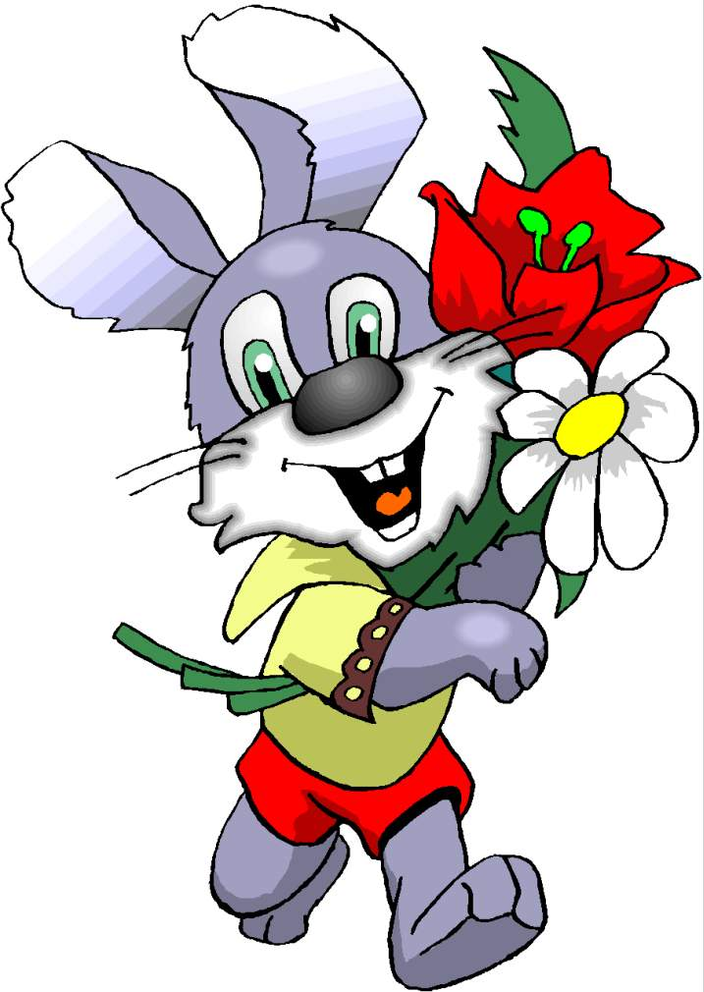
Unit 2 Second Grade
New vocabulary:-
Aunt | عمه - خاله
baby | طفل صفير
cousin | ابن عم او ابنة العم
grandma | جدة | 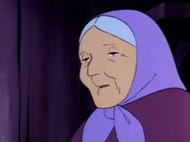
grandpa | جد | 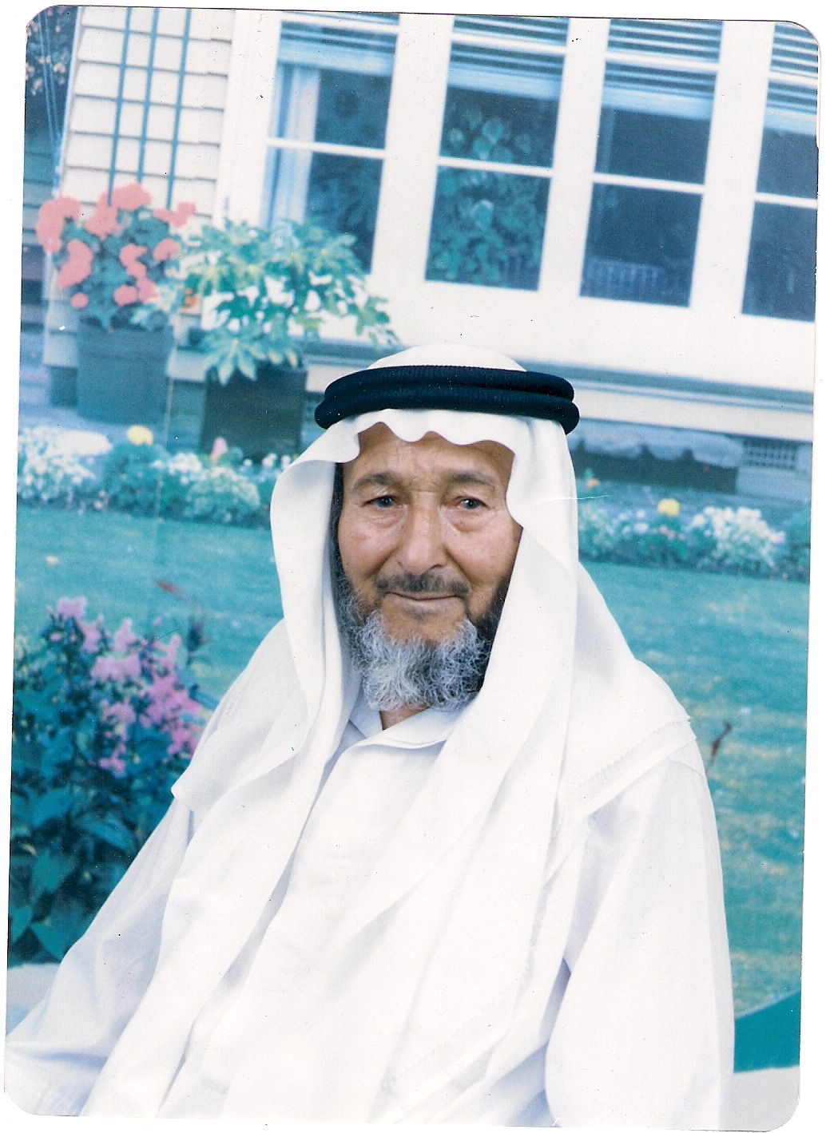
grandparents | اجداد
Live | يعيش - يسكن
Uncle | عم- خال
Who | من ؟

functions and activities
Where do you live?
I live in Amman
I live in Irbid
He lives in Salt
Where do you live?

Where does she live?
Where does he live?
She lives in Petra
Where do they live?
They live in Aqaba
Structures:
Who are these?

This --------------That
This is --------- | That is ----------------
This is --------- | That is ----------------
This is --------- | That is ---------------
Choose please:-
- I live in
- Amman b- Aqaba c- Jerash
- He lives in
- Petra b- Zarqa c- Ajloun
- They live in 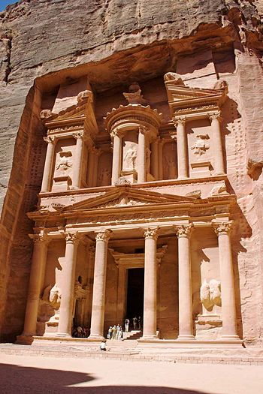
- Petra b- Amman c- Aqaba
Match please
b |  | U
Write please:
………………………………………………………………………………………………………………………………………………………………………………………………………………………………………………………………………………………………………………………………………………………………………………………………............................……………………………………………………………………………………………………………..................................................................................................................................................................................................................
………………………………………………………………………………………………………………………………………………………………………………………………………………………………………………………………………………………………………………………………………………………………………………………………............................……………………………………………………………………………………………………………..................................................................................................................................................................................................................

Unit 3 Second Grade
New vocabulary:-

Sunday | الاحد | Saturday | السبت
Monday | الاثنين | Week | اسبوع
Tuesday | الثلاثاء | month | شهر
Wednesday | الاربعاء | Today | اليوم
Thursday | الخميس | School trip | رحلة مدرسية
Friday | الجمعة | Zoo | حديقة الحيوانات
help | يساعد | park | منتزه
play | يلعب | read | يقرأ
Tidy | يرتب | Visit | يزور

functions and activities
What day is it today?
It’s Sunday
What was yesterday?
It was Saturday
On Friday I visit my grandparents

On Thursday I read a book
On Monday I play football
On Tuesday I tidy my bed room s
On Saturday visit a zoo
On Sunday I help mum

Structures:
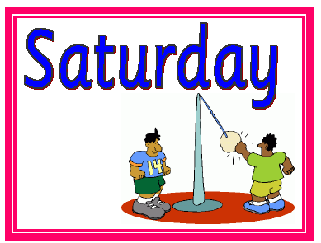
Match Please:-
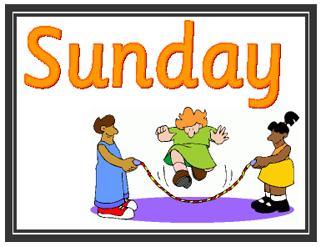
- We go fishing on-------------

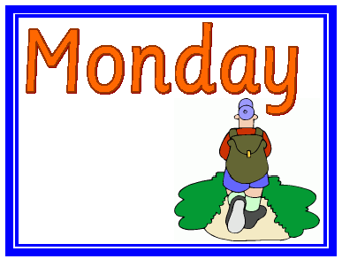
- We read a book on----------

- We use computer on -----------
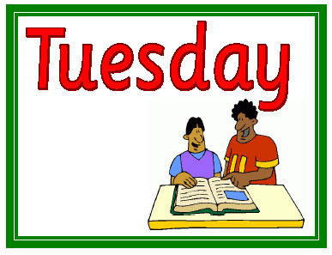
4-She paints a picture on ----------.

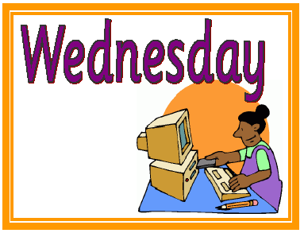
5-He does his homework on------

6-We play on --------------.
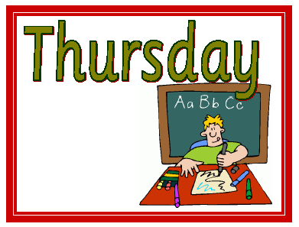
7-He goes to school on ------------.
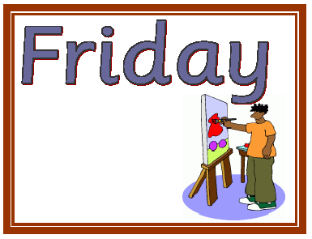



…………………………………………………………………………………………………………………………………………………………………………………………………………………………………………………………………………………………………………………………………………………………………………………………………………………………………………………………………………………………………………………………………………………………………….................................................................................................................................................................................................................................................................
…………………………………………………………………………………………………………………………………………………………………………………………………………………………………………………………………………………………………………………………………………………………………………………………………………………………………………………………………………………………………………………………………………………………………………...........................................................................................................................................................................................................................................................

....................................................................................................................................................................................................................................................................................................................................................................................................................................................................................................................................................................................................................................................................................................................................................................................................................................................

…………………………………………………………………………………………………………………………………………………………………………………………………………………………………………………………………………………………………………………………………………………………………………………………………………………………………………………………………………………………………………………………………………………………………………...........................................................................................................................................................................................................................................................

…………………………………………………………………………………………………………………………………………………………………………………………………………………………………………………………………………………………………………………………………………………………………………………………………………………………………………………………………………………………………………………………………………………………………………...........................................................................................................................................................................................................................................................
…………………………………………………………………………………………………………………………………………………………………………………………………………………………………………………………………………………………………………………………………………………………………………………………………………………………………………………………………………………………………………………………………………………………………………...........................................................................................................................................................................................................................................................

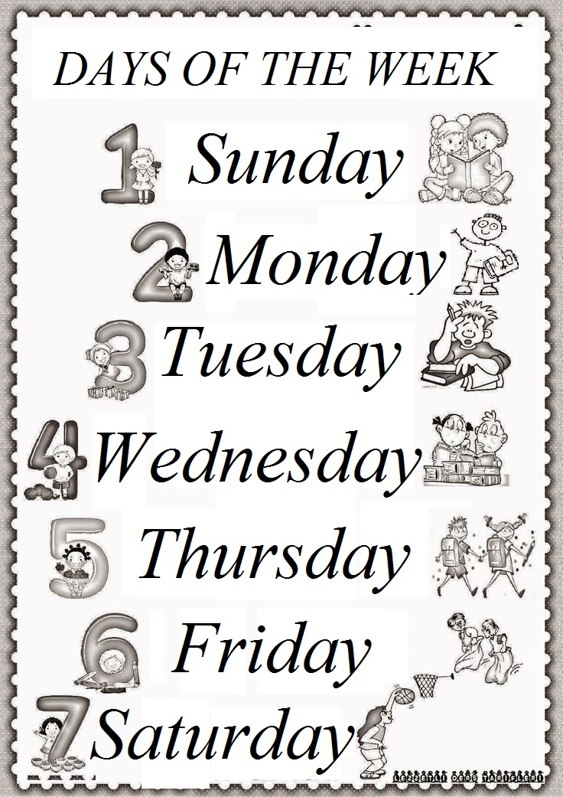

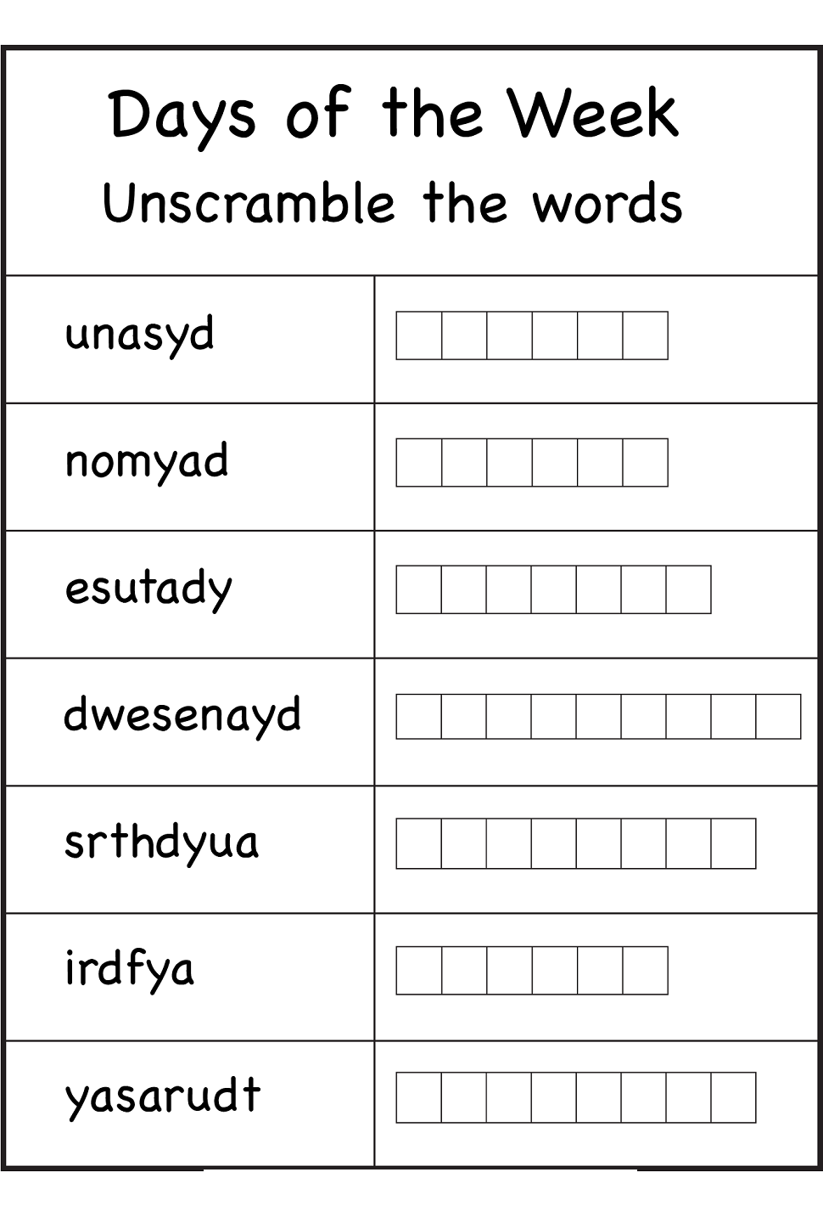

Where do you live?
I live in Amman

