Complete.


must, mustn’t


- You…………………………eat vegetables.
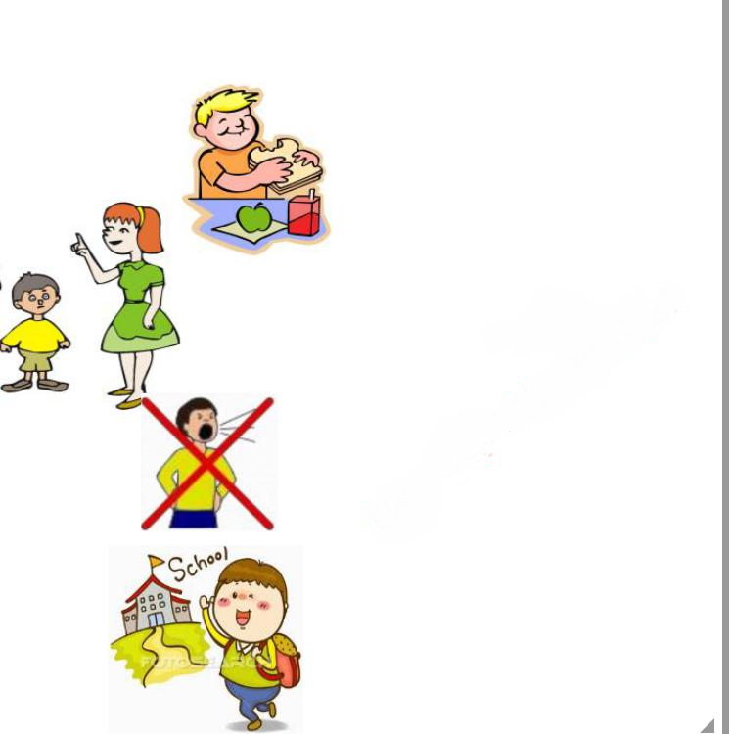
- Ahmad ……………………forget his homework.

- You …………………………have your breakfast.

- I…………………………listen to my mother.

- You …………………..shout in the classroom.

- Heba ……………………….go to school every day.

Read and write.
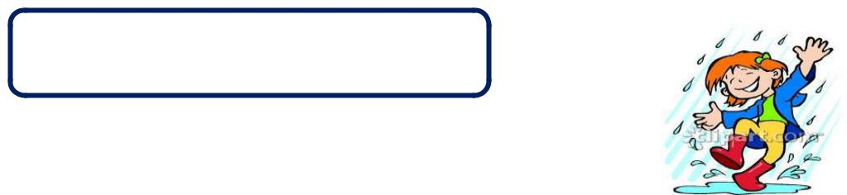

must, mustn’t

walk in the rain.
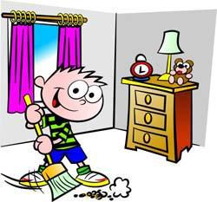

Clean your bedroom.
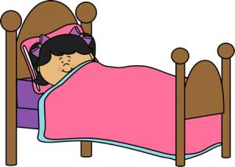

sleep at 8 o’clock.

1-You………………………………………………………………………………………

2-……………………………………………………………………………………………

3-……………………………………………………………………………………………

