1-Mach:-
1-play ground
2- sea

3-swimming pool
4- zoo
5- Park
6- river

2-Complete please: ( shop- river- big- philadelphia-smaller)
1-I n the past Amman was called-----------------.
2- Qurayesh Street was------------in the past.
3-When I was baby wasn’t very-------------------.
4- In the past the houses were--------------------.
5- In the past t---------------weren’t here.
3-Compare between tow pictures:-
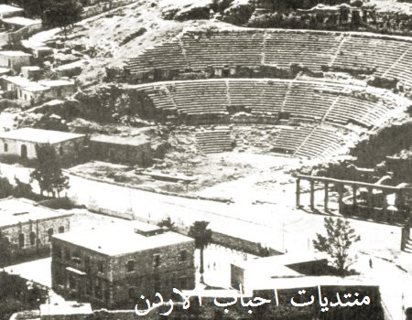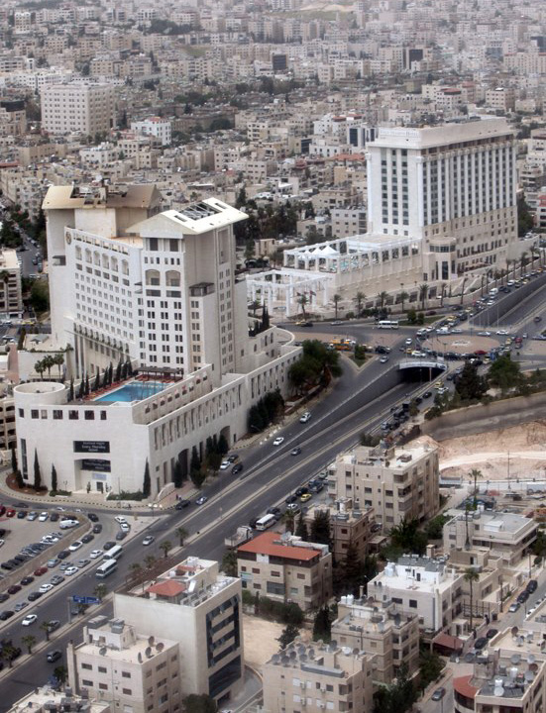
1-Now,this is--------------.In the past,the-------------wasn’t here.It was-----
2---------------------------------------------------------------------------------------------
3---------------------------------------------------------------------------------------------
4---------------------------------------------------------------------------------------------5---------------------------------------------------------------------------------------------.

4- Draw your city:-

