Work sheets for 6th grade

Pronouns

It | He | She | They | You | We | I | Subjective Pronouns
is | is | Is | are | are | are | am | Subjective Pronouns

Exercise 1 :-
Choose the suitable subjective pronoun ( I, We , You, They , She, He, It)

1. My cousin and her friend were at the mall. were at the mall.
2. Peter is a little sick. is a little sick.
3. Does your aunt know what happened? Does know what happened?
4. The door is locked. is locked.
5. My friend Linda and I are going on a trip. are going on a trip.
6. Am I a good student? Yes, are a good student.
7. My cats are hungry. are hungry.
8. Mr. Jones is a good teacher. is a good teacher.
9. Is Swedish a difficult language. Yes, is a difficult language.
10. My brother and I live together. live together.

Work sheets for 6th grade

Pronouns
Exercise 2 :-
Use ( is , am , are ) :-
1) I …………… tired.
2) You ………… nice.
3) We …………..sleepy.
4) She …………funny.
5) Saeed ………….. excited.
6) My mother and my father …………… watching a movie.
7) The students ……………… happy.
It | He | She | They | You | We | I | Subjective Pronouns
it | him | Her | them | you | us | me | Objective  Pronouns

Examples:-
1- I can't see Mary. I can't see ________
him she her
Can you help Peter and Ann? Can you help ________?
they you them
Drink your apple juice! Drink ________!
it you him
These are my bananas. You can't eat ________
they them it
Carol is at school. She can't come with ________
we us they
The cat is under the chair. Can you see __________?
he she it
Work sheets for 6th grade

Parts of speech
Parts of Speech
Prepositions | Adjectives | Verbs | Nouns
On, in, of, from, at | Funny , old ,big, small, exciting, beautiful ……... | Read, run , talk write ……. | Examples:- a table, Ali , Jordan, writing ……

Exercise 1:-
Read the text carefully and find the following :-
Hello. My name is Ali. I sometimes write letters, but I prefer sending emails on my laptop. Writing letter isn't as quick as typing emails. Emails are very quick.
Emails are neater than letters because typing is very neat. I like horse riding and tennis. I could play tennis when I was seven. I cannot ride horses very well, but My father is teaching me to ride horses.

1. Nouns ………………….. …………………….. ……………………….
2.Ajectives ……………………… …………………………….
3. Verbs ……………………………. ……………………………….
4. Prepositions …………………………. …………………….
5. Pronouns ………………….. …………………….. …………………

Work sheets for 6th grade

Wh- Questions
How | Why | Who | Where | When | What | Wh - Questions
manner | reason | person | place | time | things | Wh - Questions

Exercise 1: Complete each sentence using what, when, where, who, why, how:-

1) ................ are my keys?

2) ................ is the problem?

3) ................ is your favourite singer?

4) ................ is your birthday?

5) ................ old are you? I'm ten years old.

6) ................ is your telephone number?

7) ................ are you from?

8) ................ is your best friend?

9) ................ is your e-mail?

10) ................ are you? I'm fine, thanks.

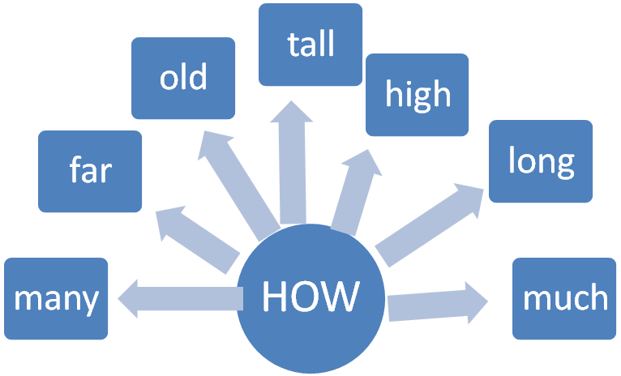

Exercise 2 :-
Complete the questions using how:-

How …………….. tea do you need?-

-How ………………sisters do you have?

-How ………………. are ? I am 10 years old.

-How ……………… is it from Amman to Jerash?

-How ………………is Um Addami mountain?

- How ………… is the tower ?

Work sheets for 6th grade

Countable and Uncountable Nouns
- Countable nouns are nouns that can be singular or plural. We can count them like girls, flowers, boys, apples and tomatoes.
Examples :-
1-The students are playing now.
2-A fig tree is very big.

- Uncountable nouns are nouns that can only be singular. We can't count them like tea, water, sugar, salt, cheese, hair, money, rice …..
Examples :-
1-Water is very important.
2- Cheese is delicious.

Exercise 1 :- Are these nouns countable or uncountable?
1. water …………………. 2. sugar ………………..

3.an egg ………………… 4. butter ……………….

5.glasses …………………6. milk……………………

Exercise 2 : Use is \ are
1-There _________sand in my shoe.

2-There __________five boys in my room.

3-There _____________ apples in the basket.

4-There ________________ butter in the fridge.

5-There ________________3 bags in my closet.

6-There ________________ a radio in the kitchen.

7-There ________________ many windows in our classroom.

8-There ________________ jam in the cupboard.

Work sheets for 6th grade

Sentence Pattern
SENTENCE PATTERN
Object \ Complement | verb | Subject
Tennis | plays | Ali

Exercise 1 :-
-Rearrange the following words to form meaningful sentences:-
1. dog my runs fast very
______________________________________________________________
2. went house I night. friend’s my to last
__________________________________________________________
3. buy would a car I
______________________________________________________________
4. last my Saturday. was birthday It
______________________________________________________________
5. house I live a in big .
____________________________________________________________
6.need I for a stamp letter. my
______________________________________________________________
7. me tell the please? time you Can
______________________________________________________________
8. spaghetti like like but pizza. I don’t I
______________________________________________________________
9. My is Oliver book favourite by Dickens. Twist
______________________________________________________________
10. Sunday came my to sister us. On see
__________________________________________________________

Work sheets for 6th grade

Simple Past

Function: Talking about past events.
Form: ( I , We ,You, They, She, He, It) + V2
Examples:-
1. I cooked mansaf yesterday.
2. We went shopping last night.
Interrogative | Negative | Affirmative
Did you walk to school? | I didn’t walk to school | I walked to school

Keywords:-
Yesterday, last week, last month, last year, ago, in 1990
Regular verbs end with ed\ ied \d
played | play
studied | study
invited | invite
walked | walk
visited | visit

Irregular verbs
Saw | see
Ate | eat
Wrote | write
Went | Go
flew | fly

Correct the verb between brackets:-
1. Lana ……………. to the cinema last night. ( go)
2. We ……………..our aunt in Amman mall yesterday. (see )
3.Omar …………… spaghetti 2 days ago.( eat)
4. I ………….my homework last week.(not do )
Work sheets for 6th grade

Simple Present
Function: Talking about daily routine.
+ V1 Form: ( I , We ,You, They)
( She, He, It) + V+s\es\ies
Examples:-
1. I cook mansaf every Friday.
2. She goes shopping daily.

Interrogative | Negative | Affirmative
Do you walk to school? | I don’t walk to school | I walk to school
Does she drink milk? | She doesn’t drink milk | She drinks milk everyday

Keywords:-
always, usually, often, sometimes and never
every day, every week, every month

Choose the correct form of the following verbs:-
wake(s) up - open(s) - speak(s) - take(s) - do(es) - cause(s) - live(s) - play(s) - close(s) - live(s)
- Ann hand ball very well.
- I never coffee.
- The swimming pool at 7:00 in the morning.
- It at 9:00 in the evening.
- Bad driving many accidents.
- My parents in a very small flat.
- The Olympic Games place every four years.
- They are good students. They always their homework.
- My students a little English.
- I always early in the morning.

