Name:----------------- The First Month Exam For the Second Grade Qusour Co/Ed S.1

1. Write the numbers :

a. sixteen:--- b. twelve:---- c. nineteen:---- d. fifteen:---- e. twenty:----- f. seventeen:-----

2. Draw the hands:

Half past ten six o'clock eleven o'clock seven o'clock

2. match between actions and pictures:

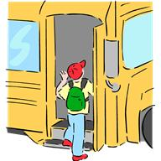
1. brush teeth

2. Have breakfast

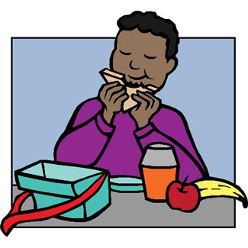

3. Go to school

4. Get up

3. Write the missing letters:




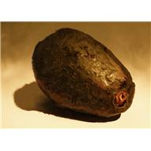

1. ---weet 2. ---live 3. ----ig 4. ---ates

Name:-----------------
Section The First Month Exam For the First Grade Qusour Co/Ed S.1

1. Match:
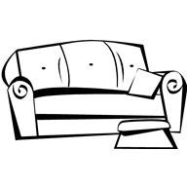

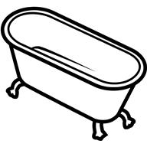

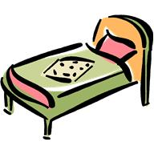

1. T.V 2. Box 3. Bed 4. Sofa 5. Bathtub
************************************************************
2. Circle:

1. On in under


2. On in under

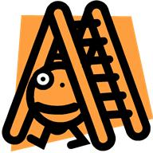

3. On in under

*********************************************************
3. Write the missing letters:

1.---indow

3. ---unny
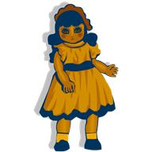

2. ----oll

