mark

404 40
The Ministry of Education
The Education Directorate of---------
Final Exam- Second Term
Class: 5Th Grade (Action Pack 5) Material: English Language
Date: - \\2022
Name: ....................................................................................................... .Section ( )
_________________________________________________________________________________________

QUESTION ONE : Reading: (8Points):-

A: Read the following text and answer the following questions. (8 marks):-
Mustafa Salameh worked in a hotel for ten years. He liked climbing . He said, I think that I will c climb the highest mountain on Earth .
On Independence Day 2008, Mustafa put the Jordanian flag on the highest mountain. . There were celebrations in Jordan.
1-Who is Mustafa Salameh?

2- where did he work?

3- Why were celebrations in Jordan in 2008?

4- Find in the text a word opposite to lowest ..
5- What does the underlined pronoun refer to : .............................................................................
6- Where will you travel when you grow up?

7- What did Mustafa Salameh like?

8- Do you like climbing a mountain?

QUESTION TWO : Speaking:- ( 12 Points):

Q1: Complete the sentences with words from the box. (6 points) :-

Taste  fireworks - Independence Day - skyscrapers – astronauts- project

1- Jordanian people enjoyed ---------------.
2- ------------- will discover new planet.
3- Bananas------------delicious.
4-In twenty years, I think that people will live in --------------.
5-There were some colourful---------------- at night.
6- She's got a---------------- for school.

Q2: Look at the pictures and answer the questions: (6 points):-
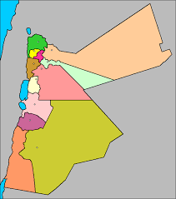
a- Amman is in the .

b- Aqaba is in the .. .

c- Irbid is in the .

d- The Dead Sea is in the ..

QUESTION THREE:- Writing:- (12 Points)

Choose the correct answer:- 1

1. I have never ..to India. A- be b- been c- am

2. You read your book a- usually b- always c- never

3. I've already clean .my room. a. ing b. s c. ed

4- Have you visited Petra? a- ever b- be c- always

5- We .. watch a lot of television a- should b- shouldnt c- always

6- We play a lot of sport .., we are strong. a- because b- so c-?

A- Choose the correct punctuation:

1. Have you ever swum in the sea a- ? b- ! c- .

2. I've never seen Arabian Oryx .. a- . b- ? c- ,

B- Oder and Write:

1)- Everybody \ smiling. \ is

2- breakfast /am / I / had /a / not / hungry / I / big / because /
.
C-: Write a sentence about each picture.(2 points):-

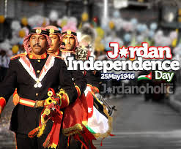

QUESTION FOUR:- Listening (8 Points)

Q1:: Listen and choose the word you hear.( 2 points ):-
- airport autumn board Jordan
- bronze desert fizzy zoo

Q2: : Listen and match( 6 points ):-
Teacher thinks that
1-Omar will be a .
2- Nada will be a
3- Ahmed will be a ..
4- Ali will be a

a- b-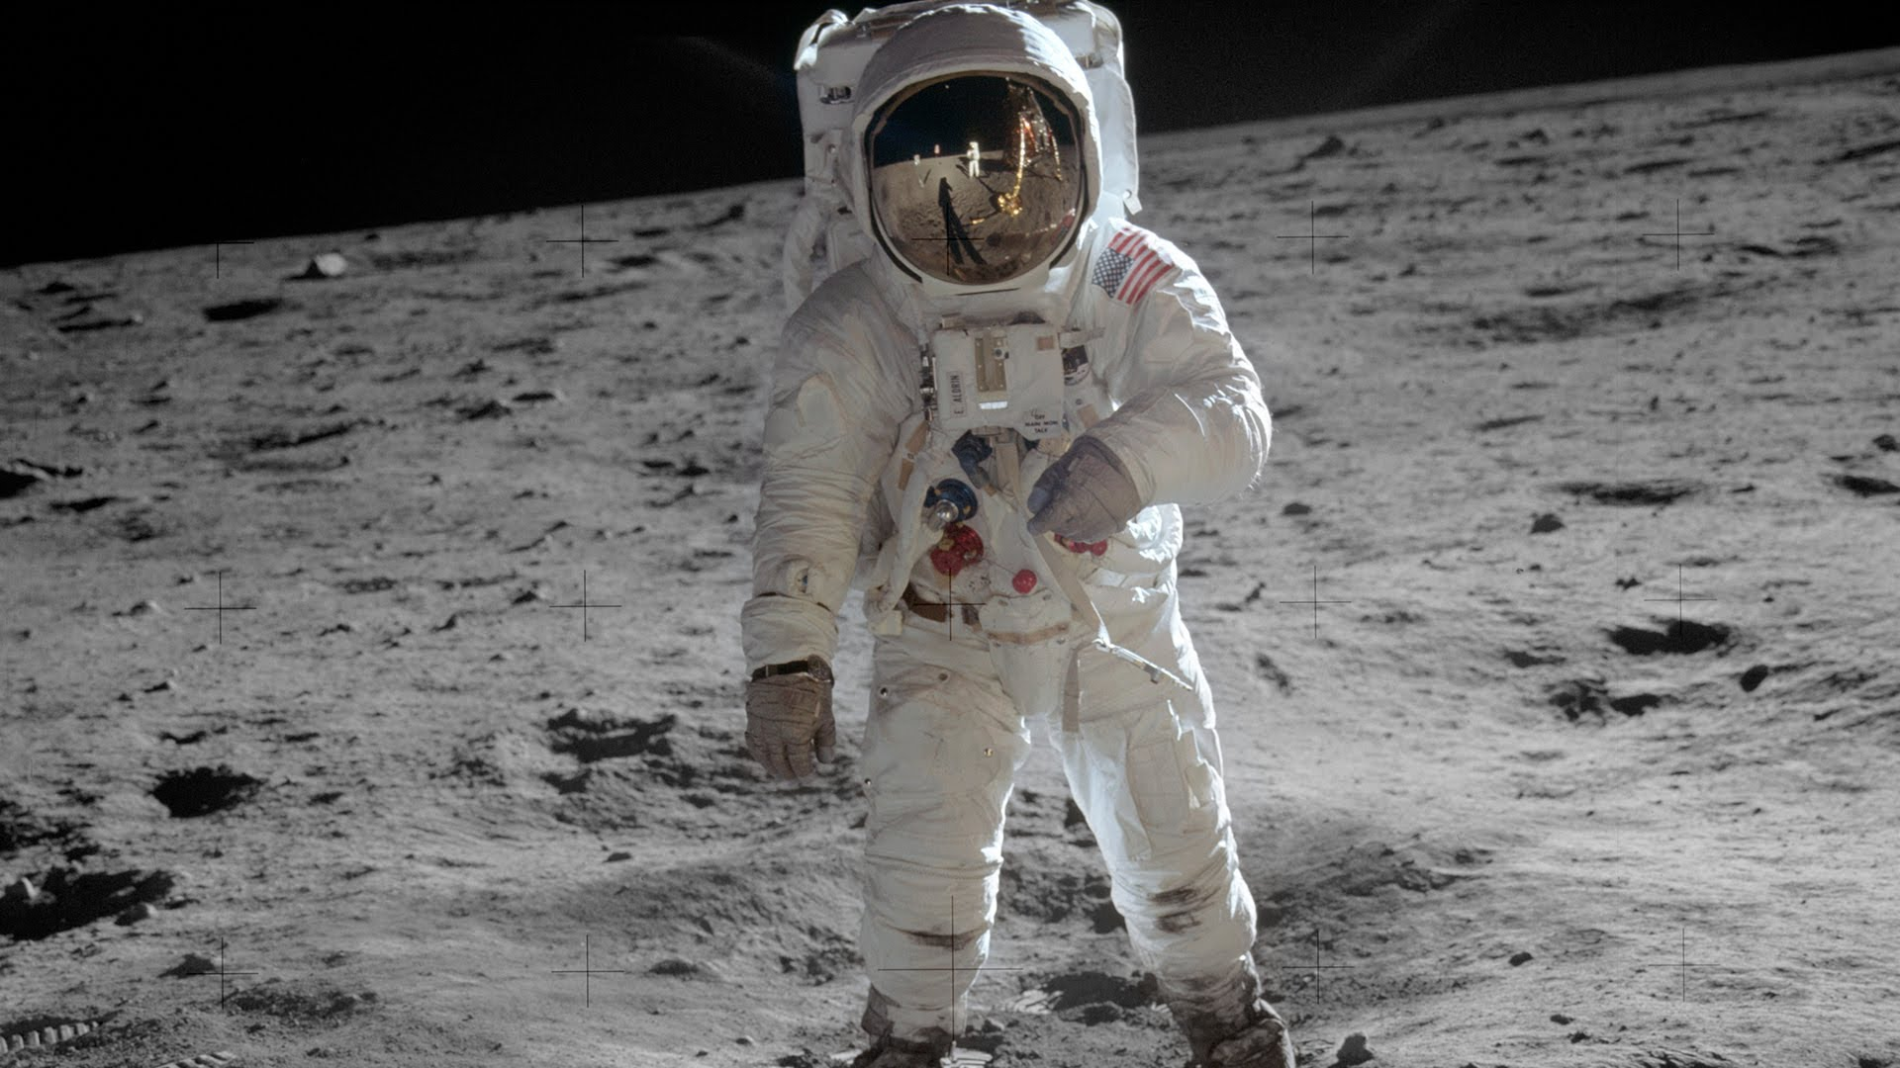
d- -cc

