4th Grade
1st Test
Name:-----------------------
ــــــــــــــــــــــــــــــــــــــــــــــــــــــــــــــــــــــــــــــــــــــــــــــــــــــــــــــــــــــــــــــــــــــــــــــــــ
Q1: Look and Match : ( 5 points )

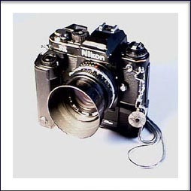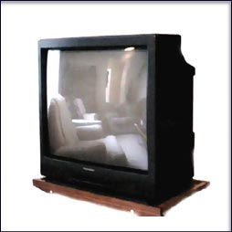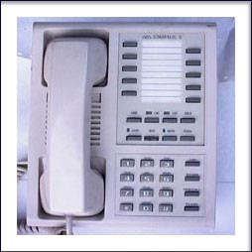

T.V Computer Phone Letter Camera

ــــــــــــــــــــــــــــــــــــــــــــــــــــــــــــــــــــــــــــــــــــــــــــــــــــــــــــــــــــــــــــــــــــــــــــــــــ
Q2: Complete the sentences with the correct words from the box. ( 3 ps )

Usually | Always | Never

1- Huda ----------------------plays football. ( √√ )
2-Anas ----------------------does his homework every day. (√ )
3-Sami-----------------------writes stories daily. (x)

Q2 B : Complete the following sentences with suitable verb from the box. ( 6 points)
Opened | L listened | watched | played
1- Khalid ----------------the door yesterday.
2- Faris ---------------TV last night.
3- Mansour--------------tennis.
4- Khaldoun ------------------to music.
ـــــــــــــــــــــــــــــــــــــــــــــــــــــــــــــــــــــــــــــــــــــــــــــــــــــــــــــــــــــــــــــــــــــــــــــــــــ
Q3- Punctuate the following sentences. ( 3 points )

1- ali likes going to amman
3- what are you doing

Q4: Match the following questions with answers. ( 4 points )

1-What is your name? a- I am 10 years old
2-How old are you? b-I am fine thank you
3-What are you good at? c- My name is Hamad
4- How are you? d- I am good at English

Q 5 – A : Match the pictures with the suitable words . ( 6 points )



hot Windy snowy cloudy rainy sunny

Q6-Write how many : ( 5 points )
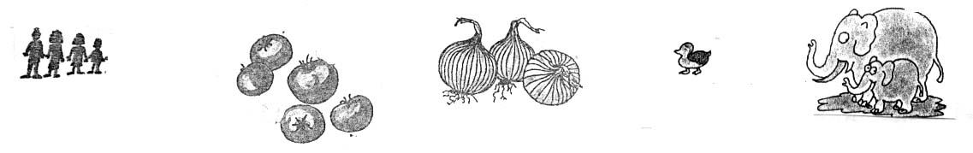
.
Q7- Match the clocks ( 8 points )
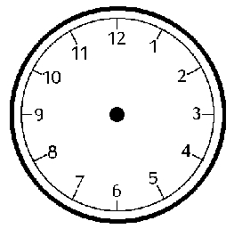

1-It's ten o'clock 2- It's quarter to eight 3- It's half past three 4- It's quarter past one

Good luck
…………………..

