Ministry of Education Subject : English Language
Directorate of Education Class : 2nd grade
Al-Montalaq AcademyTime :1:30
Student's name :……………..Final Exam Date :/12/2017
Q1:Read the following text then answer the questions below: (7 marks)
It is Mum’s birthday.Mum likes sweets, cakes and flowers.
Sam and Amy cannot buy sweets, cakes or flowers but they can make flowers.
Sam is drawing and painting flowers.Amy is cutting out the flowers.
There are ten flowers. They are blue, yellow, pink, purple, orange and red.
Sam is writing on the card “Happy birthday, Mum”.
Circle the correct choice:
- It is __________‘s birthday.
- Mum b. Dad

- Mum likes ________.
- Orange juice b. sweets, cakes and flowers

- Sam and Amy can make _________.
- Flowers b. cakes

- Sam is drawing and ___________ flowers.
- Painting b. dancing

- How many flowers are there?
- Three b. ten

- Flowers are _________
- Blue, yellow, pink, purple, orange and red. b. blackand white

- What is Sam writing on the card?
- I’m fine b. Happy birthday, Mum

Q(2): Write the words into the suitable picture: (6 marks)
Write clothes swing run cook lunch

 |  | 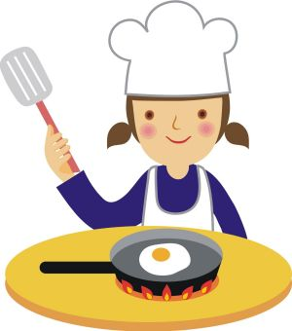 | 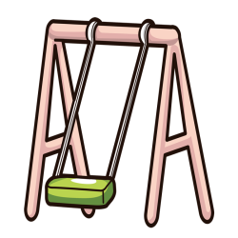 | 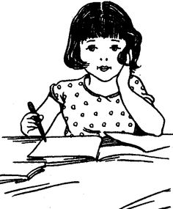 | 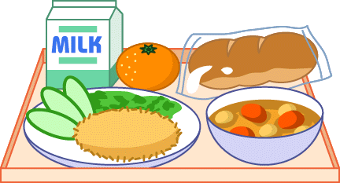
______________________________________________________________________
Q(3): choose the correct answer: (5 marks)
- Does he like / likes bananas?
- This is / are my book.
- They are hop / hopping.
- Is he climbing the ladder? Yes, he is / isn’t.
- What / How many birds are in the tree? Three.
- Do / Doesyou like cakes?
- After Sunday is Friday / Monday.
- Do they like cakes? No, they don’t / doesn’t.
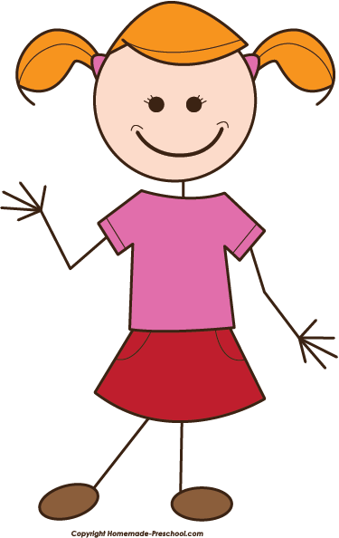
- That / These is my ball.
- I am / is playing football.
Q(4): Add ( - ing) to these words: (2 marks)
- dance _______________.
- ride ________________.
- bake ________________.
- write________________.
______________________________________________________________________
Q(5): Find the odd word .Circle it: (2 marks)
- make bake cake swing .
- line nine slowly like.
______________________________________________________________________
Q(6) Read the words in the box and write a sentence: (3 marks)


make a cake

- She ________________________________________.
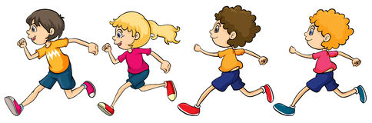

run quickly

- They ____________ ____________________________.
English Department

