English language Exam
Second Semester/Second Exam
Class: 5TH grade Name----------------------
Reading: Read the following text carefully :  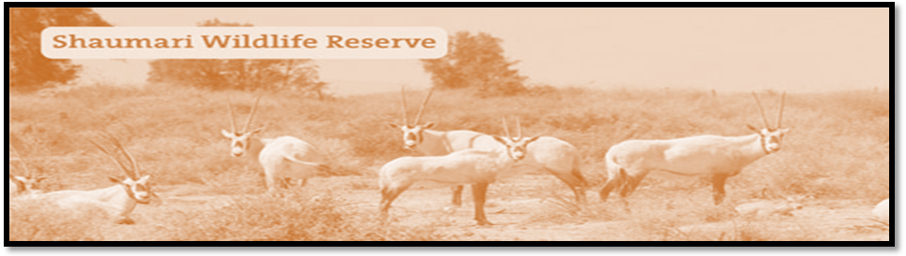
I took this photo from the top of the tower at the Shaumari Reserve in Jordan the you can see Jordan’s national animals, the Arabian oryxes, they are safe now because the live at the nature reserve.
The national colours of Jordan flag are red, black, white and green. These colours show the past of our country.
1-Where is Shaumari Reserve situated?------------------------------------------------------------
2-What can you see in Shaumari Reserve?--------------------------------------------------------
3-why do Arabian Oryxes safe now? ---------------------------------------------------------------
4-The Arabian Oryx is our national animal. (T F)
5- There are many colours in the Jordanian flag . mention to them
-----------------------------,------------------------------,-----------------------and---------------------------.
6- The under lined pronoun (they ) refers to----------------------------------------
7- Find word from the first paragraph which means ( watch)-------------------------
8- Critical thinking: Do you like to visit Shaumari Reserve? Why/ or why not?
-------------------------------------------------------------------------------------------------------------------

2-Choose the correct word to complete the sentences:
( market , Arabian Oryx , play , important )

1-Good health is very---------------------------------
2-Iam going to the ----------------------------- to buy some tomatoes.
3- ---------------------------- is Jordan national animal.
4 - Sami go to the sport center to ------------------- tennis .

3- What does this sentence mean in the following?
Students should study hard about their exams ---------------

4-Choose the suitable item to complete of the following sentences:-
1- You ---------------go to bed early. (should / shouldn’t )
2- you --------------eat sweets. (should / shouldn’t
3- you shouldn’t shout. (Yes / No)
4- you should drink a lot of water. (Yes / No)
5- You study hard---------------- you success. ( so / because)
6- We speak Arabic -------------- we are from Jordan. ( so / because)
5- Read and order:-

1- happy/ on holiday/ he’s/ because/ jabber/ is .

2- go/we /learn / a lot / we /to school/ we /so
............................................................................................................................................

6- Correct the underlined words.

rand should playing sport every day and he doesn’t like fizy drink .

7- Talk about you:

1-I--------------------------------------------------------------so------------------------------------------------
2-I-------------------------------------------------------because----------------------------------------------

8- write a short paragraph about :

- a trip you are going to go with your family to the Nature Reserve.
B – describe how to make bread and meat arayes.

Good luck: Rania Ahmad

