mark

404 40
The Ministry of Education
The Education Directorate of---------
Final Exam- Second Term
Class: 5Th Grade (Action Pack 5) Material: English Language
Date: - 30 \5\2016
Name: ....................................................................................................... .Section ( )
_________________________________________________________________________________________

QUESTION ONE : Reading: (8Points):-

A: Read the following text and answer the following questions. (8 marks):-
Mustafa Salameh worked in a hotel for ten years. He liked climbing . He said, I think that I will c climb the highest mountain on Earth .
On Independence Day 2008, Mustafa put the Jordanian flag on the highest mountain. . There were celebrations in Jordan.
1-Who is Mustafa Salameh?
………………………………………………………………………………………………………………
2- where did he work?
………………………………………………………………………………………………………………
3- Why were celebrations in Jordan in 2008?
………………………………………………………………………………………………………………
4- Find in the text a word opposite to lowest…………………………………………………………..
5- What does the underlined pronoun refer to :….............................................................................
6- Where will you travel when you grow up?
………………………………………………………………………………………………………………
7- What did Mustafa Salameh like?
………………………………………………………………………………………………………………
8- Do you like climbing a mountain?
………………………………………………………………………………………………………………

QUESTION TWO : Speaking:- ( 12 Points):

Q1: Complete the sentences with words from the box. (6 points) :-

Taste – fireworks - Independence Day - skyscrapers – astronauts- project

1- Jordanian people enjoyed ---------------.
2- ------------- will discover new planet.
3- Bananas------------delicious.
4-In twenty years, I think that people will live in --------------.
5-There were some colourful---------------- at night.
6- She's got a---------------- for school.

Q2: Look at the pictures and answer the questions: (6 points):-
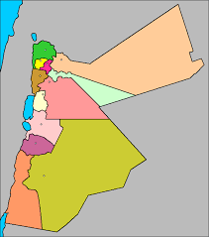
a- Amman is in the…………….

b- Aqaba is in the…………….. .

c- Irbid is in the……………….

d- The Dead Sea is in the ………………..

QUESTION THREE:- Writing:- (12 Points)

Choose the correct answer:- 1

1. I have never………..to India. A- be b- been c- am

2. You…………… read your book a- usually b- always c- never

3. I've already clean…….my room. a. ing b. s c. ed

4- Have you…………visited Petra? a- ever b- be c- always

5- We ……….. watch a lot of television a- should b- shouldn’t c- always

6- We play a lot of sport …….., we are strong. a- because b- so c-?

A- Choose the correct punctuation:

1. Have you ever swum in the sea……… a- ? b- ! c- .

2. I've never seen Arabian Oryx……….. a- . b- ? c- ,

B- Oder and Write:

1)- Everybody \ smiling. \ is
………………………………………………………………………………………………………………
2- breakfast /am / I / had /a / not / hungry / I / big / because /
…………………………………………………………………………………………………………….
C-: Write a sentence about each picture.(2 points):-

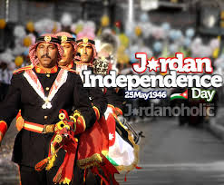
………………………………………………………………………………………………………………………………………………………………………………………………………………………………………………………………………………………………………………………………………………………………………………………………………………………………………………………………………

QUESTION FOUR:- Listening (8 Points)

Q1:: Listen and choose the word you hear.( 2 points ):-
- airport autumn board Jordan
- bronze desert fizzy zoo

Q2: : Look and complete ( 6 points ):-

Teacher thinks that :-

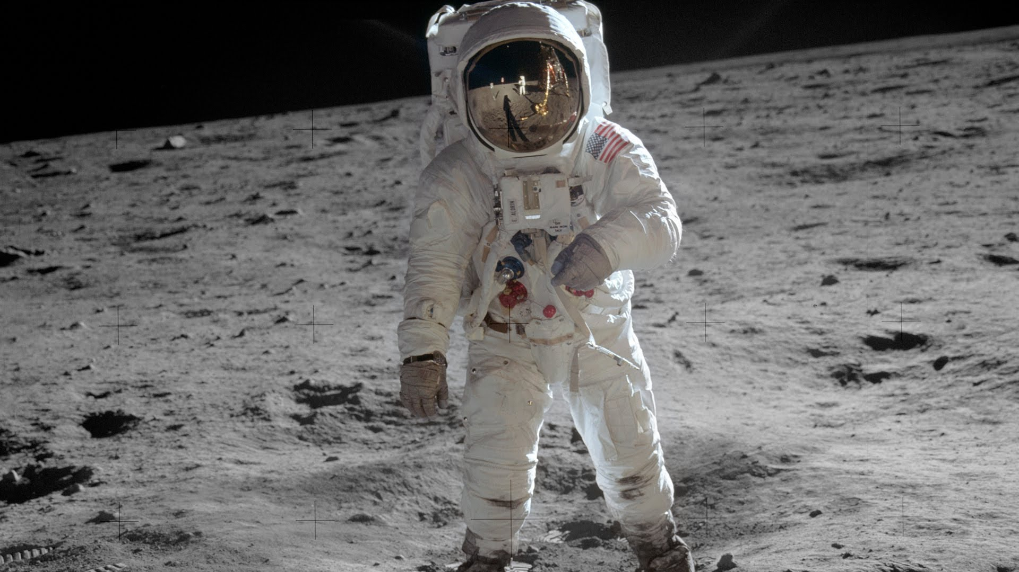 - 

1 1- Omar will be a……………. 2- Ahmed will be a …………..
d- - c

3- Nada will be a ……………… 4- Ali will be a …………………

WITH MY BEST WISHES
TEACHER:---------------

