
PREDICTIONS: What is going to happen?
INTENTIONS: What are they going to do?

Complete the gaps with the “be going to” future. Write (P) for predictions or (I) for intentions in the circles.

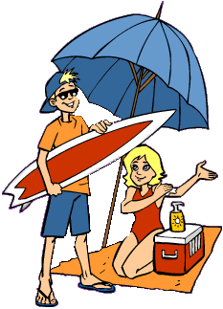

1. She is going to go to the beach.

2. I _____________
________________
a delicious cake.

3. He ____________
________________ and spill the coffee.

4. We____________
_____________our holidays in Spain.

5. She___________
________________a car accident.

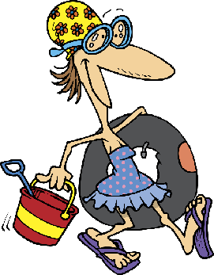
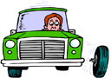
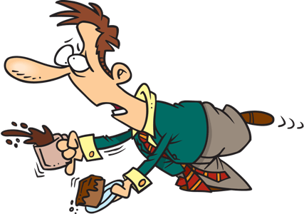
I


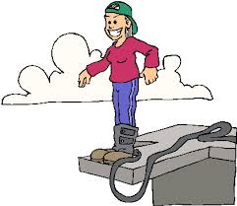
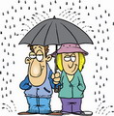

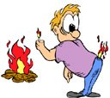

10. He ___________
________________ himself again.

6. He____________
________________ for work again.

7. I _____________
________________ now.

8. It _____________
________________ cats and dogs.

9. She ___________
________________ her friend Nancy.

HAVE ● BUY ● CALL ● MISS ● GO ● LAUGH ● SPEND ● EAT ● TAKE ● JUMP
BUILD ● FALL ● WIN ● FIND ● LOSE ● BE ● RAIN ● BAKE ● BREAK ● BURN

11. He ___________
________________ when he sees you.

12. They__________
________________ a house for us.

13. I _____________
________________ this delicious meal.

14. We___________
________________ lots of presents.

15. The dog _______
___________ some more bones here.


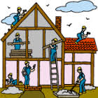
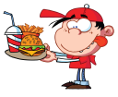
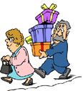


16. I _____________
________________ my piggy bank.

17. He ___________
________________ all his stuff.

18. She __________
________________ a few pills.

19. He ___________
________________ his ex-girlfriend.

20. We___________
________________ this race.

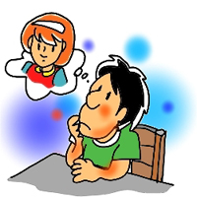
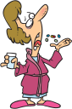

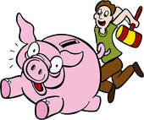
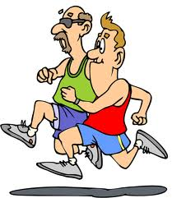


PREDICTIONS: What is going to happen?
INTENTIONS: What are they going to do?

Complete the gaps with the “be going to” future. Write (P) for predictions or (I) for intentions in the circles.

1. She is going to go to the beach.

2. I _____________
________________
a delicious cake.

3. He ____________
________________ and spill the coffee.

4. We____________
_____________our holidays in Spain.

5. She___________
________________a car accident.

I

10. He ___________
________________ himself again.

6. He____________
________________ for work again.

7. I _____________
________________ now.

8. It _____________
________________ cats and dogs.

9. She ___________
________________ her friend Nancy.

HAVE ● BUY ● CALL ● MISS ● GO ● LAUGH ● SPEND ● EAT ● TAKE ● JUMP
BUILD ● FALL ● WIN ● FIND ● LOSE ● BE ● RAIN ● BAKE ● BREAK ● BURN

11. He ___________
________________ when he sees you.

12. They__________
________________ a house for us.

13. I _____________
________________ this delicious meal.

14. We___________
________________ lots of presents.

15. The dog _______
___________ some more bones here.

16. I _____________
________________ my piggy bank.

17. He ___________
________________ all his stuff.

18. She __________
________________ a few pills.

19. He ___________
________________ his ex-girlfriend.

20. We___________
________________ this race.

Key

1. She is going to go to the beach.

2. I am going to bake a delicious cake.

3. He is going to fall and spill the coffee.

4. We are going to spend our holidays in Spain.

5. She is going to have a car accident.

I
P
I

P
I

10. He is going to burn himself again.

P

P

I

P

6. He is going to be for work again.

7. I am going to jump now.

8. It is going to rain cats and dogs.

9. She is going to call her friend Nancy.

I

11. He is going to laugh when he sees you.

12. They are going to build a house for us.

13. I am going to eat this delicious meal.

14. We are going to buy lots of presents.

15. The dog is going to find some more bones here.

I

I

P

P

I

16. I am going to break my piggy bank.

17. He is going to lose all his stuff.

18. She is going to take a few pills.

19. He is going to miss his ex-girlfriend.

20. We are going to win this race.

P

I

P

P

I

