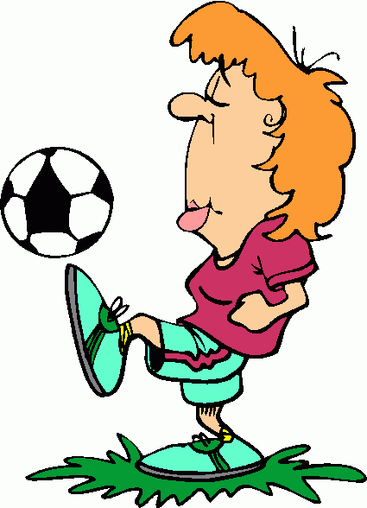

He is going to ....
What are they going to do?
1.- play /football Henry is going to play football
2.- score / some goals Henry ………………………………………………
3.- kick/ the ball. Henry ………………………………………………..
4.-his parents/ see/ the match His parents ..……………………………….
5.-Paul/ do/ snow jumping. Paul ………………………………………….
6.-The rabbit/ jump /very fast ……………………………………………….
7.-Robert / do/ bungee jumping ……………………………………………….
8.-Tom / play / golf/ with his father ……………………………………………
9.- John /sail / in the lake. ……………………………………………….
10.-Willy / swim/ in the pool ……………………………………………….
11.-Martha /peel / an orange …………………………………………………...
12.-Gloria/ phone/ her friend …………………………………………………..
13.-Margaret/ open/the presents …………………………………………………
14.-You/ learn /some English. ………………………………………….
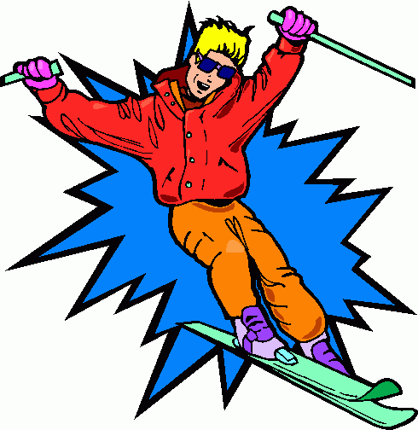
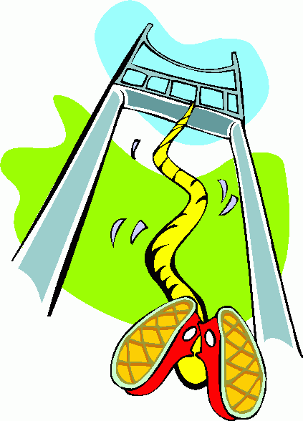
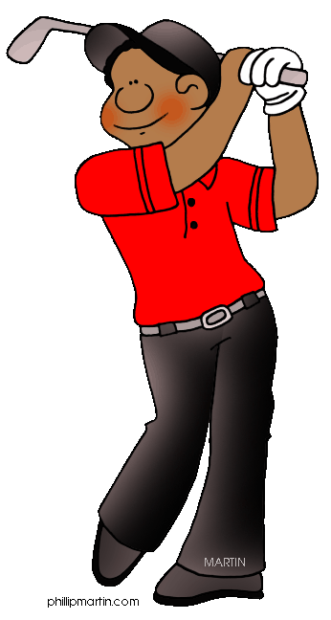
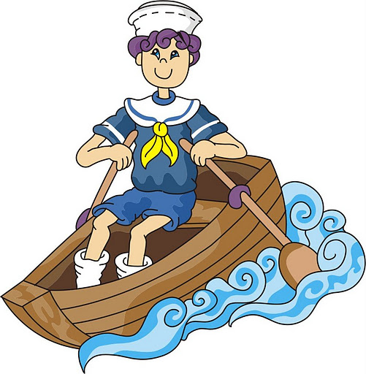
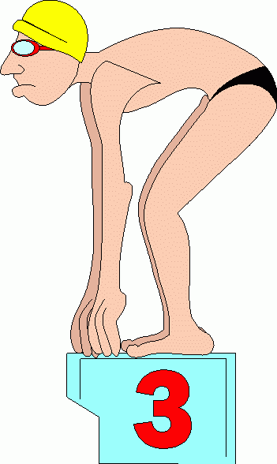
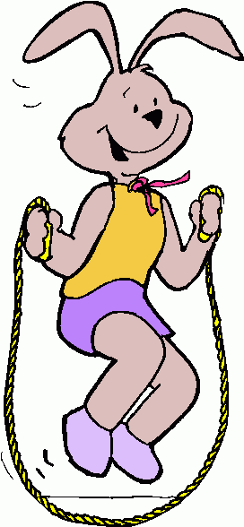
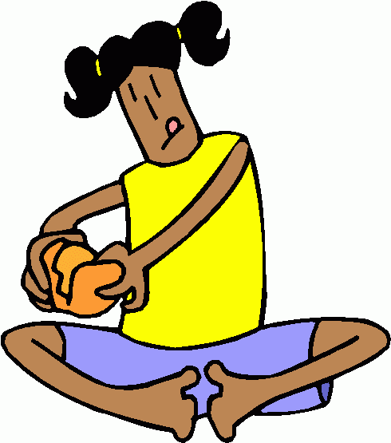
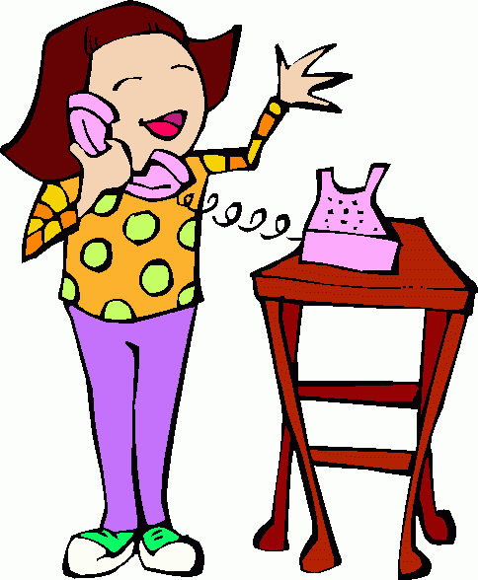
PAUL
HENRY
ROBERT
TOM
JOHN
MARTHA
GLORIA
WILLY
RABBIT

