English language Exam
Second Semester
Second Exam
Class: 5TH grade Name----------------------
1-Read the following text carefully ,and answer the questions :- (5 points) 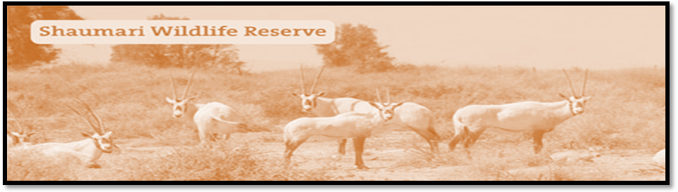
In 1975, RSCN began fencing areas with in Shaumari in preparation for the first wildlife protection reserve in Jordan, covering an area of 22 km2. Shaumari Shaumari Wildlife Reserve is now home to some of the rarest species of animals in the Middle East, such as the Arabian Oryx Ostriches Struthio camels, Goitered Gazelles Gazelles subgutturosa and Persian Onagers Equus hemionu.
1-Where is Shaumari Reserve?
2-What can you see in Shaumari Reserve?
3-The Arabian Oryxes can eat meat. ( T F).
4-The Arabian Oryx is our national animal. (T F)
5- What colour were the Oryxes at the reserve?
2-Complete the following sentences :-

1- I come to school to --------------------
2- Sami go to the sport center to -------------------.
3- Alia visit the library to----------------.
4- I go to the market to---------------------. (4 points)
3 -Choose the answer from those given to complete each :

1-She is --------------to make cake.
a- go b- going c- went
2- She’s -----------------fun with her friends.
a- b- has c- having
3- Honey is nice because it’s---------
a- sweet b- hot c- cold
4- You study hard you---------------- you success.
a- so b- will c- because
5- We speak Arabic -------------- we are from Jordan.
a- so b- because c- should (5 points)
4-Choose the suitable item to complete of the following sentences:-
1- You ---------------go to bed early. (should shouldn’t )
2- you --------------eat sweets. (should shouldn’t
3- you shouldn’t shout. (Yes No)
4- you should drink fizzy drink. (Yes No) (4 points)

5- Read and order:-

1- happy holiday he’s because jabber is on.

2- friend excited she’s present because my is got a.
............................................................................................................................................
(1 point)

Talk about you:-

1-I--------------------------------------------------------------so------------------------------------------------
2-I-------------------------------------------------------because----------------------------------------------

(4 points)

The End
With my best wishes
Teacher: Sana Al-Omar

