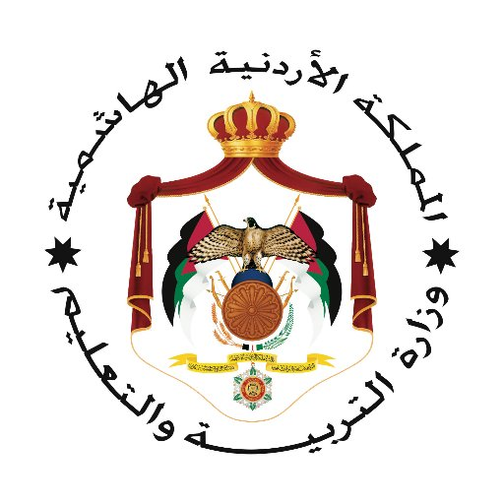
بسم الله الرحمن الرحيم

30
مديرية التربية والتعليم للواء الجامعه
مدرسة علي رضا الركابي للبنين
التقويم الثاني للفصل الدراسي الثاني 2023
الاسم : ........................................................ المادة : ENGLISH التاريخ : / 5 /2023م
الزمن: 35 دقيقة فقط الصف: التاسع الشعبة: ( )
ملحوظة أجب عن جميع الأسئلة الآتية جميعها وعددها ( 2 ), علماً بأن عدد الصفحات ( 1 ). معلم المادة : موسى اسماعيل عشا

- Read the text and Circle the correct answer : (5 points )
In 1877, the Ottoman Empire went to war with Russia. The medics who took care of the wounded soldiers on the Russian side marked their ambulances with a red cross. This was the symbol used by all countries to protect medics during battles. However, the cross reminded the Ottoman Empire of previous wars against soldiers carrying a similar flag. So the Ottoman officials used a red crescent to mark their ambulances instead. Some time later, other Muslim countries accepted this symbol, and it was formally adopted in 1929. So far, 33 Islamic countries have recognised the Red Crescent. The Red Crescent Society is part of the International Federation of Red Cross and Red Crescent Societies. This is a huge organisation that has 97 million members, volunteers and supporters in 187 National Societies. Red Crescent societies are important to the International Federation, as they have developed guidelines that include non-Western traditions. Today, the Red Crescent is very important in responding to disasters such as earthquakes or fires, as well as providing aid to developing countries. A key principle of the organisation when providing this aid is neutrality. Red Crescent volunteers work to prevent
suffering for everyone – regardless of nationality, race, religion or gender.
- The text is about
- Scribe b) temple c) wars d) red crescent
- The Ottoman officials used a ______ to mark their ambulances :
a) crescent b) figures c) cross d) ancestor
- The word who in bold refers to .
- people b) medics c) red cross d) temple
- The word in the text that means someone who gives help in the army is :
- Teacher b) soldier c) medic d) messenger
- In your opinion why is Red Crescent important.

- Fill in the words form the box : (5 points )
Disaster , penny , miser , neutrality , greedy

- He is a ________. He likes to have money and hates to spend it.
- _______is the state of not supporting any side .
- A terrible event that causes a great damage is a _____________.
- A coin that has low value is a ____________.
- She is so ________, she always wants more money than she needs.
- Circle the correct word between brackets : (6 points )

- He is popular because he has ( many , much , little ) friends .
- Can you give me ( many , any , few ) advice ?
- ______(so , but , although) I love my clothes, I donated most of them to the poor.
- I love chocolate , I usually eat ( few , much , may ).
- Could you give me (a little , few , many ) sugar , please?
- Many ( volunaars , voluners , volunteers ) works in charity shops.
انتهت الاسئلة

