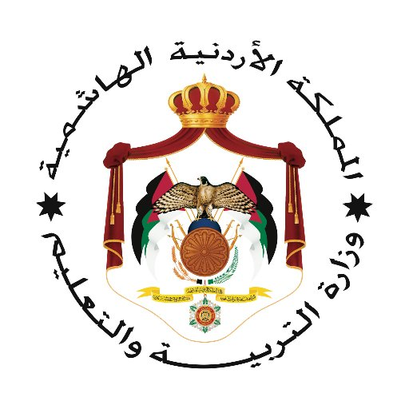

بسم الله الرحمن الرحيم

80
مديرية التربية والتعليم للواء الجامعه
مدرسة علي رضا الركابي
امتحان نهاية الفصل الدراسي الثاني 2023 /2024
الاسم ........................................................ المادة English التاريخ / / 2024م
الزمن 60 دقيقة فقط الصف التاسع الشعبة ( )
ملحوظة أجب عن جميع الأسئلة الأتية جميعها وعددها (6), علماً بأن عدد الصفحات(2).

Q1: Read the following text and answer the following questions. (16 points)
Famous for his achievements in geography and exploration, Al Idrissi was born in 1100 in Sabtah, which is a city in North Africa. His noble ancestors come from Hassan Ibn Ali, who was the grandson of Prophet Mohammad, Peace Be upon Him. He received his education in Cordoba and Marrakesh and dedicated his life to doing research and studying geography. Al Idrissi used his knowledge to make maps and write books like encyclopedias about Africa, the Indian Ocean and the Far East. He spent many years working for the King of Sicily and made the best map of the world at that time. In his atlas, he used various codes and colours to indicate countries, geographical features and climates. He strongly believed that the world was not flat, but spherical. Al Idrissi wrote about explorers from North Africa who sailed far and eventually reached an island. This helped Columbus in his journey westward when he was trying to reach India. Al Idrissi’s success is so important that his achievements are remembered even after centuries have passed.
- Al Idrissi was famous for his achievements in : (3 p)
- Medicine b- geography c- sport d- oceans
- Al Idrissi wrote : (3 p)
- Books and maps b- dictionaries c- short stories d- medicine books
- He strongly believed that Earth is : (3 p)
- Flat b- square c- an island d- spherical
- The word in bold ( which ) refers to :- (3 p)
- Al Idrissi b- Cordoba c- Sabtah d- geography
- Do your think that Al Idrissi was a really famous scientist? Why ? why not? (4 p)
………………………………………………………………………………………………..
………………………………………………………………………………………………..

Q2: Complete the following sentences with the words in the box. ( 10 points)
to plot | volunteer | earn | explorer | continent | neutrality
1- Africa is a big…………………...It is bigger than Europe.
2- Scott was a famous British …………………...
3-…………………is a verb, which means to show something on a map.
4-How much money does Ali ………………….every month?
5- If you want to help people, you can become a …………………in the Red Crescent.

Q3-Write the correct forms of verbs between brackets in the gaps: (10 points)
1-If I get a good grade in English, my parents………..me a new mobile. (buy , will buy)
2-My elder brother …………….. a student 2 years ago. (has been , was)
3-Ahmed …………..……..in America for 15 years. (lives , has lived)
4-My friends ……………………………me yesterday. (have visited , visited )
5- Ali will join university if he …………….hard at school. (work , works , worked)

Q4-Choose the correct answer the best completes the sentence: ( 24 points)
1-Ahmed is going to stay at home……………………….the weather is very rainy.
a-because b-also c-so
2- I usually come to school late………………………..I get up early .
a-because b-but c-although
3-If you help me …I will help you .
a- ? b- , c-! .
4- Which sentence is punctuated and formed correctly.
- What will you buy if I give you money .
- What you will buy if I give you money?
- What will you buy if I give you money?

5-There is ……………oil in this dish .
a-many b-a few c-much
6-There is not …………….coffee in the cup.
a-some b-any c- many
7-I have known Ali ………………….. 2010.
a-for b-since c-ago
8-China is a big country…….……….…...people live there.
a-so many b-a little c-so much

Q 5-Decide whether these sentences are (√) or ( ×) and correct the wrong ones :( 10 point
1- I don’t have money much. ( )

……………………………………………………………………………………………
2- How many books do you read every month? ( )

…………………………………………………………………………………………?
3- I have waited Ali three hours for . ( )

…………………………………………………………………………………………….
4- If you invite me , I will visit you .( )

………………………………………………………………………………………… .
5- Few water is needed to make this meal delicious.( )

…………………………………………………………………………………………..

Q6-Copmplete the following to make meaningful sentences: ( 10 points)
1- If you wake up early …………………………………..
2- You will get sick if……………………………………..
3- ……………………………………………………….if you study harder.
4- If you exercise daily ………………………………………….
5- …………………………………………………….….if we don’t drink enough water.
مع التمنيات للجميع بالنجاح
موسى اسماعيل عشا

