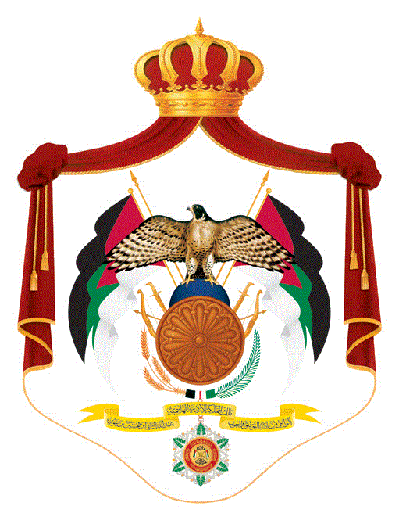
وزارة التربية والتعليم
مديرية التربية والتعليم /لواء عين الباشا التاريخ : / / 2018
مدرسة صلاح الدين الأساسية للبنين الزمن : ساعة ونصف
مادة اللغة الانجليزية للصف الخامس الاسم : ___________________
الفصل الدراسي الثاني الشعبة : أ ب

A) Reading comprehension ( 10 marks)
- Read and answer :
Last Friday , Ali and his family went to Aqaba. They went by bus. There were a lot of people there. Some people were swimming and some people were diving . At lunch time they sat on the beach and enjoyed their time very much. They saw the old castle in Aqaba. Ali took a lot of nice photos. In the evening they ate fish. It was delicious.
- Where did Ali and his family go to ?__________________.
- When did they go?________________________________ .
- How did they go ?________________________________ .
- What did they see in Aqaba?____________________ .
- What did they eat in the evening?____________________ .
b) vocabulary ( 10 marks)
- Fill in the gap with the suitable words from the box
.astronaut , queen , health , reserve , ostrich , herbs

- ____________ discover new planets .
- ____________ Rania is the wife of King AbudullahII .
- Add some __________ to make Mensaf tasty.
- Fizzy drink is bad for people’s ______________.
- Many animals are kept safe in the ______________.
- Write the names of these pictures form the box:
Fireworks , robot , poster , firefighter , skyscraper

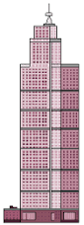 | 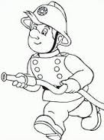 | 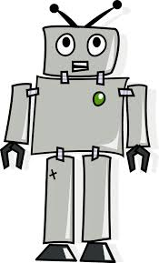 | 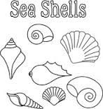 | 

c- structures ( 10 marks)
- Correct the verbs between brackets :
- Have you ever (talk)___________ to a famous singer?
- They (was)__________ driving very fast .
- She ( were ) __________brushing her teeth.
- I will (played )____________ football with my friends.
- Have you seen Ali? Yes, I (haven’t)________________.
D- writing , spelling and handwriting (10 marks)
Write a sentence using the words in the boxes.
will
should
Shouldn’t
Have ?
..didn’t

انتهت الاسئلة \ اسماعيل عشا

