
Name :………………………
Date :…………………………..
International English schools
First grade
English Final exam
Question (1) ( / 5 ) marks
Match the picture with the correct words
Hot  Snowing  Cold  Sunny  raining | 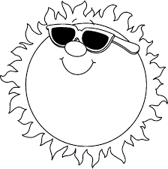    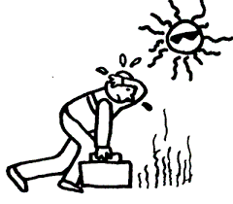  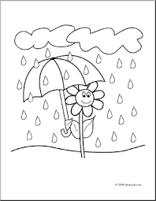  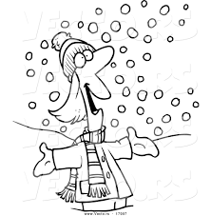
Question 2 ( / 10)
Circle the correct answer
She …………………………….. reading ( is / are )

They…………………………. abook ( have got / has got)

I am …………………….. to music (listen / listening )

You ………………..... sitting (are / is )

She ………………… a bag ( has got / have got )

………………….. you got a car ? (have / has )

He …………………. to the moon ( look / looking )

………………….the words ( read / jump )

The bird …………………. Fly ( can`t / can )

He ………………………….a glasses (has got / have got )

Question 3 ( / 5 )
A – write the sound ck
So………… du……………….. ki……………… sa…………………
b- complet the letters
Ll / Mm / ………………… / Oo/ Pp / ……………………../ ………………../ Ss
Question 4 ( / 5 )
Write ( is / are )
It ………………… singing
She ………………….. counting
They ……………………. Jumping
The boy ……………. Playing at the garden
We ……………….. laughing

Your teacher : faten shldan

