المملكــــــــة الأردنيــــــــــة الهاشـــــــمية  وزارة التربــــــــــــية و التعلـــــــــــــــــيم  مديرية التربية و التعليم /  مدرســة |  | الفصل الدراسي الثاني : 2017 / 2018  المــــــــــادة : اللغـــــــــــة الإنجليزيــــــــة  مدة الاختبار : ساعة واحدة.  التاريــــــــخ : / / 2018
 | الاختبار النهائي - الصف الرابع الأساسي

الاسم:.............................................................................................................الشعبة : ...............................

Question One 5 Points

-Read the following text carefully and then answer all the questions below:

We must plant more trees .Trees are very important .Trees are home for many animals and birds. They give us shade in the summer. They help to clean the air and give us wood and paper.
Every year on 15th January children plant trees. It is an important day. We sing songs; we take photos, and make videos. We watch the trees grow.

- Are trees important? ___________________________________________

- Trees are home for many ___________ and ______________.

- What do trees give us in summer? __________________________

- Trees give us ________ and ____________

- Children plant trees on

a) 15th January b) 16th January c) 17th January

Question Two 10 Points

A- Read and complete the sentences:

bridges | old | birds | big | Madaba

1- Last week Kareem and Samira went to ---------------.

2- The map is very----------------- and very ------------.

3- They saw---------------- over the Jordan River.

4- Kareem and Samira saw ---------------- and animals on the mosaic map

B- Write the words with similar meaning:

Grandpa , Grandma , Mum , Dad

1. | Father | ……………………………………………………………
2. | Mother | ……………………………………………………………
3. | Grandfather | ……………………………………………………………
4. | Grandmother | ……………………………………………………………

C- Put the following sentences in the correct order:

______ You must water the plant.

______ You must put the plant in the ground.

______ You must dig a hole.

______ You must wait the plant to grow.

Question Three 15 points

A- Choose the answer from those given to complete each:

1- The planetarium is the ------------ room in the museum.

a-big b- darker c- darkest

2 - ------------is your brother?

a-who b- when c-what

3 - ----------do you live?

a-what b- where c- when

4- Yesterday I ------------the library.

a-visit b- visiting c-visited

5 - Sereen is ---------------- than Akram.

a- tall b- taller c- tallest

6-What ---------------you do yesterday

a- do b- does c- did

B- Complete the table:

Present | Past
find
Buy
see
drive

C- Write the correct sentence under the picture:

We went to the museum We had a meal in a restaurant

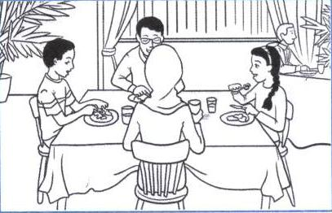
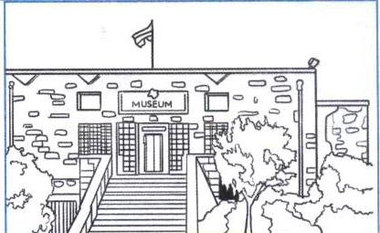

1. __________________________________ 2. __________________________________

D -Complete the following:

ph | wr | kn

1- ele------- ant 2 ------- ite

3 -------- ee 4 -------- one

Question Four 10 Points

Answer the following questions:

1- What is your name?
………………………………………………………………………………………………………….

2- Where do you live?
………………………………………………………………………………………………………….

3- How old are you?
…………………………………………………………………………………………………………..

4- What is your favorite food?

……………………………………………………………………………………………………………

THE END

WITH MY BEST WISHES

