U.N.R.W.A
Class:2nd grade Department of Education Section:
Name: Education Development Centre Mark: /40
Achievement Test for Diagnostic purposes
Reading: <13 Marks> 

A) Read and answer: <6 Marks>
A blue T-shirt, look ! A blue T-shirt.
A yellow dress, look ! A yellow dress.
A green jacket, look ! A green jacket.
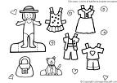

1. What's the color of the dress ?....................................................................
2. What's the color of the T-shirt?...................................................................
3. What's the color of the jacket?.....................................................................

B) Read and circle : < 5 Marks >

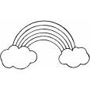
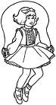
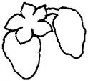
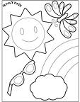
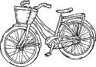

red hop dates windy bike
rabbit skip apples sunny bus
rainbow jump bananas rainy car

C) Read and match:< 2 grades >
K
D
H
R

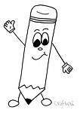
k
r
h
d

Writing: < 8 Marks >
A) Match each part of the body with its name: < 3 Marks >

nose
eyes
leg
hand
foot
arm

INCLUDEPICTURE "http://t1.gstatic.com/images?q=tbn:BLFdkgOQReEeUM:http://www.thecolor.com/images/Orange.gif" \* MERGEFORMATINET
B) Write the sentences correctly : < 2 Marks >
1. ( oranges – like – I )
I ……………………………… .
2. ( I've – hair – got – brown )
I've………………………………

C) Copy the letters correctly: < 3 Marks >
B b D d E e G g R r H h

Speaking: < 12 Marks >
A) Answer the following questions :
How old are you?
I'm…………………………
( three – seven )

What do you like ?
I like…………………………
( bananas - thank you)

How many sisters have you got?
I've got………………………… sisters.
( short - two )

B) Match :

1. What is it ?........ a. I'm Suha

2. How many cats ?....... b. It's a fox

3. What's your name?......... c. two cats

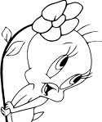
GOOD LUCK

