The Ministry of Education
The Education Directorate of---------
Second Exam first Term
Class: 2nd Grade language English
Name:-------------------------------------------------------------

Mach please(4 marks) 1-
Mosque 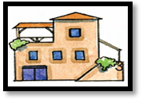
 school
Park 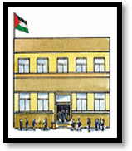
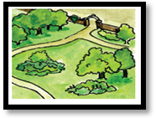
House
Choose the correct answer :- (2 marks) 2-
1- We go to on ------------
a- Sunday b- Friday c- ?
2 I visit my  on-----------
a- Sunday b- Monday c- Friday

Order please:(7 marks) 3-
Friday, Monday, Tuesday,Thursday,Saterday ,Wednesday, Sunday
1----------------------- 2-------------------- 3----------------------------- 4----------------------
5--------------------------- 6------------------------------- 7---------------------------------
4- Look and complete (8 marks)
-------------- the------------------------
In
Under
on
Bed
Table
bag
-------------- the--------------------
-------------- the-----------------------
Answer the following questions(2marks) 5-
1-Where do you live?
I live in------------------------------------------------------------------------------------------------------.
2- Where does your uncle live?
He lives in--------------------------------------------------------------------------------------------------.
6- copy please:-(2 marks)
I help mum on Friday

