mark

The Ministry of Education 25
The Education Directorate of---------
Second Exam first Term
Class: third Grade (Action Pack 3) Language English
Date:
Name: ...................................................................................................................
_________________________________________________________________________________________
PART ONE
Question One: Reading Comprehension (5 points)
-Read the following text carefully and then answer all the questions below:

I like my school. Islamic Education and English are my favourite lessons. I visit my grandparents on Friday and Saturday.
My father is a doctor. He works in a hospital in Aqaba.
My mother is a teacher. She works in a school in Aqaba.

Best wishes,
Majeda

1- Majeda's favourite lesson is ……………………………
a-Arabic b- Islamic Education c- Math’s

2-When does Majeda visit her grandparent?
........................................................................................................................................................................

3- Majeda's father is………………………………………………………………………………………

4-What does Majeda's mother do?
........................................................................................................................................................................

5-Does Majeda's mother work in a hospital? a- Yes, she does b-No, she doesn't

.PART TWO
Question Two: Focus on Vocabulary (4 points)
A-Read and match :-( point)
1-Does Ali like football? a- He's a pilot

2- Does your mum a teacher b-Yes, we do

3- Do we have Moths on Monday c- No, he doesn't

4- What does Ali do? D- Yes, she does

B. Read and complete: - (3points)
- in - under - next to 0n

1. the snail is-------------- the box. 
2. the snail is-------------- the box. 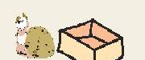

3. the snail is-------------- the box. 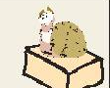
PART THREE
Question Three: Focus on Language and Structures (7 points)
A. Choose the correct answer in the following sentences: ( 5points)

Sunny | winter | ride | have | work

1-We.............................. Science at nine o'clock.
2-Does she ...................... in a hospital?
3-My favourite season is .........................
4-In spring, I ……………….... my bike.
5-Jordan is hot and ......................... in summer.
B--Complete the following question with (Do) or (Does):- (2points)
A-.........you like playing chess?
B-Where...........she work?
C-When ......... he arrive?
D-........ they work in a hospital?
ART FOUR
Question Four: Focus on Writing (4 points)
1-Write the correct time:
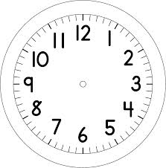

2) Copy and complete with the punctuation: (capitals, . or ?): (2 points)
1. Ibrahim is a chef .He works in a restaurant.

2- We have English on Sunday.

2) Order the sentences: (2 pts)
THE END WITH MY BEST WISHES

