
UNRWA/ Department of Education
Education Development Centre
Achievement Test for Diagnostic Purposes 2018/2019
Name: ------------------- 3rd grade

/ 40

Question one.
Read the following text then answer. (5 marks)
Laila and Ahmad live in Amman. They go to school at 8 o'clock .Laila likes eating figs, dates and apples. Ahmad likes nuts and orange juice. They will go to the zoo with their dad on Monday. They will see lions, giraffes and elephants.

Are the following sentences right (√) or wrong (X)
1. Laila and Ahmad go to school at 7 o'clock. . ( )
2. Ahmad likes nuts and orange juice. ( )
3. They will go to the zoo on Friday. ( )

1. What are the animals that they will see in the zoo?
…………………………………………………………………………..

2. Who will go with them?
……………………………………………………………………………
Question seven.
drinking
bananas
short
blue
Complete: (4 marks)

1. I have got ------------------ eyes and ------------------ hair. I like

------------- and apples .I like --------------------- juice.
Question three
Circle the right answer. (3 marks)
1. Nader (has got, have got) a blue bag.
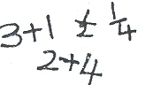
2. This is my (skirts – skirt).
3. It’s time to learn (Arabic, Maths).

Question four

Write the missing number. (6 marks)
1.
15
17

2. Count and write the number?
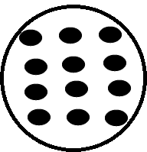
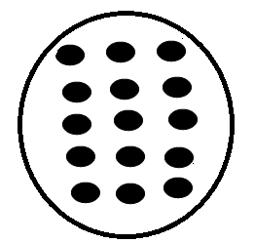
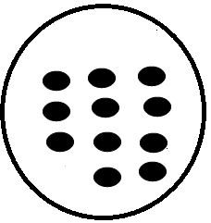

-------------------- ------------------- ------------------
Question five: (3 marks)
Choose and write the correct answer (in - on- under)
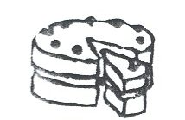
1. The cake is ---------- the table.

2. The ball is ------------ the table.

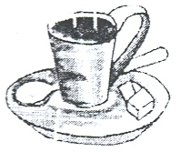
3. There is some tea ---------- the cup.

Question six ( 4 marks )
Reorder the sentences and the words.

1. The, drinking, are, lions, water.

………………………………………………………………….
2. Tuesday, Sunday, Saturday , Monday

……………..… ………………… ……………… ………………
Question two
Match the capital with the small letter. (6 marks)
T h
H r
B e
R b
G t
E g

Question eight.
What's the time? (3 marks)
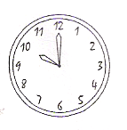
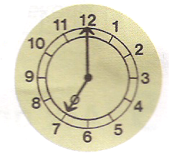


------------------ ---------------- ------------------
Question nine: (2 marks)
Salam has got a long black hair, big eyes and a small mouth.
Which girl is Salma?
A B



Question ten : ( 4 marks )
Write this sentence on the stave: Heba likes reading books.

Good luck!

