منتدى معلمي الاردن

The Ministry of Education 20
The Education Directorate of---------
Second Exam first Term
Class: Sixth Grade (Action Pack 6) Language English
Date:
Name: ...................................................................................................................
_________________________________________________________________________________________
PART ONE
Question One: Reading Comprehension (5 points)
-Read the following text carefully and then answer all the questions below:

I live in Ajloun in Jordan .It's .It's a beautiful city. There are hills and valleys .There's a big forest, too.
There are lots of interesting trees and plants in the forests and many animals live there.
Ajloun has a famous castle. It, s very old .You can't see tall skyscraper here.

1. Ajloun is in the -----of Jordan. a. north b. west c. south (1 point)
2. Mention three things you can find in Ajloun ?. (1.5 points)
a- --------------- b--------------- c---------------------
3. What is the weather like in Ajloun ?
----------------------------------------------------------------------- (1 point)
4- There are tall skyscrapers in Ajloun . a- Yes b- No, c-? (.5 points)
5- The underlined pronoun refers to--------------------- (1 point)
PART TWO
Question Two: Focus on Vocabulary (5 points)
1-Write one sentence about each picture :- (2 points)

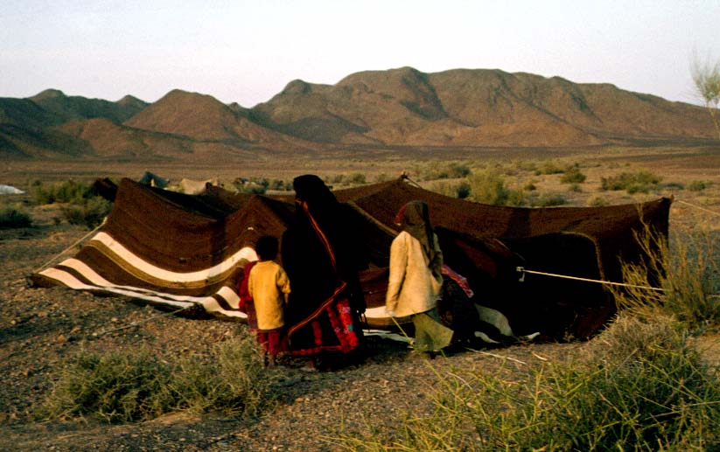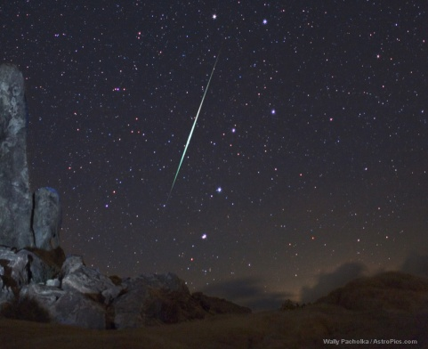

B. Read and complete: (3 points)

- Pyramid - building - Coral reef hill

1. There's a beautiful ……………………………………… in the sea.
2. There's a great ------------in Egypt.
3. There is a big---------in Umm Qais.
PART THREE
Question Three: Focus on Language and Structures (7 points)

A. Choose the correct answer in the following sentences: (3 points)

1 The tower is 900years----------- . a. old b. deep c. long
2Amman isn't as---------as Riyadh in the summer. a. colder b . bigger c. hotter
3. Jordan isn't as---------as Egypt the summer a. colder b.drier c. ?
B. Use "as------as ..?" in the following: (4 points)

Riyadh | Amman
43 degrees centigrade | 32 degrees centigrade | Summer
14 degrees centigrade | 12 degrees centigrade | Winter
120millimetres | 200millimetres | All year
1--------------------------------------------------------------------------------------------------
2---------------------------------------------------------------------------------------------------
3--------------------------------------------------------------------------------------------------
4------------------------------------------------------------------------------------------------
ART FOUR
Question Four: Focus on Writing (3 points)

A. Write about Jordan (3 points)
Dear my friend ………………………………………………………………………………………………………………………………. ………………………………………………………………………………………………………………………………………………………………….. …………………… ……………………………………………………………………………………………………………………………………………
……………………………………………………………………………………………………………………………………………………………………
………………………………………………………………………………………………………………………………………………………………………………………………………………………………………………………………………………………………………………………………………………………………………………………………………………………………………………………………………………………………………………………………………………………………………………………………………………………………………………………………………………………………………………………………………………………………………………………………………………………………………………………………………………………………………………………………………………………………………………………………………………………………
The End With My Best Wishes

