Second English Exam
Name: ---------------------------- Grade: 5th / -----------
Q1: Read and answer:( 5 marks)
Dear Aunt Muna,
I am learning about the traditional costumes of Jordan for a school project. In the past, women sewed traditional costumes. Some costumes were very colourful. The dresses had a rectangle with special sewing around the bottom, the neck and the sides of the costumes.
Best wishes,
Samira
- What is Samira learning about?
--------------------------------------------------------------------------------------------
- Did the children sew traditional costumes in the past?
----------------------------------------------------------------------------------------------
3.Traditional means: ---------------------------------------
- Write Yes or No:
A ) Some costumes were very colorful ----------------------------------- .

B ) The dresses had a triangle with special sewing ---------------------- .
------------------------------------------------------------------------------------------------------------------------------
Q2: Read and complete: (2 marks)
Clever – tidy – helpful – kind
- Laila was ------------------ .she put the books on the shelf.
- Ali was -------------------- yesterday. He helped the man.
- Mohand and Nadia were ----------------- .They set the table.
- Huda complete the puzzle yesterday. She was ---------------------- .
----------------------------------------------------------------------------------------------------------------------------------
Q3: look and complete using: (3 marks)
am, is , are , going , to
- Kareem --------------- going ---------- make model planes on Monday.
- My friends ----------- ------------ to visit me next week.
I --------- going to do lots of home work today.
--------------------------------------------------------------------------------------------------------

Q4- Write the correct time:
1 ) 2)
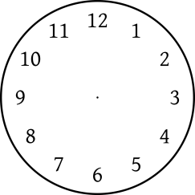
It is--------------------------- It is---------------------------
3)
It is----------------------------------
---------------------------------------------------------------------------------------------------------------------
Q5) Read and complete the table:(Camera , Juice , sun , uncle , make , glass ) (3 marks)
S | K
Q6: Read and write:( helicopters , lorries , motorbikes , planes ) (3 marks)
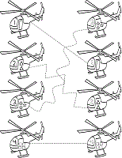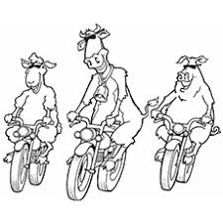
1-They are going to see ------------- .2-They are going to see ----------------
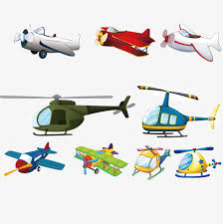 3-They are going to see -------

