 مدرسة
الاسـم :_________________ امتحان الشهر الأول في اللغة الإنجليزية الصف: التاسع الأساسي

Q-1) Read the following text and answer the questions below (15points (
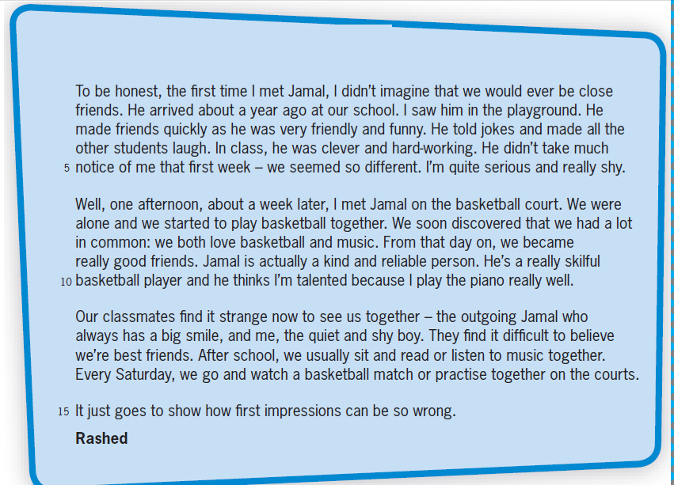

1. Put a suitable title for the text?____________________________________________________________
2. When did Jamal arrive to school?_______________________________________________________
3. Jamal and Rashed both don’t like music and basketball. (( True // False ))
4. What does the underlined pronoun refer to? ( who ):______________________________________
5. According to the text, Jamal thinks that Rashed is talented. Explain why._____________________
_____________________________________________________________________________________

Q-2) Match the word in A with the clues in B : ( 4 points)
A B
1. reliable………… A) talented or ability to do something.
2. first impression…………. B) sensible.
3. skilful………….. C) first idea.
4. serious………….. E) to be trusted.

Q-3) Complete the table by adding the missing verb (6points)

NO. | V.1 | V.2 | V.3
1 |  |  | cost
2 |  | became
3 | bite |  | bitten
4 |  | catch
5 | buy
6 |  | did

Q-4/ Choose the correct answer (5 marks)
1. Every morning, Jamal and I _________ about four kilometers. ( walk / walks / are walking)
2. Sultan_____lately ______ Jerash. ( has visited / have visited / hasn’t visit )
3. My parents thinks that I __________ high degrees in English. (will get / have gotten / get )
4. Have you ever_______to the Roman Theatre? ( go / been / was )
5. Rakan _________like Maths. (doesn’t / isn’t / wasn’t )

Q-4/ Read the information in the table, and then write two sentences using linking words (10points)

Ways to reduce traffic accidents…
- choose the proper way or road.
- respect rules and regulations.
- drive slowly.
- check your car before driving.

-------------------------------------------------------------------------------------------------------------------------------------------------------------------------------------------------------------------------------------------------------------------------------------------------------------------------------------------------------------------------------------------------------------------------------------------------------------------------------------------------------------------------------------------------------------------------------------------------------------------------------------------------------------------------------------------------------------------------------------------------------------------------------------------------------------------------------------------------------------------------------------------------------------------------------------------------------------------------------------------------------------------------------------------------------------------------------------------------------------------------------------------------------------------------------------------------

The End
BEST WISHES

