25

The Ministry of Education
The Education Directorate of /
……………………… School
Final Exam- First Term
Name: ____________
Class: 3rd grade Date: /1/2016
-----------------------------------------------------------------------------------------
Question number 1: Read and answer (5 points)
We are in Canada. It is winter. It is cold and snowy today. My brother goes I ice-skating. My sister is making a snowman. Dad is helping her. Mum is taking a photo.

- Where are they?______________________
- What season is it? ____________________
3. Who is making a snowman? ____________________________ .
4. Mum is taking a photo. ( T - F )
5. It is hot and windy. ( T - F )

Question number 2: Fill in the blanks : (6 points)

email/ setting /restaurant / photo / What / delicious
- Asma is writing an ___________.
- _________would you like?
- This salad is________________.
- Mohammad is taking a _____________.
- My father is a chef. He works in a _________________.
- Ziad is______________the table.

Question number 3: Look, read and Match (5 points)

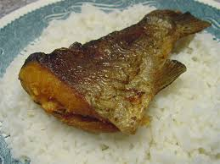

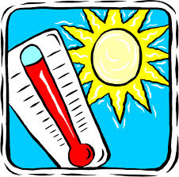
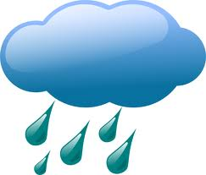
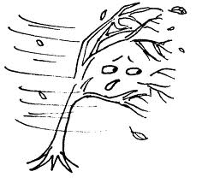

( rainy - aubergine - fish and rice - hot and sunny - windy )

Question number 4: Circle the correct answer: (4 points)

1. They _____at home. (are – is- am)

2. Is it cold and snowy? No, it_______. (isn't – aren't- doesn't)

3. My book is ________my bag. (on – under – in )

4. I am ________a basketball. (playing- reading- eating)

Question number 5: Copy this sentence correctly: (2 points)

1. Dad is driving his car.
____________________________________________________
____________________________________________________
. ____________________________________________________
____________________________________________________

Question number 6: Order the sentence. (2points)

Taking / I/ am /photo/a ______________________________

Question 7: Odd the one out! (1 points)

- rice – meat - computer - aubergines

- winter – sunny – spring – summer – autumn

***************************************************************************************************************************

THE END
WITH MY BEST WISHES

