


25
Department of Education / Zarqa Area
English Language Second Exam
First Semester 2016 / 2017
School : Amir Hasan Prep Boys / 2
Name : ------------------------------------------------ Grade 1 ( )
QUESTION ONE Match capital with small letter ( 6 points )
A B C D E F

b a d c f e

QUESTION TWO count , write the number and colour ( 3 points )
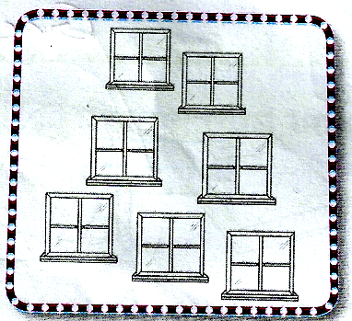
Seven red windows

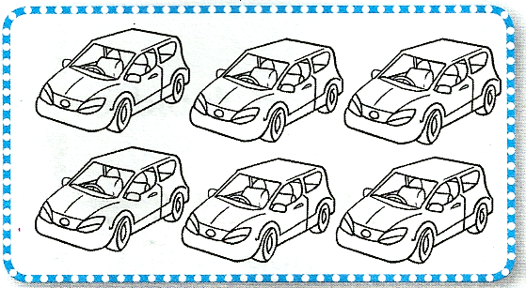
Sex green cars
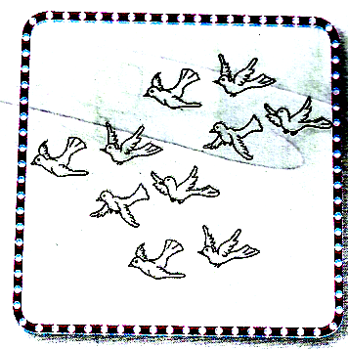
Ten blue birds

QUESTION THREE Write the missing letters ( 2 points )

2
------irl ------wo
QUESTION FOUR copy the letters correctly (6 points)

G g H h Ii J j K k L l

QUESTION FIVE Write the numbers (5 points)

QUESTION FIVE Look and write (3 marks )
clock | pencil | car | window | book | chair


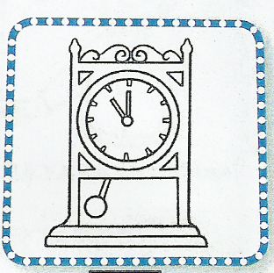

-------------------------------- ----------------------------

-------------------------- -------------------------



--------------------------------------- ------------------------------------
Good Luck
English teacher Emad Sbeihat

