

25

Department of Education / Zarqa Area
English Language Second Exam
First Semester 2016 / 2017
School : Amir Hasan Prep Boys / 2
Name : ------------------------------------------------ 3rd Grade ( )
QUESTION ONE Read and answer ( 8 points )
I like my school. Islamic Education and English are my favourite lessons. I visit my grandparents on Friday and Saturday.
My father is a doctor. He works in a hospital in Aqaba.
My mother is a teacher. She works in a school in Aqaba.
Best wishes,
Majeda
A ) Answer : ( 3 points )
1 - When does Majeda visit her grandparents ?
---------------------------------------------------------------------------
2 - What does Majeda's mother do?
---------------------------------------------------------------------------
3 - Does Majeda's mother work in a hospital?
---------------------------------------------------------------------------
B ) Complete : ( 3 points )
1- Majeda's favourite lesson are ……………………… and ---------------------
3- Majeda's father is…………………
C ) Put ( ) or ( ) ( 2 points )
1- Majeda’s father works in a hospital in Amman . ( )
2 – Majeda likes her school . ( )
QUESTION TWO Match the questions with the right answers ( 4 points )

- What does your uncle do ? | A – I like summer .
- What is your favourite season? ? | B - Yes , she is .
- Is your mum a teacher ? | C - Yes , he does .
- Does he work in a hospital ? | D - He’s a teacher
Answers : 1 --------------- 2 ----------------- 3 ----------------- 4 ----------------
-----------------------------------------------------------------------------------------------------------------------------
QUESTION THREE Choose the right answer ( 3 points )
1 - My father is a teacher . He works in a -------------------
a . hospital b . school c . restaurant
2 - In summer , I ---------------- ice cream .
a . make b . eat c . play
3 - Ibrahim is a ------------------------- . He works in a restaurant .
a . chef b . teacher c . doctor

QUESTION FOUR Study the map then answer the questions ( 3 points )
- What is the weather like in Amman ?
----------------------------------------------------
- What is the weather like in Aqaba ?
----------------------------------------------------

- What is the weather like in Irbid ?
--------------------------------------------
QUESTION FOUR Copy the sentence (2 points)
It’s cold and snowy in winter .
.

QUESTION FIVE Look and write ( 5 points )
snowmen | Ice-skating | plane | airport | pilot
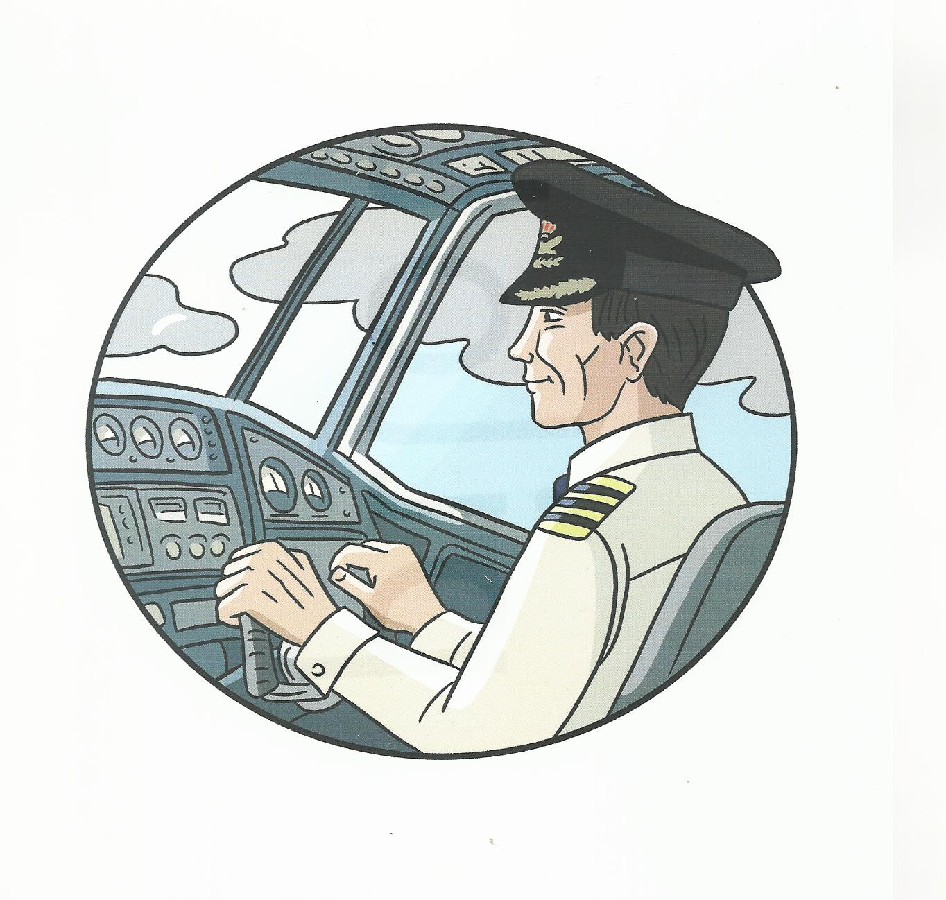
1 ) My father is a --------------------

He travels to many countries .
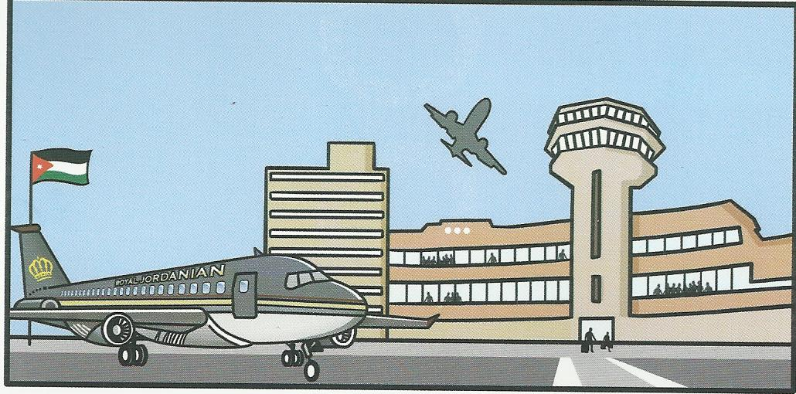
He drives his car to the------------------
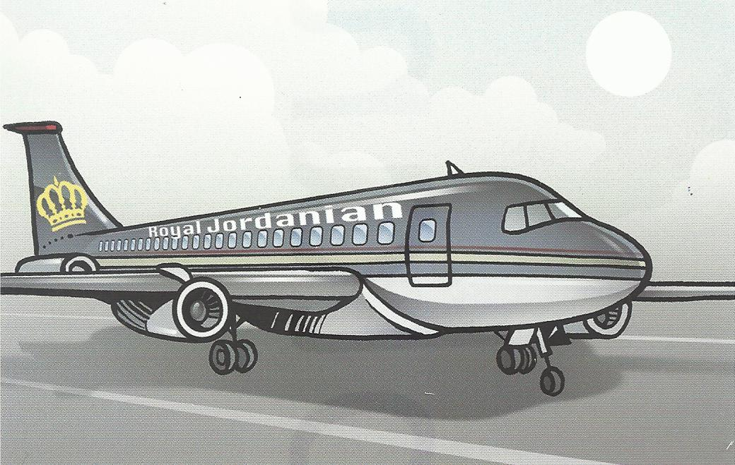
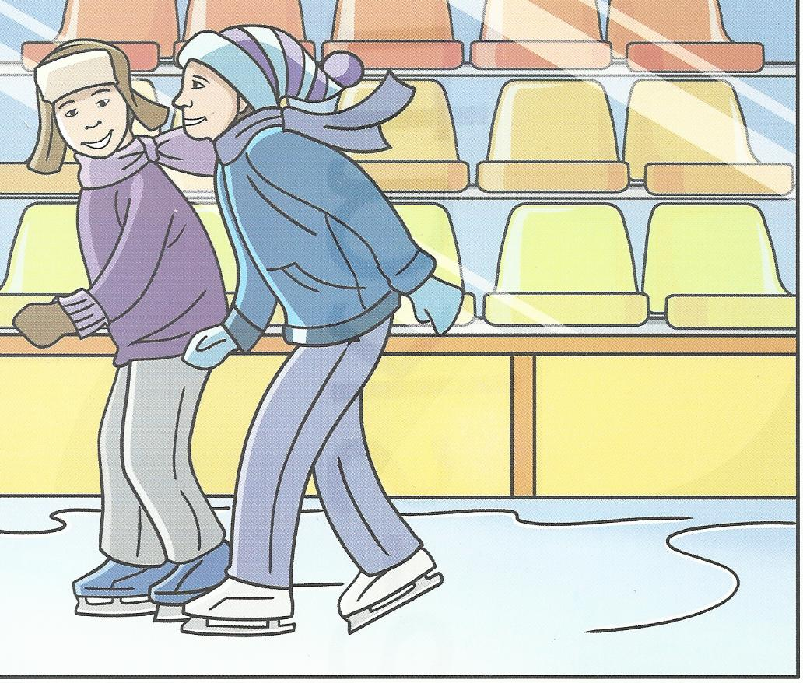
He flies a --------------------

2)Children go --------------------- in winter .

They make ---------------------- in snowy weather
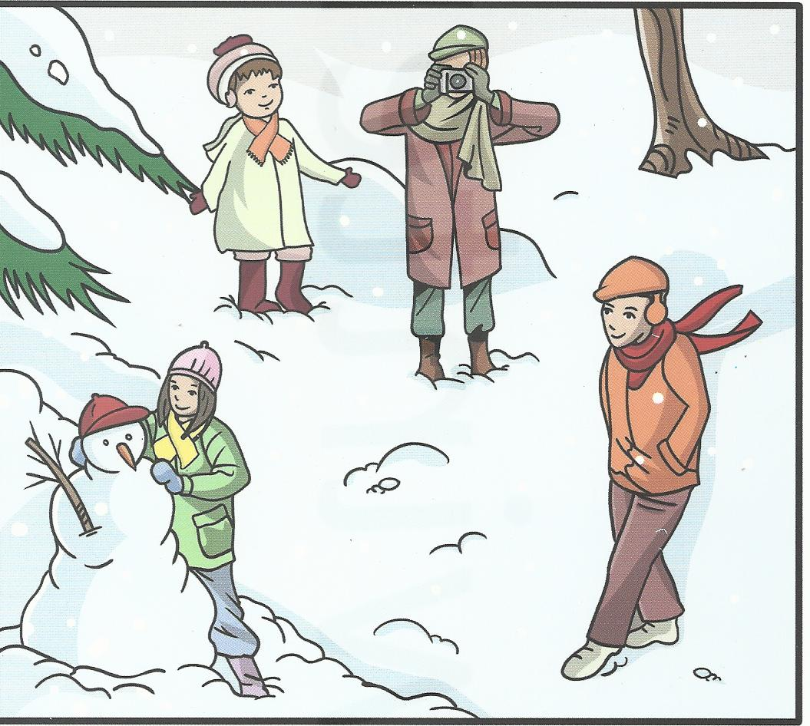
Good Luck
T. Emad Sbeihat

