مدرسة الخشافية الثانوية للبنيين
الاختبار ألثاني للفصل الدراسي الثاني 2015/2016
الاسم : الصف: العاشر اليوم والتاريخ :24/11/2015
المادة : أللغة الإنجليزية الشعبة: الزمن: 45 دقيقة

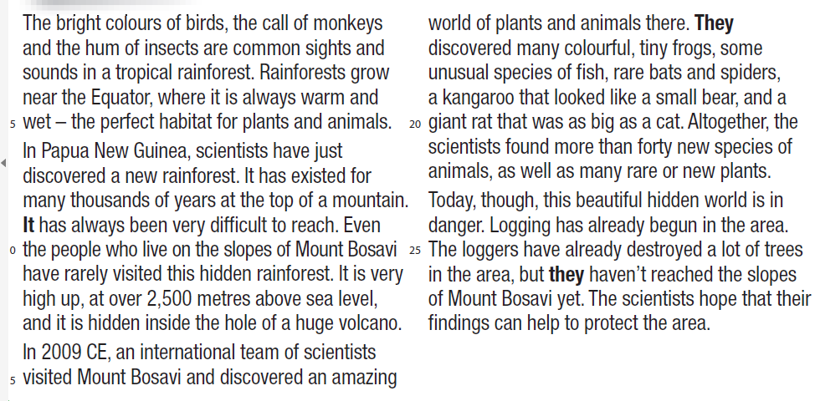
Question 1 Reading (7 marks): Read the following passage then answer the questions below:

1. Where do rainforests grow?.................................................................................................................
2. What makes rainforests a perfect habitat for plants and animals?.......................................................
3- Where have scientists discovered the new rainforest? ………………………………………………………..
4- Where is the rainforest hidden? .......................................................
5- Mention three animals scientists have found in the rainforest?……………, ……………,……………
6- Describe the Kangaroo and the rat which lived there?
-Kangaroo……………………………………………………….
-Rat ………..………………………………………………………
7- Why is the hidden world in danger?....………………………………………………………………………………………………
8- What do the pronouns in bold refer to? It……………... They……..………. They…..………..
9- Why do you think loggers cut trees?…………………………………………………………………………………………………

Question (2) vocabulary: A-From the words between brackets, Fill the blanks with the correct word.
(Spider, Extinct, Snake, Logging, Carbon dioxide, Volcano, monkey, Habitat, species, Frog,)
1- The environment where animals and plans live…………….
2- The act of cutting trees in order to sell wood and make money…………….
3- A small insect that has eight legs ………………
4- A mountain with an opening at its top from where lava is erupted………..
5- Related to a group of animals that don’t exist anymore……………………
6- Air which plants breathe………………….
7-Types of animals and plants……………………..
8- This animal is a reptile…………………
9- This animal is an amphibian………….
10-This animal is a mammal…………
Question (3) Grammar: A- Answer the following questions using the present perfect with yet and already:
1- Have you tidied your room? Yes ………………………………………………………………………………………………..
2- Have you been to jerash? No……………………………………………………………………………………………………….
3-Have you studied for the exam? Yes…………………………………………………………………………………………….
4-Has she been to Ajloun nature reserve? No…………………………………………………………………………………..
5-Have they visited the Roman Theatre? Yes…………………………………………………………………………………..

Questions (3) write down the Arabic meaning for each of the following words:
Logging: Caterpillar:
Loggers: Parrot:
Grow: Crocodile:
Mammals: Equator:
Reptiles:
Amphibians:
Discover:

