25
Class: 1st Grade Date:
Name:………………………… Time: 35 Minutes

Q1: Read and Match( 2 points )
- What’s your name? A. It’s a clock.

- What’s this? B. I’m Samira.

- How are you? C. It’s white.

- What colour is it? D. I’m very well thank you.

Q2: Match objects with their names.( 6 points )

1.door 2. Window 3. Chair 4. Pencil5. Robot 6. Bag

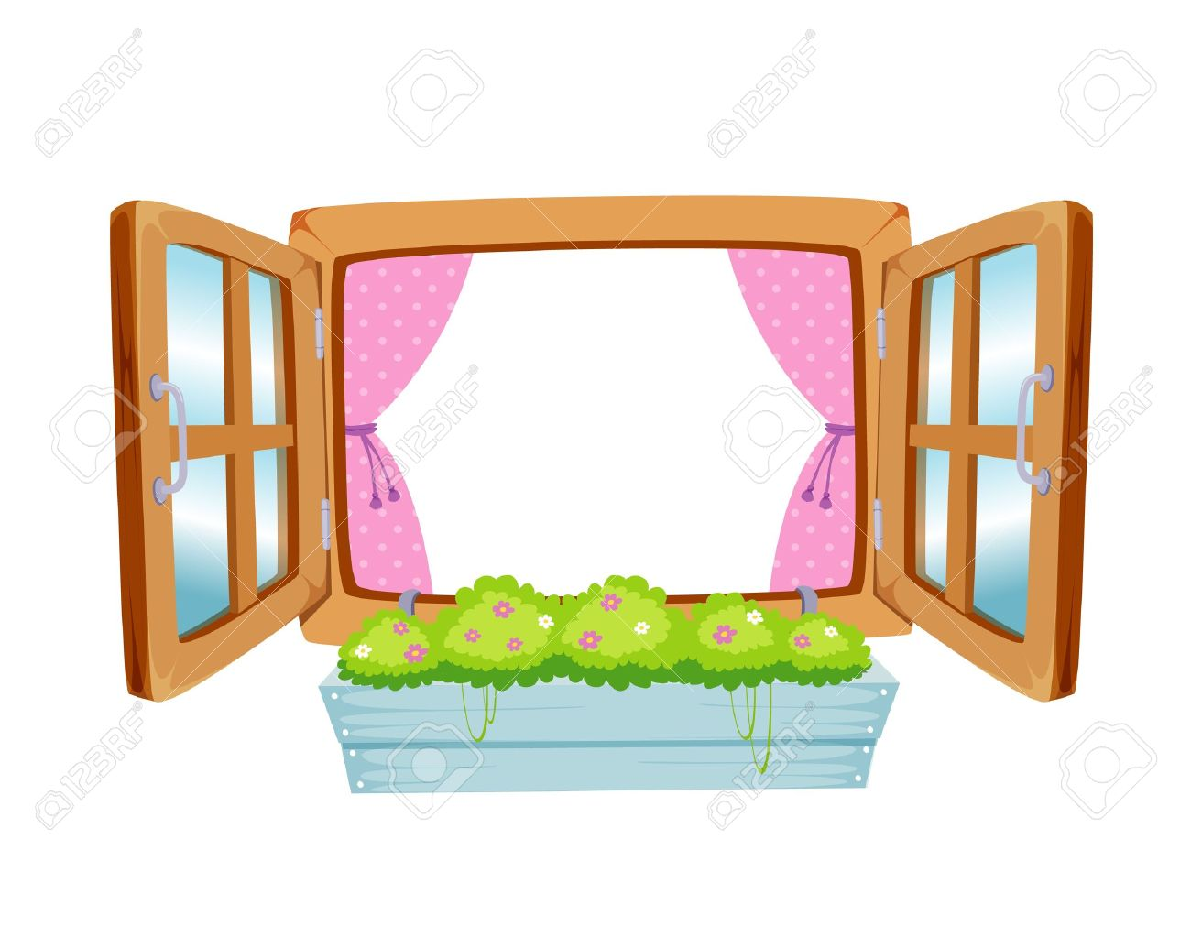
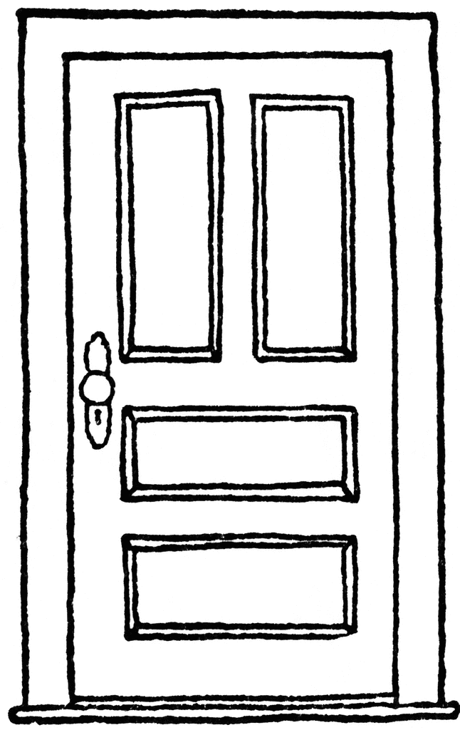

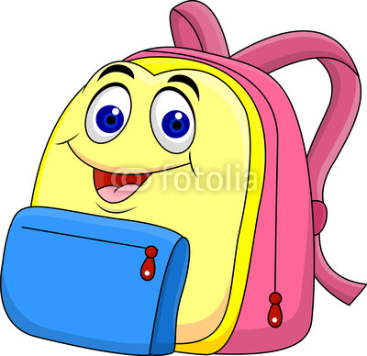
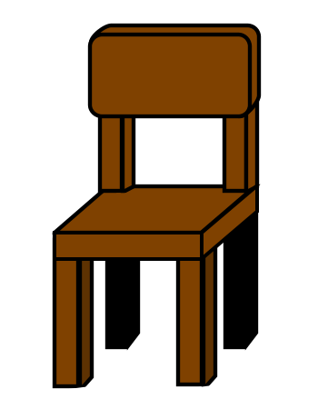


Q3: Look and circle( 3 points )

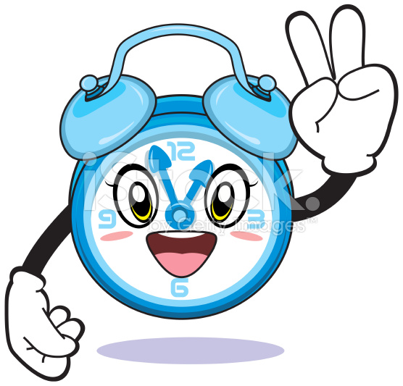

- This is a book a.b.

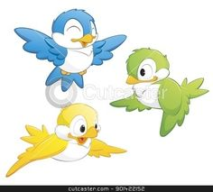

- Three birds a. b.

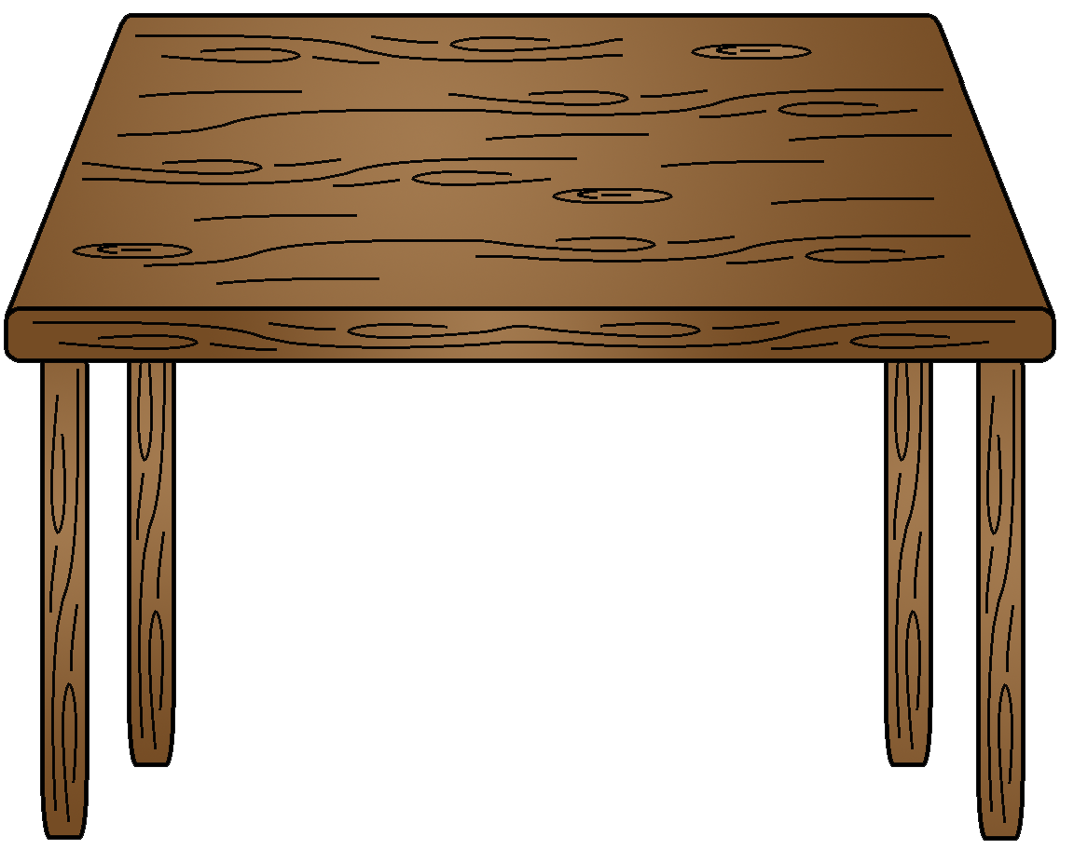
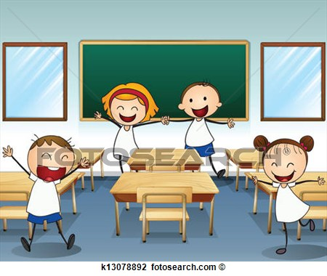
- This is a table a. b.

Q4: Count ( 5 points )
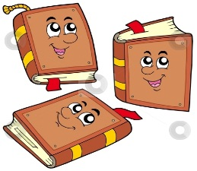
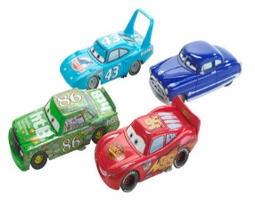
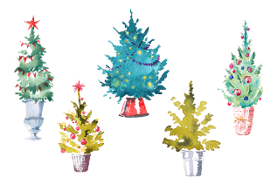

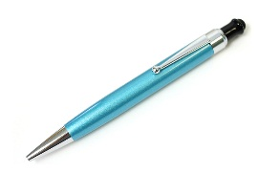

Q5: Listen and color ( 3 points )

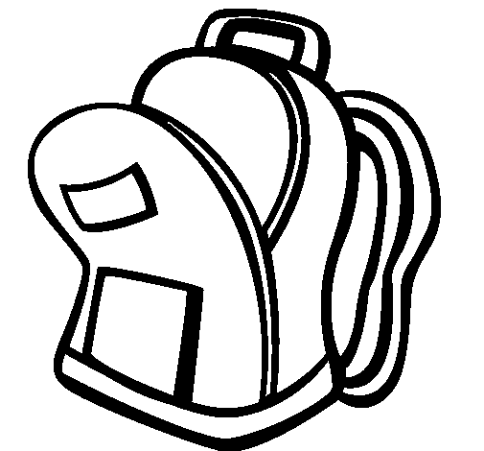

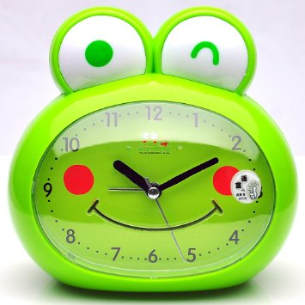

Q6: Write the letters ( 6 points )

A |  | C | D |  |  | G | H |  |  | K
 | b |  |  | e | f |  |  | i | j

25
Class: 1st Grade Date:
Name:………………………… Time: 35 Minutes

Q1: Read and Match( 2 points )
- What’s your name? A. It’s a clock.

- What’s this? B. I’m Samira.

- How are you? C. It’s white.

- What colour is it? D. I’m very well thank you.

Q2: Match objects with their names.( 6 points )

1.door 2. Window 3. Chair 4. Pencil5. Robot 6. Bag

Q3: Look and circle( 3 points )

- This is a book a.b.

- Three birds a. b.

- This is a table a. b.

Q4: Count ( 5 points )

Q5: Listen and color ( 3 points )

Q6: Write the letters ( 6 points )

A |  | C | D |  |  | G | H |  |  | K
 | b |  |  | e | f |  |  | i | j

Best Wishes
☺T. Fatima Ramadan

25
Class: 1st Grade Date:
Name:………………………… Time:

Q1: Read and Match( 2 points )
- What’s your name? A. It’s a clock.

- What’s this? B. I’m Samira.

- How are you? C. It’s white.

- What colour is it? D. I’m very well thank you.

Q2: Match objects with their names.( 6 points )

1.door 2. Window 3. Chair 4. Pencil 5. Robot 6. Bag

Q3: Look and circle( 3 points )

- This is a book a.b.

- Three birds a. b.

- This is a table a. b.

Q4: Count ( 5 points )

Q5: Listen and color ( 3 points )

Q6: Write the letters ( 6 points )

A |  | C | D |  |  | G | H |  |  | K
 | b |  |  | e | f |  |  | i | j

Best Wishes
☺T.




25
Department of Education / Zarqa Area
English Language Second Exam
First Semester 2016 / 2017
School : Amir Hasan Prep Boys / 2
Name : ------------------------------------------------ Grade 1 ( )
QUESTION ONE Match capital with small letter ( 6 points )
A B C D E F

b a d c f e

QUESTION TWO count , write the number and colour ( 3 points )
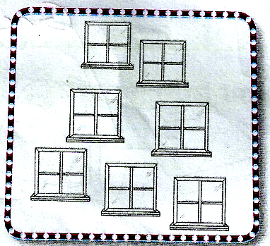
Seven red windows

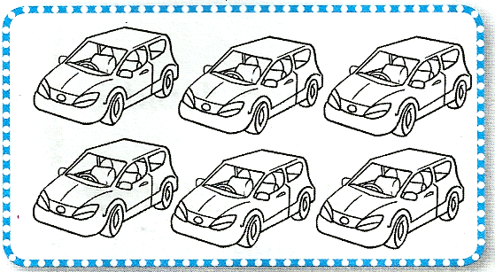
Sex green cars
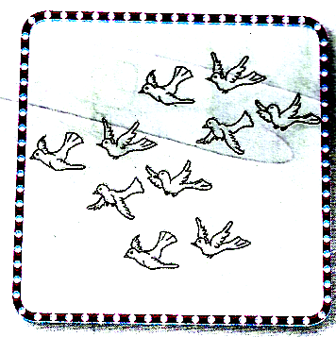
Ten blue birds

QUESTION THREE Write the missing letters ( 2 points )
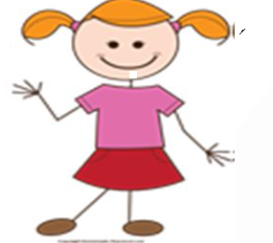
2
------irl ------wo
QUESTION FOUR copy the letters correctly (6 points)

G g H h Ii J j K k L l

QUESTION FIVE Write the numbers (5 points)

QUESTION FIVE Look and write (3 marks )
clock | pencil | car | window | book | chair



 

 



 

