
2

25

School: Amir Hasan elementary Boys /2
ٍSecond month exam
Date : / 11 \ 2016 Class : ^{2 nd} ( )
Name : ------------------------------------------------
QUESTION ONE Write the missing letters ( 5 marks )
Aa |  | Cc | Dd |  | Ff | Gg |  | Ii
 | Kk |  | Mm | Nn |  | Pp |  | Rr
 | Tt | Uu |  | Ww | Xx | Yy
--------------------------------------------------------
QUESTION TWO Write the missing days of the week then answer the question ( 4 marks )
Monday | Friday | Wednesday

1 – Sunday 2 - --------------- 3 – Tuesday 4 - -----------------
5 – Thursday 6 - -------------------- 7-Satuday
What day is it today ? Today is --------------------
-----------------------------------------------------
QUESTION Three Look and write ( 3 marks )
lion | bear | turtle
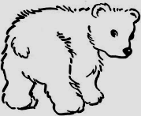



------------ ------------ ---------- -
UESTION FOUR Write the missing letter ? ( 2 marks )
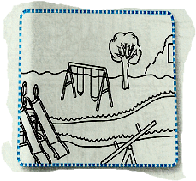
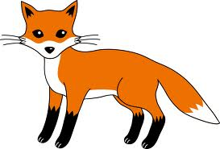
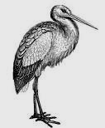
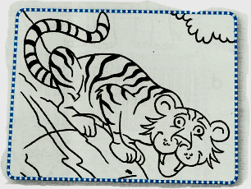

Fo ---- stor ---- ---iger ---ark
-----------------------------------------------------
QUESTION FOUR Write the numbers 5 marks
QUESTION FIVE Answer the questions ( 4 marks )
1- What's our name ?---------------------------------------

2- Where do you live ?-----------------------------------------

3- Can turtles fly ?----------------------------------------------

4 – Can giraffes swim ? ---------------------------------------

QUESTION SIX Read and order ( 2 marks )

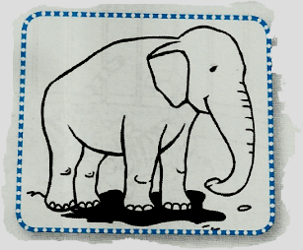

1 ) I can an elephant . I’s ------- ( small / big )

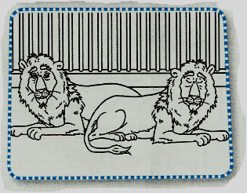

2 ) I can see lions . They’re ------------- ( old / young )

Good Luck
English teacher Emad Sbeihatgg SSsslklklklklhjhjhغففففغفغلللل

