


25
Department of Education / Zarqa Area
English Language Second Exam
First Semester 2016 / 2017
School : Amir Hasan Prep Boys / 2
Name : ------------------------------------------------ Grade 2nd ( )
QUESTION ONE Write the missing letters ( 10 points )
Aa |  | Cc | Dd |  | Ff | Gg |  | Ii
 | Kk |  | Mm | Nn |  | Pp |  | Rr
 | Tt | Uu |  | Ww | Xx | Yy
QUESTION TWO Answer the questions ( 3 points )
1- What's your name ?---------------------------------------

2- Where do you live ?-----------------------------------------
3- What can you see ?
I can see a ( lion / bear / tiger )

QUESTION THREE Write the missing letters ( 2 points )
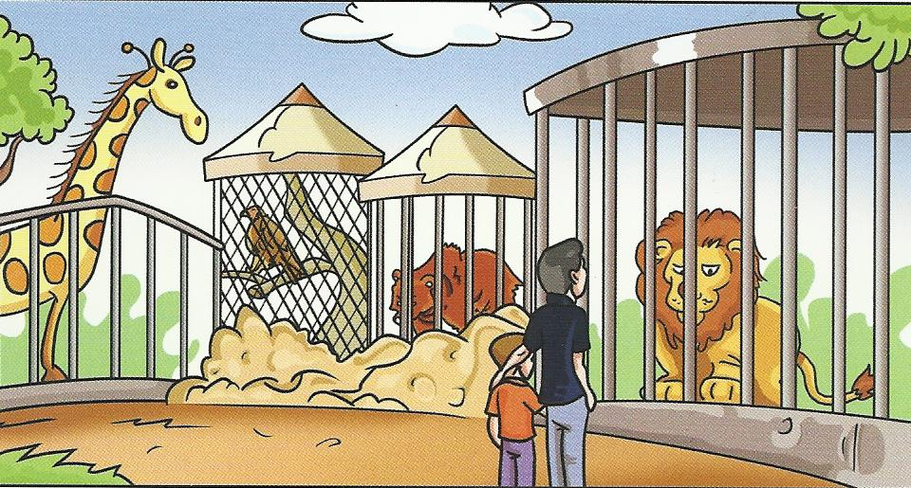
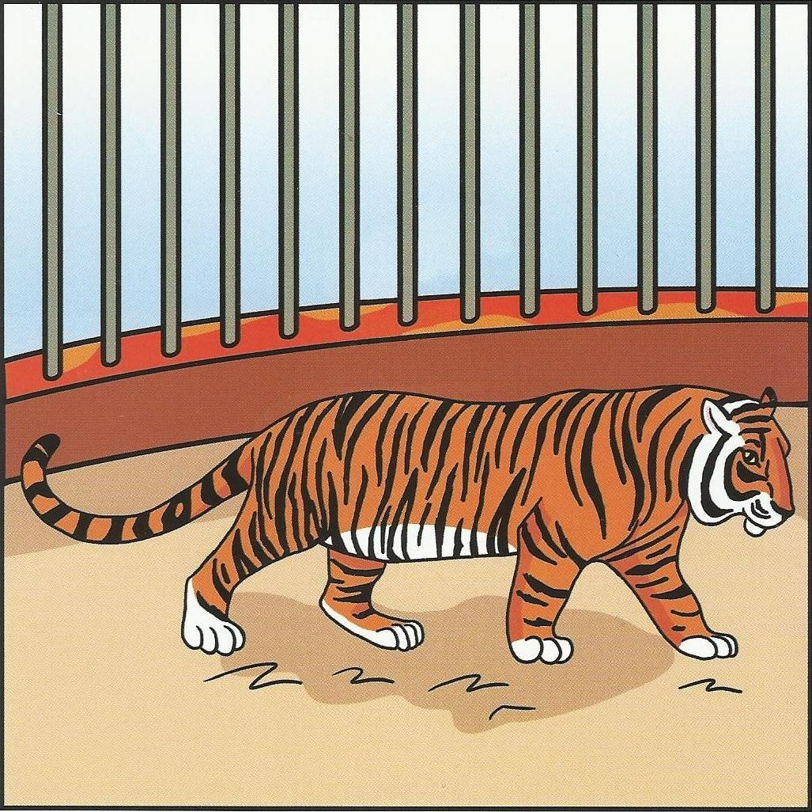

-------oo -------iger
QUESTION TWO ( 4 points )
Write the missing days of the week then answer the question
Thursday | Tuesday | Sunday

--------------------- , Monday , ------------------------ , Wednesday , ----------------------- , Friday , Saturday
What day is it today ?
Today is ---------------------------

QUESTION FIVE Look and write (6 marks )
small | park | big | elephant | lion | old
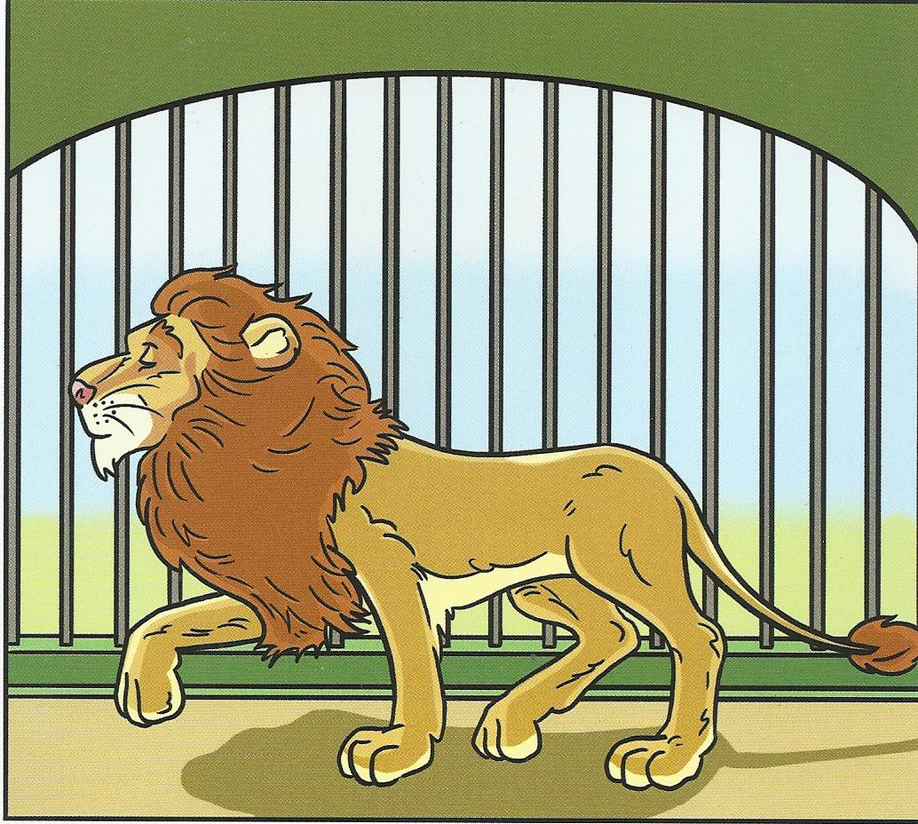

I can see a ------------------------- .
It’s -------------------------

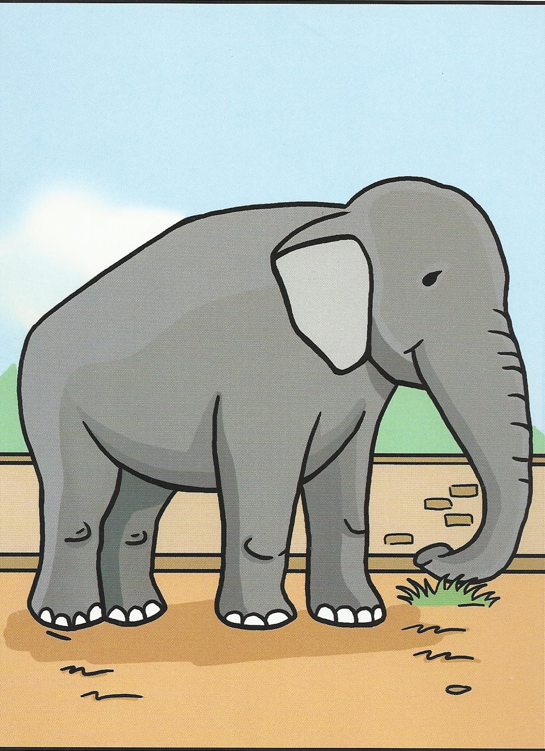

I can see an ----------------------- .
It’s -------------------------

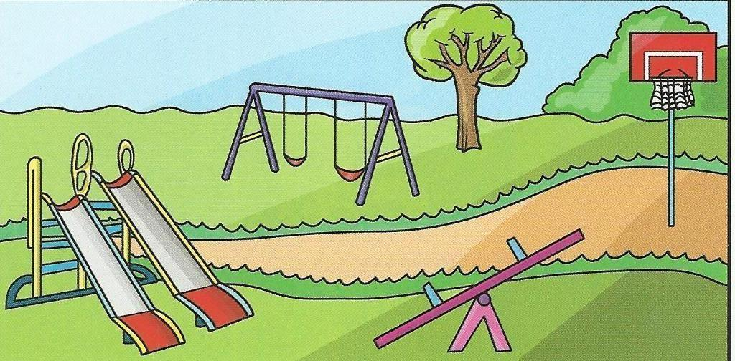

On Sunday ,I play in the ------------

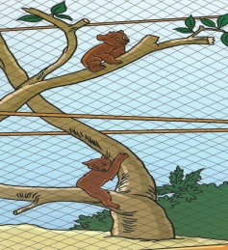
Good Luck
English teacher Emad Sbeihat

Look ! Two bears .
They’re -------------------

