

20

Department of Education / Zarqa Area
English Language Second Exam
First Semester 2016 / 2017
School : Amir Hasan Prep Boys / 2
Name : ------------------------------------------------ 4th Grade ( )
QUESTION ONE Read and answer ( 7 points )
Dear Grandma and Grandpa ,
We’re in Aqaba .We’re staying in a hotel by the sea . We’re at the Marine Park on the beach . We aren’t swimming . We ‘re looking at fish and a turtle . The turtle isn’t swimming . It’s sleeping ! Mum is buying some postcards .
Samira and Kareem
A ) Answer : ( 3 points )
1 - Where are Samira and Kareem ?
---------------------------------------------------------------------------
2 - Where are they staying ?
---------------------------------------------------------------------------
3 - Are they swimming now ?
---------------------------------------------------------------------------
B ) Complete : ( 2 points )
1 - Samira and Kareem are at the ……………………… on the beach .
2 - Mum is buying some …………………
C ) Put ( ) or ( ) ( 2 points )
1- The turtle is swimming . ( )
2 – They’re looking at fish and turtle . ( )
QUESTION TWO Match the questions with the right answers ( 4 points )

- What are you doing ? | A – Football .
- What is your favourite sport? ? | B - Yes , I am .
- Is Kareem swimming ? | C - No , he isn’t .
- Are you learning English ? | D - I’m reading a book .
Answers : 1 --------------- 2 ----------------- 3 ----------------- 4 ----------------
-----------------------------------------------------------------------------------------------------------------------------
QUESTION THREE Choose the right answer ( 3 points )
1 - We’re ---------------------- the computer .
a . use b . using c . uses
2 - Samira -------------- sending an email .
a . is b . am c . are
3 - The dolphins are -------------------- .
a . jump b . jumps c . jumping

QUESTION FOUR ( 3 points )
Rewrite with capital letters . question mark and full stops
1 ) ahmad is studying english now

2 ) do you write a dairy about aqaba

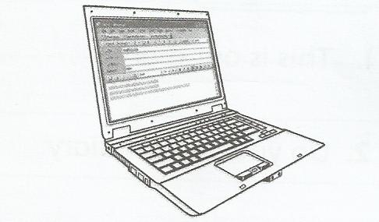
QUESTION FIVE Look and write ( 3 points )
printer | mouse | computer

1 ) I’m sending an email from my----------------------

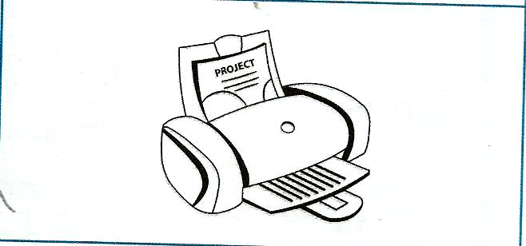
2 ) I’m using the ---------------- .I’m dong my project .

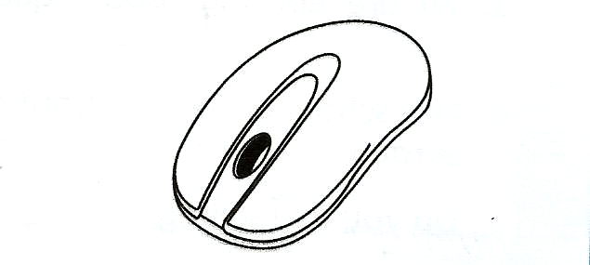

3 ) I like using the --------------------

Good Luck
T. Emad Sbeihat

