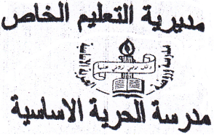
ـــــــــــــــــــــــــــــــــــــــــــــــــــ
Private Education
Al-horiya School
Second Exam
Fifth Grade
Name:...................................

Reading:-(4 marks)

Read and answer:-

We arrived at the Royal Automobile Museum at five to ten. It's ten o'clock now and the museum is open. We're going to learn about the oldest cars and the oldest motorbikes. The oldest car is more than one hundred and twenty years old. The old motorbike is more than one hundred years old.

1- When did they arrive to the museum?
.......................................................................

2-What did they learn about?
.......................................................................

3- the oldest car is more than:-

A- 120 years old B- 100 years old

4-Extract the following:-

A- Noun:-...................... B- Preposition: .............

Writing :-( 6 marks)

1- What time is it? ( 3 marks)

2-Write a letter to your friend about your favourite day in the holiday? (3 marks)
............................................................................
............................................................................
............................................................................

Speaking:- (6 marks)

1- Complete the following comparative sentence :- ( 2 marks)
A- Ali is ..................... Ahmad. ( tall)
B- Gold is ............................ silver. ( expensive)

2- Correct the verbs between brackets:-(4 marks)

A- She .......................... Aqaba next weekend.(go)
B- ........... you........... to Petra last year? (go)
3-He .............. football every week. ( play)

Listening:- ( 4 marks)

1) Listen and number:-

Good Luck

