The Ministry of Education
The Education Directorate of ------------
Final Exam- Second Term
Class: 2nd Grade (Action Pack 2) Material: English Language
Date:
Time: One hour.
Name: .......................................................................................................................................Section :(..................)
PART ONE
Question One: Reading Comprehension (7.5 points)
-Read the following text carefully and then answer all the questions below:
My uncle is tall. He's got brown eyes and short grey hair. My aunt's short ,she's got brown eyes and black hair .

1. My uncle is---------- a-short b- tall (1 points)

2. He's got brown eyes. ( T - F) (1.5 points)
…………………………………………………………………………………………………………………………………………………………..
3.My aunt's got, ------------- eyes and-------------------- hair. (3 points

4. I've got ---------------eyes. a- black b- brown c-blue (2 points)

Question Two: Focus on Vocabulary (5 points)
A. Look, match and write: (5 points)

Cycling - reading - running - playing tennis - drawing

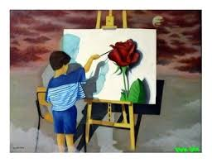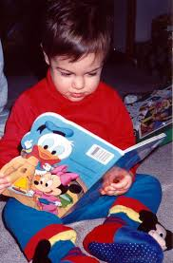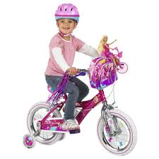

----------------------------------- ---------------------------------- ---------------------------------
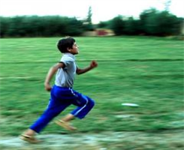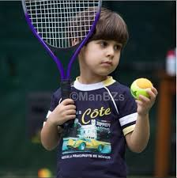

------------------------------------------- ------------------------------------------------

Question Three: Focus on Language and Structures (7.5 points)
A. Choose the correct answer in the following sentences: (5 points)

1. Is it a ball 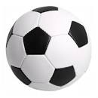?. A-Yes it is b-No it isn't c- No there isn't

2. There-----------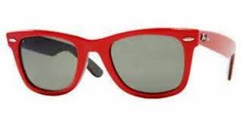 sunglasses. a- is b- are c- ?


3. -------------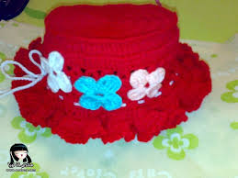 a hat ? a-Is there b- Are there c- Is it

4- Is he go to school? a- yes he is b- N o he isn't


5- I-------------breakfast. a- has b- have

B. count and write: - (2,5 points)


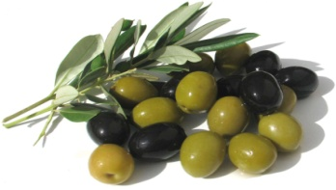

------------------------------------------------------------- ------------------------------------------------------------

PART FOUR
Question Four: Focus on Writing (3 points)
A. Spell the following words: (3points)
1. Mazen.--------------------
2- Hammad.---------------------
3- Salem.------------------------

B. write please : (2 points)

……………………………………………………………………………………………………………………………………………………………………………………………………………………………………………………………………………………………………………………………………………………………………………………………………………………………………………………………………………………………………………………………………………………………………………………………………………………

……………………………………………………………………………………………………………………………………………………………………………………………………………………………………………………………………………………………………………………………………………………………………………………………………………………………………………………………………………………………………………………………………………………………………………………………………………………

……………………………………………………………………………………………………………………………………………………………………………………………………………………………………………………………………………………………………………………………………………………………………………………………………………………………………………………………………………………………………………………………………………………………………………………………………………………

……………………………………………………………………………………………………………………………………………………………………………………………………………………………………………………………………………………………………………………………………………………………………………………………………………………………………………………………………………………………………………………………………………………………………………………………………………………

