
Education Departmen / Zarka Area
25
Second Exam
School: Amir Hasan elementary Boys /2
Date : 26 \ 11 \ 2015 Class : 1st ( )
Name: -------------------------------
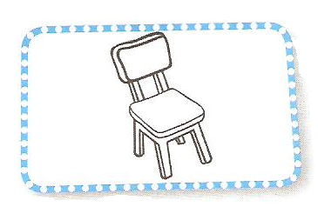
QUESTION ONE listen and colour (4 marks )
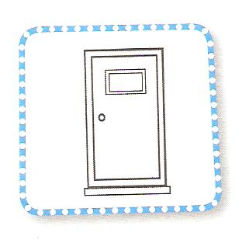
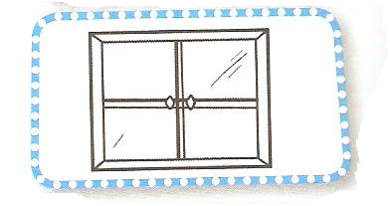


-----------------------------------------------------
QUESTION Two Count and write the numbers ( 5 marks )
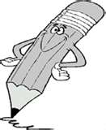




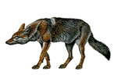

-----------------------------------------------------
QUESTION FOUR Write the numbers 5 marks
--------------------------------------------------------
QUESTION FIVE Look and match (5 marks )
pencil | car | door | book | chair


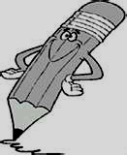
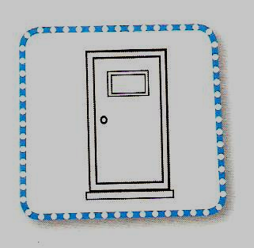
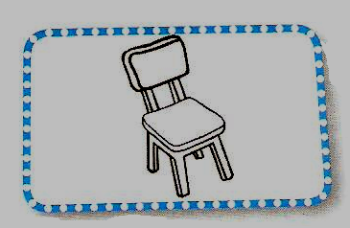

QUESTION FIVE copy the letters correctly (6 marks )

A a B b C c D d E e F f G g H h Ii J j K k L l

Good Luck
English teacher
Emad Ahmad Sbeihatغففففغفغلللل

