Gharnata Primary School | Ministry Of Education | 5th Grade
 | Madaba Directory
Name: …………………………………………………………. | Second Exam  1st Semester 2015 / 2016 | Wednesday 2 / 12 / 2015

Questions 1: Vocabulary
Match the words 1-5 to their meanings a-e: (5 Marks)

- transport | - ملكي
- royal | - مواصلات
- history | - مختبر
- question | - تاريخ
- laboratory | - سؤال

Questions 2:
Complete the following sentences with (is / are / am): (2.5 Marks)
- She …………… going to play with her friends.
- I …………… going to paint pictures.
- They …………… going to go to the park.
- Ali and I …………… going to write an email.
- My friend Ossama…………… going to do his homework.

Question 3:
Answer the question: (5 Marks)
- What time is it?


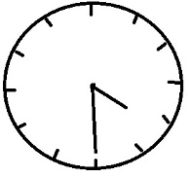
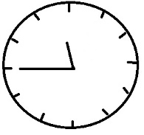
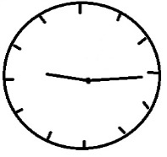
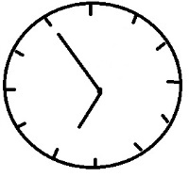



It is ……………………………………........... It is …………………………………………………

Question 4:
Complete the words with the (f) sound: (2.5 Marks)
- ……… oto.
- Gira………e .
- ……… ire………ighter .
- lau……… .
- al………abet.

Question 5:
Write the (Past Tense) of the following verbs: (3 Marks)
- go: …………………………………………
- phone: ……………………………………
- play: ……………………………………….
- take: ……………………………………….
- visit: ……………………………………….
- write: ……………………………………..

Question 6:
Complete the following sentences with the correct words: (2 Marks)
dentist | firefighter | scientist | teacher | Fire station | laboratory | school | Dentist's surgery

- A ........................................ works in a .........................................
- A ........................................ works in a ........................................ .
- A ........................................ works in a ........................................ .
- A ........................................ works in a ........................................ .

The End
3ammar J3aydi

