Gharnata Primary School | Ministry Of Education | 5th Grade
 | Madaba Directory
Name: …………………………………………………………. | Final Exam  1st Semester 2015 / 2016 | / 12/ 2015

Questions 1: Vocabulay
Match the words 1-5 to their meanings a-e:(3 Marks)

- blanket | - اقراط
- earrings | - طبيب اسنان
- dentist | - غطاء

Questions 2:
Circle the correct answer: (3 Marks)
- Themoonis / wasa circle last night.
- Last night, theyare / were in bed.
- Aliis / was at school yesterday.

Question 3:(3 Marks)
……………
……………
……………
Read and write Yes or No
- It's a triangle.
- It has four sides .
- It has three sides.
Question 4:
Complete the words with the correct letter: (3 Marks)
- ……… otorbike.
- Gira………e .
- ……… ostume.

Question 5:
Read and answer: (3 Marks)
Hi. I'm Laila. This is the market in our town. It's near the river. It's my favorite place. I was there last Saturday. It was a beautiful day. I was happy.
- What's Laila'sfavourite place?
……………………………………………………………………………………………………………………………….
- What is near the market?
………………………………………………………………………………………………………………………………
- Was the weather nice?
……………………………………………………………………………………………………………………………….

Question 6:
Choose the correct answer:(3 Marks)
- Yesterday, Majedplay / played tennis.
- 5 years ago, Ali helped / help me with my project.

Questions 7:
Complete the following sentences with (is / are / am): (3 Marks)
- She …………… going to play with her friends.
- I …………… going to paint pictures.
- They …………… going to go to the park.

Question 8:
Write the (Past Tense) of the following verbs: (3 Marks)
- go: …………………………………………
- phone: ……………………………………
- play: ……………………………………….
- take: ……………………………………….
- visit: ……………………………………….
- write: ……………………………………..

Question 9:
Complete the following sentences with the correct words: (4 Marks)
dentist | firefighter | scientist | teacher | Fire station | laboratory | school | Dentist's surgery

- A ........................................ works in a .........................................
- A ........................................ works in a ........................................ .
- A ........................................ works in a ........................................ .
- A ........................................ works in a ........................................ .

Question 10:
Answer the question: (5 Marks)
- What time is it?

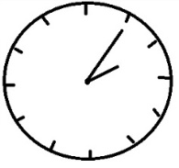
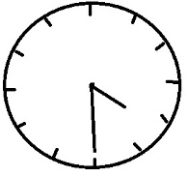
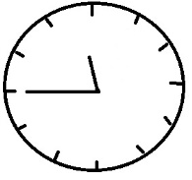
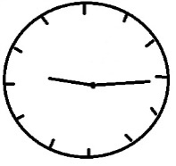
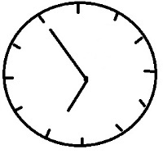

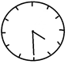

It is ……………………………………........... It is …………………………………………………

Question 11:
Complete the spaces with the correct form of the Past Continuous:(5 Marks)
- Samer and I …………………………………. (eat) our lunch.
- We …………………………………. (walk) on the street.
- I …………………………………. (talk) to my teacher.
- Samer …………………………………. (make) a model plane.
- She …………………………………. (drink) milk.

Question 12:
Complete the following table with the correct form of the comparatives and the superlatives: (3 Marks)
Adjective | Comparative | Superlative
bright | …………………………….………… | …………………………….…………
careful | …………………………….………… | …………………………….…………
good | …………………………….………… | …………………………….…………

The End
3ammar J3aydi

