Gharnata Primary School | Ministry Of Education | 7th Grade
 | Madaba Directory
Name: …………………………………………………………. | Final Exam  1st Semester 2013 / 2014 | Monday 29 / 12 / 2013

- Comprehension :
Read The Following Text:
"Welcome to the roman theatre in Amman one of the most amazing sights in the city. It was built in the second century CE (common Era) in what was the roman city of Philadelphia. The theatre was divided into three parts: important people sat in the part nearest the stage and soldiers sat further away; ordinary people sat far away at the top of the theatre but because the theatre was so well designed they could still see and hear the actors."

- Answer The following Questions: (5 Marks)
- Where does the Roman Theatre exist?
…………………………………………………………………………………………………………………………………
- When the Roman Theatre was built?
…………………………………………………………………………………………………………………………………
- What was the old name of Amman?
…………………………………………………………………………………………………………………………………..
- The theatre was divided into three parts, what are they?
…………………………………………………………………………………………………………………………………………………………………………………………………………………………………………………………………………………………………………………………………………………………………………………………………………………………………………………………………………………………………………………………………………
- What is CE?
………………………………………………………………………………………………………………………………….

- Match the words 1-5 to their meanings a-e: (5 Marks)

- Boring | - ممثل بديل
- Safe | - عامل منجم
- Miner | - ممل
- Scuba diving | - آمن
- stuntman | - الغطس

- Grammar :
- Choose the correct answer: (5 Marks)
- ………………. Many cars in Madaba.
- There am | - There is | - There are
- ………………………. A man in the building.
- There am | - There is | - There are
- I have …………………………. Books.
- any | - an | - some
- I don’t have ……………………. Cheese in the fridge
- a | - any | - some
- ……………………… any food in the kitchen.
- There am not | - There isn't | - There aren't

- Match the sentences with the pictures: (5 Marks)
It's half past four | It's five past tow | It's quarter past nine | It's five to seven | It's quarter to twelve

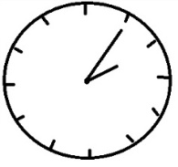
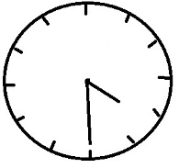
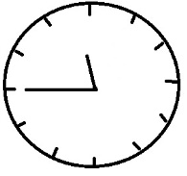

……………………………………………. | ……………………………………………. | ……………………………………………

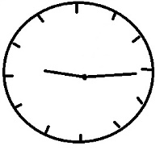
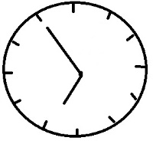

……………………………………………. | …………………………………………….
- Correct the verbs in brackets then Negate and make Questions of the sentences:
(5 Marks)
- A pilot ………………………………………. (need) courage and dedication.
Negative: ……………………………………………………………………………………………………………….....
Interrogative: …………………………………………………………………………………………………………...
- Airline pilots ………………………………………. (become) very tired from work.
Negative: ……………………………………………………………………………………………………………….....
Interrogative: …………………………………………………………………………………………………………...

- Write the verbs in the correct column: (5 Marks)
like | fly | arrive | fish | go | enjoy | study | print | need | work

-s | -es | y + -s | y + -ies

- Complete the table with the following words : (5 Marks)
meat | orange | egg | fish | tea | tomato | honey | potato | apple | sugar

Countable Nouns | Uncountable Nouns
…………………………………………………. | ………………………………………………….
…………………………………………………. | ………………………………………………….
…………………………………………………. | ………………………………………………….
…………………………………………………. | ………………………………………………….
…………………………………………………. | ………………………………………………….

- Writing :
- Rewrite this paragraph using capital letters where necessary: (5 Marks)
"in jordan, some people do dangerous activities to help poor or ill people. every year, alia fawzi and samira hafiz do rock climbing to raise money for poor children.
they climb big rocks using ropes and other tools. samira says: "i am always terribly scared."
……………………………………………………………………………………………………………………………………………………………………………………………………………………………………………………………………………………………………………………………………………………………………………………………………………………………………………………………………………………………………………………………………………………………………………………
The End
3ammar J3aydi

