English Language
Diagnostic test for the Third Grade
Name :________________ School:______________ Class:_____________

- Listening
- Circle the word you hear: [ 2 marks ]
(1) (2) (3) (4)
long shirt sister calculator
light skirt brother clock
lion short mother cup
B - Speaking
2- Finish the dialogue : [ 4 marks ]

old – seven – Hello – are – from – I'm – Basim – Fine

Ali : Hello , ________ . Basim : __________, Ali .
Ali : How ______ you ? Basim:_______ , thanks .
Ali : How ______ are you ? Basim :I'm ________ .
Ali : Where are you _______ ? Basim : ______ from Rafah .

C – Reading
3- Choose the right answer : [ 2 marks ]
1- Ahmad ________ a TV . ( have – has – is )
2- It's a _______ . ( triangle – square – circle )
3- It's a _______ snake . 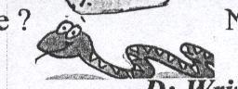 ( small – long – heavy )
4- I'm from _______ . ( Jordan – Palestine – France )

4- Odd one out : [ 2 marks ]

1- white - book - blue - green .
2- eraser - pencile - ruler - radio .
3- Jaffa - dog - Hebron - Gaza .
4- apple - orange - fig - banana .

5- Match : [ 2 marks ]
1- What's the time ? ( ) - I'm seven .
2- Who's book is this ? ( ) - It's Nadia's .
3- How old are you ? ( ) - At school .
4- Where's Ali ? ( ) - It's nine o'clock .

D- Writing
6 - Complete : [ 2 marks ]
( are – has – Is – have )
1- I _______ a red dress .
2- Nour ______ long hair .
3- These ______ my shoes . 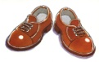
4- _____ this your bag ?
9- Answer the following questions: [ 4 marks ]

1 – How many bananas ? 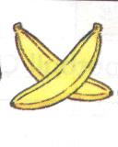
_______ bananas .
- Where's the parrot ? 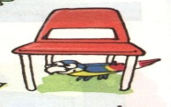
It's __________ the chair . ( on – in – under )
- What's the time ? 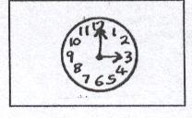
It's _______ ________.
- What's your name ?
My name's ___________ .
- Hand writing : [ 2 marks ]
I'm from Rafah .
_____________________________________________________________________________
_____________________________________________________________________________
_____________________________________________________________________________
_____________________________________________________________________________

Good Luck

