Worksheet/ Unit nine

1.The museum is next to/behind the hospital.

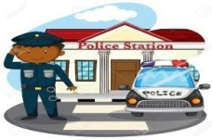
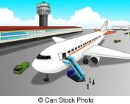
2. The police station is behind/near the airport.

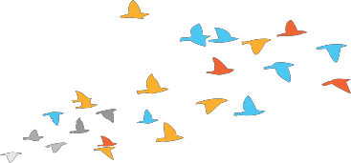

3. There are birds behind/in front of the school.

Complete.

There is, There are, Is there, Are there, there isn’t, there aren’t

- ………………………………three airports in Amman.
- ………………………………a museum in your country? 3. No, …………………………………….
4. ………………………………a mosque near your school? 5. No, …………………………………….
6. ………………………………one sports centre in my old town .

Worksheet/ Unit nine

sport , centre , mosque, Saturday,
near, train station,
shopping, buildings,

Complete:
On …………………………., I go ……………………………with my brother in the market. There are many …………………………………..in my town. There is one ……………………………….and a big mosque. The mosque is
………………… the market.

Read and write.

My name is Ahmad. I live in Zarqa. I work in Amman. There’s a big museum in Zarqa. There isn’t an airport in my city, but there are many parks and markets. There is a University next to my house. I like my city a lot.
1. I work in …………………………….

2. There is a ………………………………next to my house.

3. I live in …………………..

4. There are many ……………………………………….in my city.

5. There’s a big …………………………….in zarqa.



Worksheet/ Unit nine

Read and Answer.


On Friday, I visit my grandma with my brother and my sister. We have lamb and rice for lunch. My grandma makes a delicious fruit juice. I like juice, and my sister likes salad. We like Friday.
Best regards, Hasan
Example
1. Hasan visits his …grandma…on Friday.
- Hasan’s grandma makes a delicious…………………….
- Hasan’s sister likes……………………
- Hasan’s brother and sister have ……………………………for lunch.
- Does Hasan like juice?
……………………………………………………………..
- Does Hasan have fish and rice for lunch?
……………………………………………………………..

Third Grade
Unit 9
Name: ---------------------------------- Class: -------------
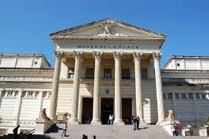
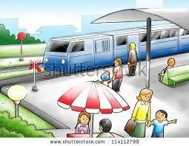
1) Match a train station a museum a plane The Roman Theatre

------------------------- -------------------------
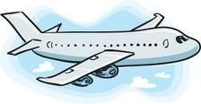
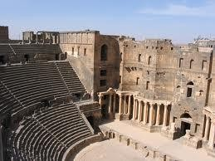
------------------------- -----------------------
2) Circle
1. There ----------- two markets
a- Is b- are c- am
2. Where is Ahmed's house? It's ------------- the museum.
a- behind b- near c- in front of
3. There ------------ a train station.
a- is b- are c- am
4. Are there any museums in your city?
a- Yes, there is. b- Yes, there aren't. c- Yes, there are.

5. Where are the markets? They're ------------- school.
a- Near b- in front of c- behind

6. Is there an airport in Amman?
a- Yes, there are b- yes, there is c- yes, there aren't

