Mark

The Ministry of Education 20
The Education Directorate of---------
Second Exam Second Term2016/2017
Class: Sixth Grade (Action Pack 6) Language English
Date:
Name: ...................................................................................................................
_________________________________________________________________________________________
PART ONE
Question One: Reading Comprehension (5 points)
-Read the following text carefully and then answer all the questions below:

The Jordanian museum is in Amman. It opened in 2013.The modern building is made of stone and glass.
The museum has lots of information about the history of Jordan. Inside the museum, there are more than 2,000 objects. The oldest objects in the museum are more than a million years old. Most of the objects are made of stone. Some of the objects are from the Roman era. They are made of clay, stone and glass. There are library, a shop, and a cafe in the museum

1. The Jordanian museum is in: a. Amman b. Jerash c. Irbid (, 5 point)
2. When did The Jordanian museum open? (1 points)
------------------------------------------------------------------------------------------------------
3. In the Jordanian museum, there are? (1, 5 points)
1-------------------------2---------------------------3------------------------
4- What does the museum tell us? (1 points)
----------------------------------------------------------------------------------------------------
5- . What does the underlined pronoun refer to?: ------------------- (1 point)
PART TWO
Question Two: Focus on Vocabulary (5 points)
A. Look, match and write :- (2 points)
1. Embroider - coach - pot - jug - weave

a. 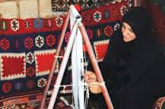 b-. 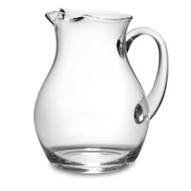 c. 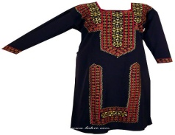 d-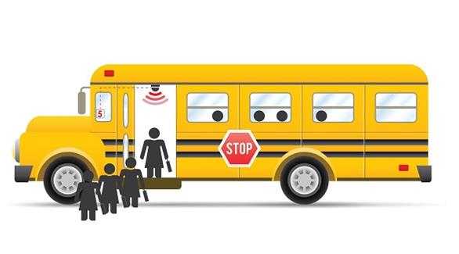

----------------------------- ---------------------------- -------------------------- -------------------------

B. Read and complete: (2 points)

Mosaics - striped - information – gifts

1. In the market, there is ……………………………………….
2. The museum has got lots of …………………………………about Jordan.
3. …………………………… are parts of Jordan’s history.
4- It’s a beautiful, ------------bottle in museum.
PART THREE
Question Three: Focus on Language and Structures (7 points)

A. Choose the correct answer in the following sentences: (4 points)

1- Read------------- an-email yesterday. a. write b. wrote c. written
2. The spoon is made of ---------------. a. clay b . stone c. metal
3. This ruler is made of----------------. a. wood b. clay c. stone
4- When Grandpa was young , he --------- use a computer . a. can b, could c. couldn’t
B. Read and rewrite ( could or couldn’t )+ V+ when (3 points)

1. speak English / Sami/ a baby /he/ was . .……………………………………………………………………………………………………………………………………..
2. Ali/swim /old/in the sea/was/10 years/he. ………………………………………………………………………………………………………………………………………..…..
3. mum/cakes/young/she/ was/make. …………………………………………………………………………………………………………………………
PART FOUR
Question Four: Focus on writing (4 points)
A- choose the correct punctuation in the following sentences:- (1.5points)
1- Aunt Muna could play tennis when she was young------ a- ? b- . c- !
2-I could---play chess. a- n,t b- ? c- ,
3- Yes---she could . a- ; b- , c- ?
Question five :-
Write three sentences about your bedroom (2.5 points)
There, s a--------------------------------------in my bedroom.
It’s made of--------------------------------------------------------.
There is -------------------------------------------------------------------------------------------------------------------------------------------------------------------------------------------- WITH MY BEST WISHES
TEACHER: SANA AL- OMAR

