Date: _________ Work sheet Name: ________
Day: __________ for 1st grade Mecca school
***********************************************************
* What's this? للسؤال عن المفرد وطريق الإجابة:
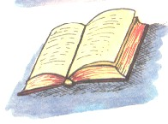
It's a book.
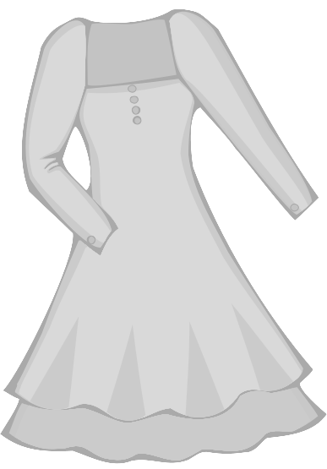
It's a green dress. ( It's = It is )
***********************************************************
* What are they?للسؤال عن الجمع وطريقة الإجابة:
They are birds.

They are red clocks.
They are trousers.
They are pink socks. ( They're = They are )
***********************************************************

Q1) Answer the questions:

What's this? What are they?

1) _______________. (white) 2) ________________. (black)

What's this? What are they?

3) _______________. 4) _______________.

