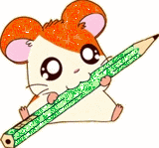
Alphabet letters

Match the capitals to the smalls:

A c
B d
C a
D e
E b

Alphabet letters

Match the picture with the first letter of its word:
a
b
c
d
e

