CLASS::-2ND GRADE

Match one part from (A) with the suitable part from (B) :

(A) (B)
1-How many cars are there ? No , there isn't .

2-There is a boy in the house

3- Is there a bird in the tree? in the barn .

4- There is a cow There are ten cars

Match one part from (A) with the suitable part from (B) :

( A ) ( B )
1- Where is the princess? It's a van.
2- Is he in the house? She is in the castle.
3- What's this? next to the tree .
4- There is a horse Yes, he is.

Supply the missing letters :


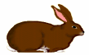

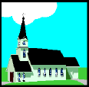

f – owe - h – u – e ra - - it c - - tle

Supply the missing letters :

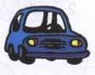

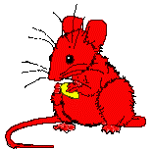


c - - b - - e m – u – e t – ai -

Underline the correct word(s):-

1- ----------- there a cat in the house?
a) Is b) Are c) Am

2- Is there a cat ----------- the tree?
a) in b) at c) next

3- Is there a cow ---------- the barn?
a) next b) in c) under

4- There is a house ---------- to the hill.
a) next b) at c) under

5- Is there a cow in the barn? Yes, ---------------.
a) there is b) there are c) there aren't

6- Is there a girl in the house? No, -----------------.
a) there isn't b) there is c) there aren't

7- There --------------- a tree.
a) is b) are c) aren't

8- There ---------- trees.
a) is b) are c) isn't

Underline the correct word(s):-

1- The mouse is ----------.
a) big b) tall c) little

2- The cow is in the -----------------.
a) kitchen b) barn c) tree

3- There is a house ----------- the hill.
a) next b) in c) on

4- There are two ------------ in a tree .
a) birds b) cows c) goats

5- There are three ------------- in the bus .
a) cows b) goats c) girls
6- ------------ there a cat in the house?
a) Am b) Is c) Are
7- ------------ there a dog in the barn?
a) Am b) Is c) Are

8- There are two -------------under the tree .
a) goats b) goat c) a goat
Read and mark ( √ ) Yes or No :
This is my house. It is on the hill. There is a tree next to my house.
There is a goat under the tree and a bird in the tree. I have a barn next to my house and there is a cow in the barn.
Yes No
- The tree is next to the house.

- The goat is in the barn.

- The cow is in the tree.

- The house is on the hill.

Look at the pictures and write the missing parts :
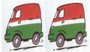
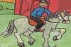

There are two - - - - . There is a man on a - - - - -
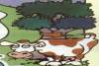
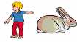

I have a - - - - - - . There is a - - - next to the tree.

Look at the pictures and write the missing parts :
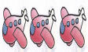
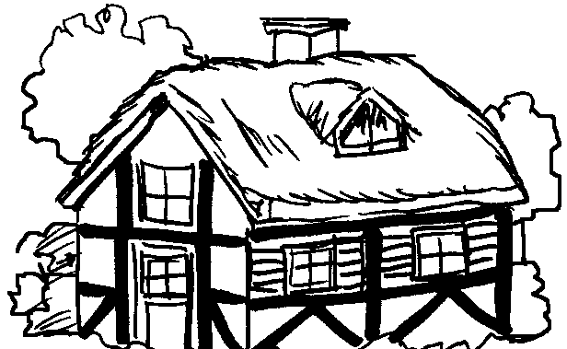

There are - - - - - planes. There is a white - - - - - .

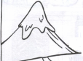


This is a - - - - . This is a man on a - - - - .

Match one part from (A) with the suitable part from (B) :
( A ) ( B )
1- Is there a bird? It's four o'clock.
2- What's the time? Yes, there is.
3- How many circles are there? is seven .
4- Nine take away two There are three circles.

Match one part from (A) with the suitable part from (B) :
( A ) ( B )
1-What's the time? He is in the living room.
2- Six take away two It's two o'clock.
3- Where's my father? in the tree.
4-There is two birds is four.
Supply the missing letters :
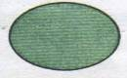
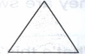
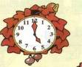

c - - ck t – ian - le w - - ch ci – c - e


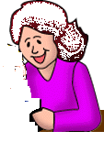

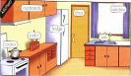

g – an – f – ther s – ua – e g – an – moth - r ki – che -

Underline the correct word(s):-

1- What is the ----------? It's one o'clock.
a) colour b) number c) time

2- It's half ----------ten.
a) past b) and c) to

3- It's six -----------------.
a) clock b) o'clock c) click

4- ------------ is the time? It's seven o'clock.
a) How b) Who c) What

5- It ------------- six o'clock.
a) is b) are c) am

6- It's half past ------------.
a) o'clock b) half c) two

7- How ------------- circles are there?
a) many b) much c) time

8- There ------------ a lion.
a) am b) are c) is

Underline the correct word(s):-

1- There ------------ one rabbit.
a) am b) is c) are

2- There ------------- sixteen triangles.
a) am b) is c) are

3- ----------- many balls are there?
a) How b) What c) Who

4- ------------ there a horse?
a) Am b) Is c) Are

5- ----------- there a dog?
a) Am b) Is c) Are

6- How many ------------ are there?
a) apples b) an apple c) apple

7- There are lots ------------ clocks at the airport.
a) of b) at c) in

8- This is the station ---------------------.
a) clocks b) o'clock c) clock

Read and mark ( √ ) Yes or No :
My name is Sally . I live in a big flat with my family. Tom is my
brother, He is in the bedroom . Meg is my sister, She is in the hall. My
father is in the living room and my mother is in the kitchen .

Yes No
1-Sally lives in a flat.
2- Tom is in the kitchen.
3-Meg is in the hall.
4- The father is in the living room.
Look at the pictures and write the missing parts :

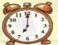
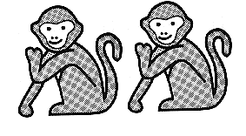

It's - - - - - o'clock. There are two - - - - - - - .
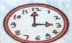
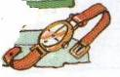

This is my - - - - - . It's - - - - - o'clock .

Look at the pictures and write the missing parts :

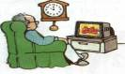


My grandfather is in the - - - - - - - - - - . It's - - - - past two
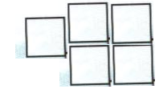
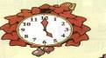

It's a - - - - -. There are - - - - squares .

Match one part from (A) with the suitable part from (B) :

( A ) ( B )
1-Do you have a car brown hair.

2- Mona has Yes, I do.

3- Who is it? Good morning, Omar.

4- Good morning, Ali . It's Sally.

Match one part from (A) with the suitable part from (B) :

(A) (B)
1-Hello, Noha. No, I don't.

2-Do you have a ball? Hello, Suzy.

3- Ali has This is my cat.

4- What's this? blue eyes .

Supply the missing letters :
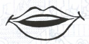
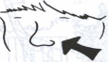
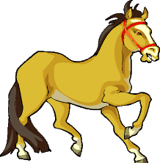


m - - th ho - - e n - - e sa - - wich

Supply the missing letters :
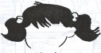
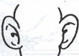
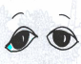
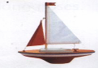

e - - s h - - r bo - - e - - s

Underline the correct word(s):-

1- I have one ---------------.
a) mouth b) ear c) eye

2- She has a ------------ mouth.
a) little b) short c) tall

3- I have two ---------------.
a) mouth b) eyes c) nose

4- ------------- has grey hair.
a) I b) You c) He

5- ------------ is my friend.
a) This b) Those c) These

6- ------------- is it? It's sally.
a) Who b) How c) Which

7- He has short blonde ----------------.
a) eyes b) hair c) nose

8- He has a big ---------------.
a) ears b) eyes c) nose

Underline the correct word(s):-

1- Do you ------------- a ball?
a) have b) has c) having

2- Do you have blonde hair? Yes, I --------------.
a) do b) don't c) have

3- Do you have a robot? No, I ---------------.
a) haven't b) don't c) do

4- ------------- you have a big nose?
a) Have b) Do c) Are

5- I ----------- a boat.
a) do b) have c) don't

6- Do ----------- have a ball? Yes, I do.
a) I b) you c) we

7- Do you have blonde hair? Yes, I --------- blonde hair.
a) do b) am c) have

8- Do you have a doll? Yes, I ---------------.
a) have b) do c) haven't

Read and mark ( √ ) Yes or No :

This is Hala. She has a pink dress and a blue bag. She has a brown
teddy and a green ball . And this is her brother Omar. He has a red T-shirt
and black shoes . He has a purple kite and a red bike.
Yes No
1- Hala has a pink dress.

2- Hala has a red ball.

3- Omar has blue shoes.

4- Omar has a red bike.
Look at the pictures and write the missing parts :
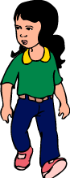
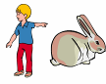

She has long - - - - . I have a - - - - - - .
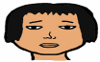


He has - - - - - eyes. She has a - - - mouth .

Look at the pictures and write the missing parts :


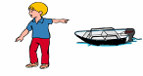

I have a - - - - . She has - - - - hair .

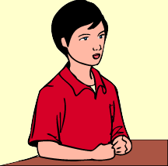
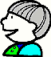

He has a - - - - - - nose . He has black - - - - .

Match one part from (A) with the suitable part from (B) :

(A) (B)
1- Giraffes have It's a rabbit.

2- What's this? long necks .

3- Crocodiles have Yes, I do.

4- Do you have long hair? big mouths .

Match one part from (A) with the suitable part from (B) :

(A) (B)
1- Elephants have Yes, They do .

2- Do they have tails? long noses .

3- Hippos have It's Ahmed .

4- Who is it? little ears .

Supply the missing letters
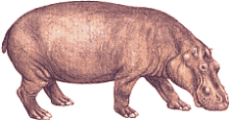
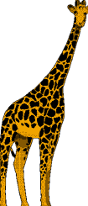
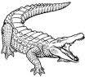
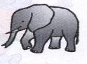

g - - aff c – oco - ile h - - po e - - phant

Supply the missing letters
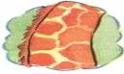
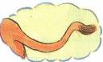
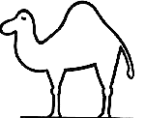
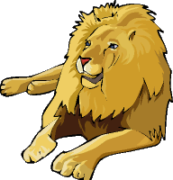

t - - l c - - el n - - k l - - n

Underline the correct word(s):-

1- ----------------- have long necks.
a) Giraffes b) Elephants c) Crocodiles

2- ----------------- have long legs.
a) Camels b) Goats c) Lions

3- ----------------- have long nose.
a) Crocodiles b) Elephants c) Giraffes

4- ----------------- have big eyes.
a) Owls b) Hippos c) Camels

5- Hippos have ----------------- ears.
a) big b) tall c) little

6- Elephants are --------------------.
a) big b) small c) little

7- We ---------------- green eyes.
a) have b) has c) having

8- Owls -------------- eyes.
a) have b) has c) having

Underline the correct word(s):-

1- Lions --------------- long tails.
a) have b) has c) having

2- Ali ------------ short black hair.
a) have b) has c) having

3- Suzy --------------- green eyes.
a) have b) has c) having

4- Amina and Nada ---------------- red bikes.
a) has b) have c) having

5- Elephants have ---------------- noses.
a) little b) long c) short

6- Monkeys and lions have long -----------------.
a) necks b) tails c) noses

7- These animals aren't big. They are -----------------.
a) little b) short c) long

8- I have two ----------------------.
a) ears b) noses c) tails

Read and mark ( √ ) Yes or No :

Bears are big animals. There are black bears, brown bears and white

bears. Bears have four legs. They don't have hands. They have little ears.

They have little tails.
No Yes
1-Bears have four legs.

2- Bears have big ears.

3-Bears have little tails .

4- Bears have hands.

Look at the pictures and write the missing parts :
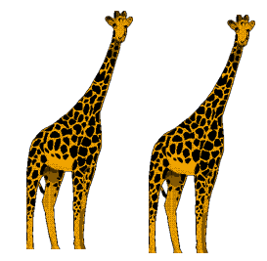
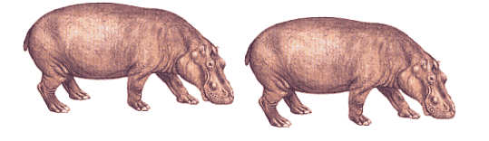

1-Giraffs have - - - - necks . 2- - - - - - - have little ears .
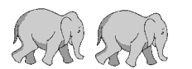

3-Elephants have long - - - - - . 4- The crocodile has - - - mouth.

Look at the pictures and write the missing parts :

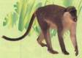

The monkey has - - - - tail . The - - - - is big .
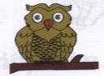

The - - - has big eyes . The - - - - - has long legs .

Match one part from (A) with the suitable part from (B) :
( A ) ( B )
1- He can ride long tails.
2- Monkeys have a bike.
3- Do you have long hair? in a tree .
4- There are two birds Yes, I do.
Match one part from (A) with the suitable part from (B) :
( A ) ( B )
1- She has on a horse.
2- There is a boy your name.

3- Please write Yes, I do.
4- Do you have black eyes long hair.

Supply the missing letters
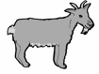
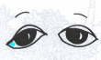
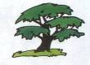

g - - t e y - - tr - - c - - codi - e

Supply the missing letters


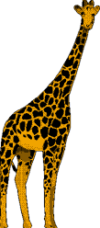


h – pp - s - - g gira - - w - - te

Underline the correct word(s):-
- There ………….. a girl .

a) am b) is c) are
- The boy is ………….a horse.

a) in b) at c) on
- Ali …………..short hair.

a) have b) has c) are
- I ………….. green eyes .

a) have b) has c) are
5-Please, …………. Your name.
a) open b) sit c) write
6- Tom can ………….. a bike .
a) sit b) ride c) sing
7- Crocodiles have big …………….. .
a) mouths b) necks c) noses
- Please, …………… down .
a) draw b) sing c) sit

Underline the correct word(s):-
1- There …………. Two birds in a tree.
a) am b) is c) are
2- There is a bird ……….. a tree .
a) to b) at c) in
3- My name ………… Soha .
a) am b) is c) are
4- There …………. a boy on a bike.
a) am b) is c) are
5- Monkeys have long ………….. .
a) necks b) noses c) tails
6- Please, …………… a song .
a) sing b) count c) open
7- Giraffes have …………… necks.
a) short b) little c) long
8- ……………. Your book, please.
a) Open b) Sing c) Count
Read and mark ( √ ) Yes or No :
I draw a picture. In this picture, I draw a woman in a yellow boat and a
girl on a blue bike . I draw a big tree. I draw three red birds in the tree and
two black cats under the tree .
No Yes
- The woman is on the bike.

- The girl is in a boat.

- The birds are red.

- The cats are black.

Look at the pictures and write the missing parts :
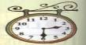

Giraffes have long - - - - - . It’s - - - - past two .
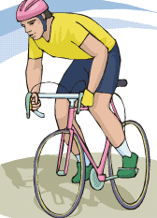

There is a boy on a - - - - . She has - - - - hair .

Look at the pictures and write the missing parts :

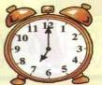

It’s - - - - - o’clock . The goat has - - - - - tail .

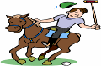

He has short - - - - . There is a boy on a - - - - - .

THE STORY
I LIKE SHOPPING
1-I like …………….
2- What's wrong, …………….?.
3- You aren't ……………….
4- Look at my …………….
5- …………do you do to your shoes?
6-I walk to ……………and I ………….home.
7- You play …………..in them.
8-We can get some new ………….for Bob.
10- We can go on the ………..... .
11- I like these red and …………… trainers.
12- You want some nice, black ………… for school.
13- Here's the shoe ………….
14- Do you ............... any school shoes?
15- Yes, these are ………. for school.

TEST (1)
A) Vocabulary and Structure
1-Match one part from (A) with the suitable part from (B) :
1- What’s this? in a tree .
2- There is a bird It’s a rabbit.
3- Mona has is seven.
4- Nine take away two long hair.
is four.

2-Supply the missing letters
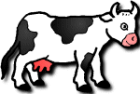
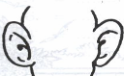
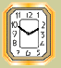

li - - c - - e - - s clo - -
3-Underline the correct word(s):-
1- The lion isn't little. It's ----------.
a) big b) short c) long
2- The cow is in the -----------------.
a) kitchen b) barn c) tree
3- How ------------- circles are there?
a) many b) much c) time

4- I have one ---------------.
a) mouth b) ear c) eye5- There ------------ a lion.
a) am b) are c) is
6- ------------- has grey hair.
a) I b) You c) He
7- Camels --------------- long legs.
a) have b) has c) having
8-Please, …………. your name.
a) open b) sit c) write

B – Reading Comprehension :
4-Read and mark ( √ ) Yes or No :
My name is Enas . I go to the zoo with my friend Sahar. In the zoo we
see the hippos , the crocodiles , the giraffes and the lions . Hippos are big.
They have little ears. Crocodiles are long and have big mouths. Giraffes
are tall , they have long necks . Lions are big and have long tails
No Yes
1- Enas and sahar go to the zoo.

2- Hippos have little ears.

3- Giraffes have short necks.

4- Lions are small.
C - Pictorial Composition :
5-Look at the pictures and write the missing parts :
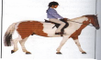
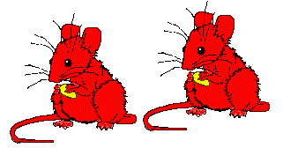

There are two - - - - - - . There is a girl on a - - - - - .
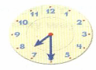

There are - - - - - squares . It’s - - - - past seven .
D - The link reader
I Like Shopping
6-Complete the following sentences
- You play …………. In them.
- You aren’t …………… .
- We can get some new ……….. for Bob .
- I like these red and ……….. trainers.

E – Handwriting :
7- Copy the following in your best handwriting :

Giraffes have very long necks.
............................................................................
TEST (2)

A) Vocabulary and Structure
1-Match one part from (A) with the suitable part from (B) :
1- What’s the time? Yes, there is .
2- Is there a cow in the barn? It’s six o’clock.
3- My father is long noses.
4- Elephants have in the living room.
No, There aren’t.

2-Supply the missing letters
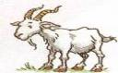
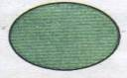

h - - se e - - s c - - cle g - - t

3-Underline the correct word(s):-
1- What is the ----------? It's one o'clock.
a) colour b) number c) time
2- It's half ---------- ten.
a) past b) and c) to

3- He has short blonde ----------------
a) eyes b) hair c) nose
4- Elephants are --------------------.
a) big b) small c) little
5- There is a house ---------- to the hill.
a) next b) between c) under
6- Is there a girl in the house? No, -----------------.
a) there isn't b) there is c) there aren't
7- It ------------- six o'clock.
a) is b) are c) am

8- ------------- has grey hair.
a) I b) You c) He

B – Reading Comprehension :
4-Read and mark ( √ ) Yes or No :
My name is Ahmed I live in a big house with my father, my mother and
my sister Noha. This is my friend Mohamed. Mohamed has a barn next to
my house. There is a cow, a goat, a horse and a camel in the barn .There is a
big tree next to the barn and there are two birds in that tree.
No Yes
1- Ahmed has a big house.

2- The barn is in the house.

3- There is a cow in the barn.

4- There is one bird in the tree.
C - Pictorial Composition :
5-Look at the pictures and write the missing parts :
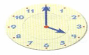
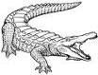

It’s - - - - o’clock . It's a - - - - - - - - - .

There is a boy on a - - - - . She has - - - - hair .

D - The link reader
I Like Shopping
6-Complete the following sentences :
- What’s wrong, ………?
- Look at my …………… .
- …………. do you do to your shoes?
- I walk to ………….. and I walk home .

E – Handwriting :
7- Copy the following in your best handwriting :
Sally has a little pink mouth.
……….……………………………………………….

