

Sawda Bint Zam'a School

Worksheets for

3rd grade second semester
2015/2016

By

Teacher:Eman El-Abweni
Third Grade
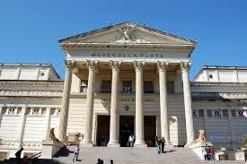
Unit 9
Name: ---------------------------------- Class: -------------

1) Match a train station a museum a plane The Roman Theatre

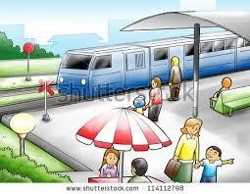

------------------------- -------------------------

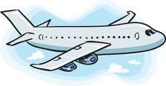
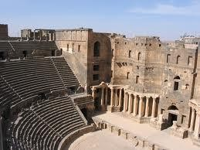

------------------------- -------------------------

2) Circle
1. There ----------- two markets
a- Is b- are c- am

2. Where is Ahmed's house? It's ------------- the museum. a- behind b- near c- in front of

3. There ------------ a train station.
a- is b- are c- am

4. Are there any museums in your city?
a- Yes, there is b- Yes, there aren't. c- Yes, there are.

5. Where are the markets? They're ------------- school.
a- Near b- in front of c- behind

6. Is there an airport in Amman?
1) Yes, there are b- yes, there is c- yes, there aren't

Third Grade
Unit 10
Name: ---------------------------------- Class: -------------

1) Complete with must mustn't

a) Amjad -------------- go to bed at 9 o'clock. b) He -------------- shout at school.
c) I --------------- tidy my room. d) She ------------ drink cola.
e) They ------------- do their homework.

f) Mayar ------------- wear a hat. It's hot and sunny. g) You ------------ put rubbish in the bin.
h) He -------------- ride a bike on flowers.

2) Order and write.

your homework mustn't forget You

go school

seven
must to
o'clock at
You

Third Grade
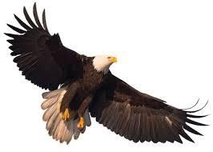
Unit 11
Name: ---------------------------------- Class: -------------

Match: leopard Eagle wolves goat

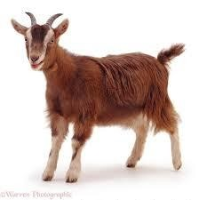

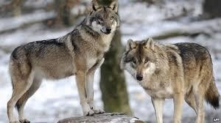
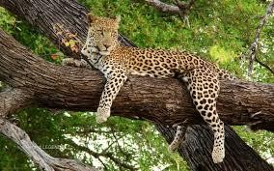

Answer:
Are they swimming?

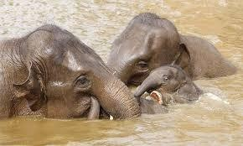

Is it sleeping?

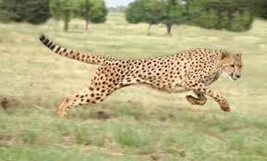

Are they flying?

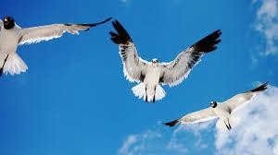
Third Grade
Unit 12
Name: ---------------------------------- Class: -------------

1) Match:
1. You mustn't shout. 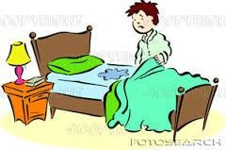

2. You mustn't touch. 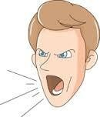
3. You mustn't stand up in the bus. 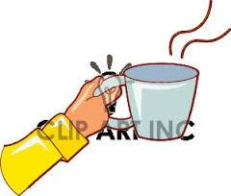

4. You must tidy your bed. 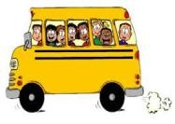

2) Match: wolves taking photos he is thirsty an owl on the tree

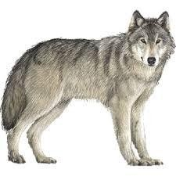
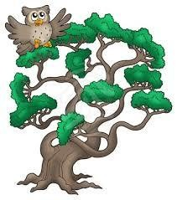

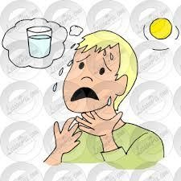

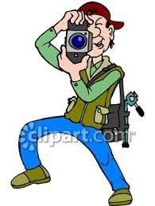

1) Circle:
1. Amjad -------------- to draw some flowers.

a- want b- wants c- wanting

2. ------------- you want to go to school?

a- does b- do c- doing

3. September -------------------- November , December

a- August b- January c- October

4. I --------------- to buy some cakes.

a- want b- wants c- wanting

5. My brother ---------------writing in a notebook.

a- like b- likes c- liking

6. Maram ---------------- want to go to party.

a- don't b- doesn't c- did

7. Do parents want to buy a present to Moayad? They ----------------- a- don't b- doesn't c- did
2) Choose:

a. We give presents to our mothers in February / March. b. Teacher's Day is in October / November.
c. We plant trees in December / January. d. The summer holiday start in July/June.

1) Complete First Next Then Finally

We go school trip on Saturday. ----------------------------, we have breakfast at the park.

------------------ we played football, ----------------------- we went to the Roman Theater.
-------------------------- We went to the Zoo, we see the Lions, Elephants, monkeys, and different animals.

2) Choose: post office butcher's market baker's Chemist's

1. I want to buy some lamb. I go to the ------------------------------

2. I want to buy some cakes. I go to the ------------------------------

3. I want to buy some vegetables. I go to the -------------------------

4. I want to buy some stamps. I go to the -----------------------------

5. I want to buy some medicine. I go to the ---------------------------

3) Write:

There are two boys in the toy shop.

The boys are playing with their toys

Fruit sports tooth computer ice

center cream game brush juice

2) Choose:

ice cream | cakes | juice | cola | vegetables
play sports | fruits | lamb | sweets | water

Healthy | Not healthy

3) Answer:

1. What foods and drinks do you like?

2. What foods and drinks does your mother like?

a) Would you like some salad? Don't eat a lot of sweets. Do a lot of exercise. b) How can we be healthy? Yes, please! It's very healthy.
c) Goodbye Miss. Go straight on, then turn right. It’s opposite

the bookshop.

d) Let's go the market. Goodbye, children. Have a good holiday. e) Excuse me, where's the baker's? Yes, I want to buy some flowers.
2) Answer:

a- What's the weather like in Jordan?

b- What would you like?

c- Are there any shops near your house?

d- Does your mum work in a hospital?

Eman Mahmoud El-Abweni

