Animals
Name:

Class:

Word bank

Kangaroo - elephant – swim – hippopotamus – monkey – fly - zookeeper

Complete

1-………………can climb a tree.

2-……………….can jump with its legs.

3- The seal can …………..in the water.

4-The ………………can feed the animals in the zoo.

5-The ……………….can swing its long nose.

6-The ………………can swim.


7-The birds can ………………..

I wish you the best

Name:

Class:

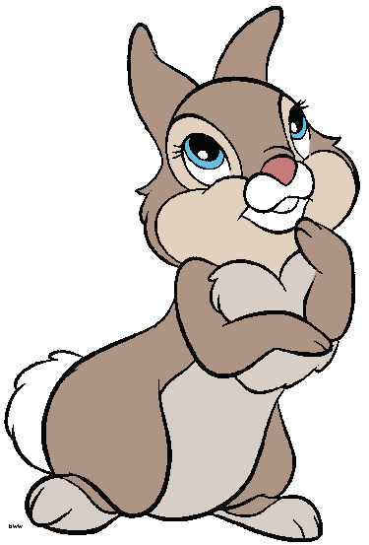
Word Bank

Camel – giraffe – elephant – bear - hippopotamus

- It has a big feet.(…………………..)

2-It has a long legs.(……………………)

3-It has long nose.(…………………….)

4-It has long neck.(…………………….)

5- It has big ears.(……………………..)

6- It has a short neck.(…………………….)

7- It has a short tail.(………………………)

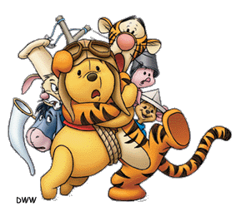
Name:

Class:

Use ( can ) or ( can’t)

- A fish …………….swim.

- A camil ……………sing.

- A bird ……………..fly.

- A kangaroo………….jump.

- A hippopotamus ……………fly.

- A monkey …………….climb.

- A seal …………….climb trees.

- A lion …………….read.

