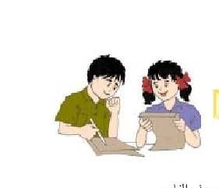

Unit ten : Are there any lentils?
There are two types of articles:
1- Indefinite articles (a, an) (used with singular nouns)
We use them in the following ways:
a: We use it with the consonants.(b.c.d.f.g.h.j.k.l.m.n.p.q.r.s.t.v.w.x.z)
I sat on a chair.
I drive a van.
an: We use it with the vowels .
Vowels are
Q2: Write ( a, an) :
_____ train.
_____ orange.
_____ apple.
_____ bike.
_____ dog
_____ computer.
2- Definite article (The)
We use the with the following
*With nouns which are unique.( The sun,The moon,The earth)
*With names of rivers ,oceans, seas( The Dead Sea ,The Atlantic ocean ,The Nile)
*With the names of nationalities: (The French,The Jordanian)
*With the words (the morning, the afternoon, the city)
*With big countries' names (The HKJ,The USA,The UN)
___________________________________________________
Now try this :
Write (a –an- the)

6
1- I saw ______ elephant.
2- I went to _______ Dead sea last week.
3- I broke ________ vase yesterday.
4- I saw the president of ________ USA on the T.V
5- _____ apple a day keeps the doctor away.
6- I had _______ big hat.
______________________________________________
Look at the picture and complete these sentences:
1. There............................ ( is, are, any ) three girls in the picture.
2. There aren't............................ ( some, a, any ) papers on the table.
3. There is................... ( a, an, some ) table in the picture.
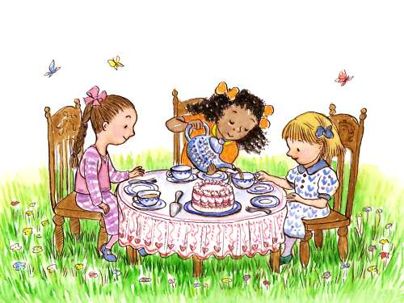
4. I can see......................... ( any, some, a ) butterflies in the picture.
5. There..................... (are, a, is ) some tea in the cup.

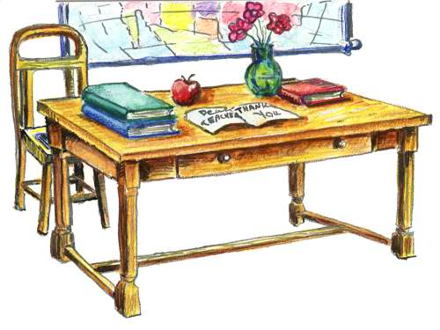
Look at this picture and write three sentences using { some, any, a, an} :

1..........................................................................................................................
2.........................................................................................................................
3....................................................................................................................
Q1: Some of these sentences need a/an correct them:
1- He goes everywhere by bike .He hasn't got _____car
2- We went to ____restaurant.
3- I clean my teeth with ___toothpaste.
4- I eat orange every day.
5- Can you tell me if there is ___bank here?
6- Yesterday we saw____ elephant in the zoo.
**************************************************************
Q2:Complete the following sentences with some , any:
1- We didn't buy ……………presents.
2- This night .I'm going out with …………………. relatives.
3- Have you seen ………………….. good cartoons recently?
4- I didn't have money, so I had to borrow ……………………
5- Can I have ……………………. coffee, please?
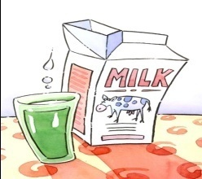
Q3: Cross the unnecessary words in the following:
1- There is some a meat in the fridge.
2- There is a some table in the room.
3- There some an milk.
4- He hasn't got any a brothers.
5- There are six an apples in the bowl.


Sense and feeling (unit eleven 11)( The meal tastes delicious)
delicious
upset
1-He looks ______________
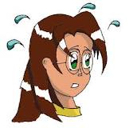
angry
excited
2- She looks ___________
scared
worried
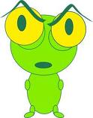
embarrassed
beautiful
3- It looks __________

cold
nervous


4- He seems ___________

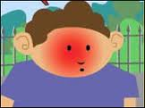
5- He looks __________

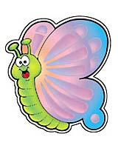
6- It looks _____________
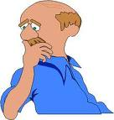
7- He seems____________
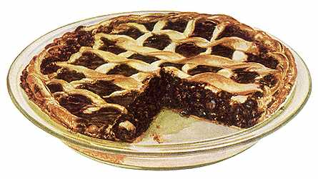
8- The pie tastes____________________
9- The ice cream looks _____________.


10-She looks _______________
Writing (Unit twelve( Why is Kareem excited))
Answer the questions with because :
1- Why is Ali sleeping ?

_______________________________________________________

2- Why is laila studying?
______________________________________________
3- Why is Dalal carrying the school bag?
_____________________________________________________________
4- Why is Talia happy?
_________________________________________________________
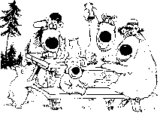
5- Why is Sami excited?
________________________________________________
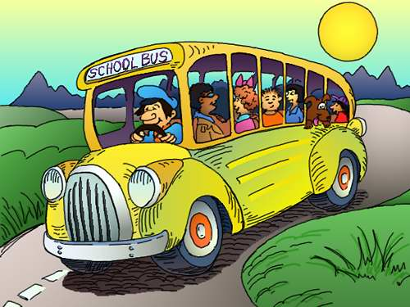
6- Why are the students interested ?
_______________________________________________
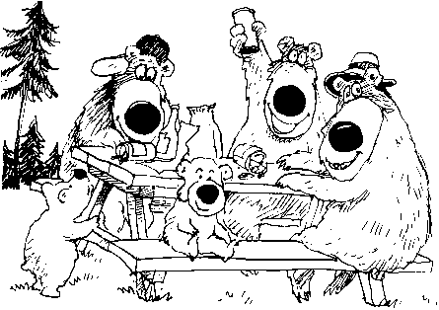

Unit fourteen(you should play sports)
Should – shouldn’t
1- Write (should –shouldn’t)
1- You ______________ play in the street

2- You _________________ play sports every week.


3- You ________________ smoke here.
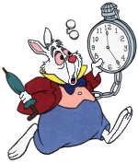

4- You ________________ go to school late.


5- You ______________________ read the Quran every day.


6- You ___________________eat fruit every day.

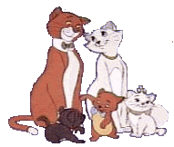
7- You _____________________ hurt cats .

Unit 15 (fifteen) There was a great celebration
Fill in the missing using the suitable verb to be(was-were-wasn’t weren’t _
1- A:________ he British ?
B: No ,he ______ . He ______ French.
2- A: _______ he a taxi driver ?
B: No, He_________. He _______ a pilot.
3- A: ______ they from Dubai ?
B: No, they ______ .They __________ from Qatar .
4- A: _________ he a lawyer?
B: Yes ,he _____
5- A: ______ Laila and Ahd in Tokyo ?
B : No ,They ______ . They __ ___ in London.
6- A: How old _______ the two of you in 2009 ?
B: We _______ 3 years old .

Unit sixteen (16) (Life will be different) Simple future in planning
Lana is planning her week .Look at her diary & write sentences using the simple future
Monday: clear the attic
Tuesday: visit grandfather
Wednesday: cook dinner for friends.
Thursday: meet laila for coffee.
Friday: go Shopping
Saturday: take children to the funfair
Sunday: fly to Syria.
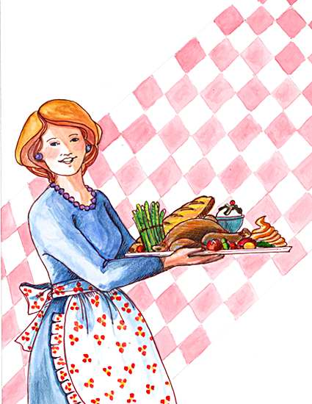

- ________________________________________

- ________________________________________

- ________________________________________

- _________________________________________

- _________________________________________

- _________________________________________

- ________________________________________.(bonus)



Match the sentences with the pictures :
1-our cars won’t use petrol
2- we will live on Earth
3- we will save more water
4- we will use electric cars

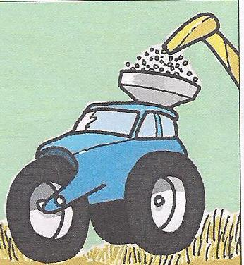
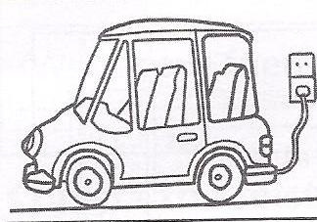
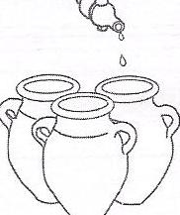
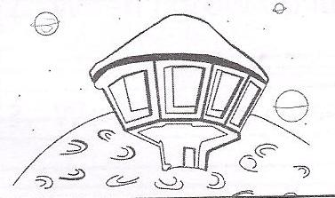
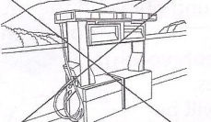

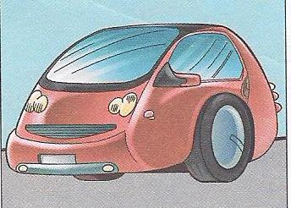
Write a sentence about each picture about the cars in the future :
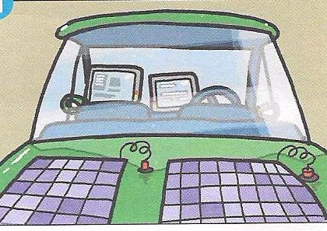

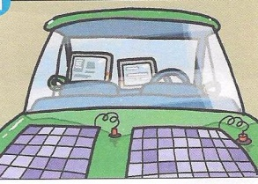

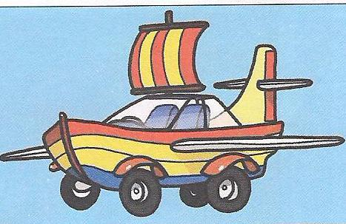
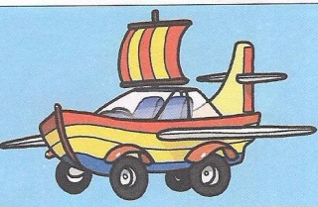

Unit 17 (Have you ever climbed a mountain?
Present perfect
Rule :
I,We,You,They+have+v3
She,he,it+has+v3

Examples:
1- She has never seen a lion.
2- I have cleaned my room for several hours.
3-We have been to Mecca for several days.
I,We,You,They+have+not +v3
She, he, it+has+not+v3

Negation(using not)
Examples:
1- she hasn't seen Ali since October.
2- I haven't been to Amman since January
Key words:
Ever : We use it in questions
Ex: Have you ever seen a snake?
Never: We use it in negative sentences
Ex: I have never played tennis.

Since: We use it with the following:
*Days of the week:Saturday,Sunday…….etc
*Months of the year: January,February…..etc
*years:1887,2006,1987…..etc
*Specific occasion :Eid,Ramadan
*Time: 6:00 o'clock, 8:00 o'clock …etc
* With words like: last, yesterday &grade
For : We use it with the following words:
*several /many/hours/days/weeks/years.
Question one: Correct the verbs between the brackets:
1- I ………… never ………..……. a mouse.(catch)
2- She …….……. never ……..……. the dishes.(clean)
3- Laila ………….. never …………..…. a story.(write)
4- ………..… you ever ………..… .. your leg?(break)
5- _______ you ever __________ a mountain?.(climb)
*********************************************************
:Question two : Write Since or For
1- He hasn't come in to work …………… a week.
2- I haven't bought anything new …………. April.
3- We haven't visited our grandmother ……….. last week.
4- She has washed her clothes …………. 10:00 o'clock.
5- I have been to Dubai ………. three years.
Verbs
Past participle V3 | Past V2 | Present V1
become | Became | become
begun | began | begin
broken | broke | break
built | built | build
bought | bought | buy
caught | caught | catch
come | came | come
done | did | do
drawn | drew | draw
drunk | drank | drink
driven | drove | drive
eaten | ate | eat
fallen | Fell | fall
given | gave | give
gone | went | go
grown | grew | grow
hurt | hurt | hurt
known | knew | know
left | left | leave
ridden | rode | ride
seen | saw | see
spoken | spoke | speak
swum | swam | swim
taught | taught | teach
thrown | threw | throw
worn | wore | wear
written | wrote | write

Choose ( How much , How many, much, many )
- We need some tea……………… do we need?
- We need some eggs…………….do we need?
- ……………. bottles do we have?
- …………….sugar do you take in your tea?
- ……………. apples do you eat in an average week?
- …………….fruit do you eat a week?
- ……………. friends do you have?
- ……………. chairs are there in your house?
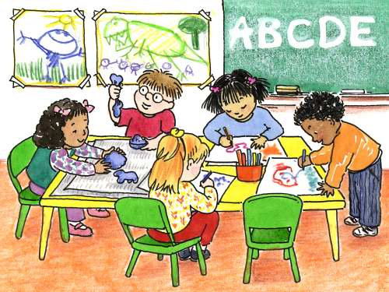
- ……………. coffee do you drink a week?
- Don't eat …………. sweets.
- …………. Milk do you drink a week?
- Don't drink ……………. Cola.
- Don't eat too…………. Chocolate.
- ………....... salad did she make?
- ……………..pizzas do you eat?

