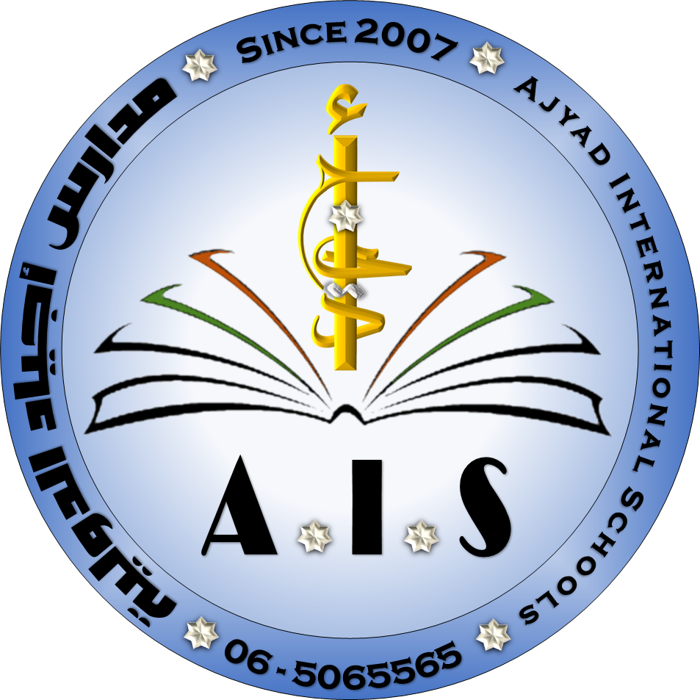
Ministry of Education
Ajyad International Schools

Scholastic years: 2018 / 2019 Second semester Grade: EIGHT
Date of exam: ………….., Time:…………
Student's name:………………………………. Teacher's name: Thaer Mamoun

Total(40) |  |  | 8 | 6 | 6 | 8 | 12 | Question mark
 |  |  |  |  |  |  |  | Student's mark
ــــــــــــــــــــــــــــــــــــــــــــــــــــــــــــــــــــــــــــــــــــــــــــــــــــــــــــــــــــــــــــــــــــــــــــــــــــــــــــــــــــــــــــــــــــــــــــــــــــــــــــــــــــ

Q1: Read the paragraph carefully and fill in the blank from the box.

Compass_ navigate_ prayer_ Astronomers_ destinations_ sundial _

Do you ever wonder how aeroplanes and ships reach their (1)--------- without getting lost? The history of science shows us that it’s more than just luck! (2)----------- studied the universe for a long time and found ways to map the Earth by looking at the stars. Muslim astronomers, like Al Fazari and Al Khawarizmi, changed the way we understand our planet, and others, like Ibn Al Shatir, showed us how to (3)--------- it. Ibn Al Shatir invented both the magnetic (4)------- and the (5)-------- . These inventions allowed people to fi nd their way to Mecca more easily, and even to know the times for (6)-------- throughout the day. Today, aeroplanes and ships use the compass for navigation.

1. What will people be able to do in zero gravity?

2. Did Newton think that space travel would be possible one day? Explain your answer.

3. Do you think space travel will become more popular for tourists in the future? Why/Why not?

Q2 : What are the meaning of?

1: Astronaut:
2: revolve:
3:scrapyard:
4: universe:
___________________________________________________________________________________

Q3: write down two sentences of the future tense using (Affirmative, Negative, interrogative)

Q4: Write down at least 3 Irregular verbs.

Verb 3 | Verb 2 | Verb 1

Q7: Write down the name of the planets in our solar system.

1.

2.

3.

4.

5.

6.

7.

8.

