Second Grade Name________________
===========================================================
Q1) Match the following
1 tweleve
7 one
12 seven
20 four
4 twenty

===========================================================
Q2) Circle the correct answer:
1-- How many ball are there?
there are / there is four balls.

2—A- Can I have some figs please?
B – Sure, how many/ how far would you like? =================================================
Q3) What is the time in each of the following clocks( match)
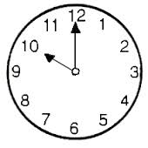
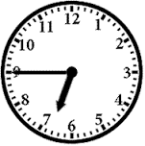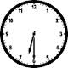
(It's quarter to seven o'clock.) (It's ten o'clock.) ( It's half past six) ===========================================================
Q5) Write the small letters of the following:
C ________ F_______ O________ D _______ V _______ W________

